# Udemy Course for MDR 2017/745

Contents

Udemy Course for MDR 2017/745 1

Section 1: Introduction to MDR 2017/745 3

1 Introduction 3

2 Why change? + Quiz 7

3 Timelines + Quiz 11

Section 2: Economic Operators 15

1 Introduction 15

2 Economic Operators 16

3 Economic Operator: The European Authorized Representative 21

4 Economic Operator: The Distributor 25

5 Economic Operator: The Importer 29

6 Economic Operator: The Manufacturer 33

7 Economic Operator: Procedure pack & systems 38

8 Economic Operator: Obligation change 42

9 Person Responsible for Regulatory Compliance, PRRC 44

Section 3: EUDAMED 48

1 Introduction 48

2 Actors registration 50

3 EUDAMED Timelines 55

Section 4: UDI / Registration 57

1 UDI, Part 1, Introduction 57

2 UDI, Part 2, How to create a UDI 60

3 UDI, Part 3, who is accredited to create a UDI in the EU 66

4 UDI Timelines 72

Section 5: Classification of medical devices 74

1 Introduction 74

2 Qualification of a medical device 78

3 Medical Device definitions 84

4 Medical Device Classification rules 89

5 Apply Medical Device Classification rules 93

Section 6: Conformity assessment 100

1 Introduction 100

2 Class I - Conformity Assessment Path 101

3 Class I (Sterile, Measuring, Reusable) - Conformity Assessment Path 105

4 Class IIa- Conformity Assessment Path 109

5 Class IIb- Conformity Assessment 113

6 Class III- Conformity Assessment 117

Section 7: Sufficient Clinical Data 121

1 Introduction 121

2 General Safety and Performance Requirements (GSPR) 122

3 Intended Purpose 129

4 Sufficient Clinical Data: Clinical Evaluation 135

5 Sufficient Clinical Data: Post Market Clinical follow-up 138

Section 8: Post market surveillance 142

1 Introduction 142

2 Post Market Surveillance System & Plan 143

3 Post Market Surveillance Report & Periodic Safety Update Report (PSUR) 149

4 Vigilance System 152

5 Analysis of Vigilance Data 157

6 Role of CA & EC within Market Surveillance 160

Section 9: Miscellaneous 165

1 Introduction 165

2 Medical Device Coordination Group “Guidelines” 166

3 Brexit 170

4 Switzerland Mutual Recognition Agreement 174

5 Turkey and EFTA MDR 2017/745 177

6 Common Specifications 180

7 The Rolling Plan 182

Section 10: Bonus section 183

# Section 1: Introduction to MDR 2017/745

## 1 Introduction

Hi, what will we discuss in this section?

I will discuss a general introduction into the medical device regulation 2017/745.

The actual medical device regulation is a resource attached to this lecture.

Please have it open on another screen as you make your way through the course as a reference.

If you want to, print it that would also be a good idea.

Understand why there was change from a directive to regulation, we would examine the timelines for

the transition from a directive to a regulation.

Hi, welcome to the Medical Device Regulation 2017/745 lecture introduction.

What are the learning objectives?



You will understand the transition from the medical device directives to the medical device regulation.

What will the changes bring?

What does the medical device regulation contain?

I will give a quick summary of the chapters and the annexes.

I want students to understand that this is a brief summary of the medical device regulation.

The module will explain the principles of the regulation in further detail.

There is a transition in the medical device regulation that governs the European Union, the Active

Implantable Medical Device Directive 93/85 EEC and the Medical Device Directive 93/42 EC is being replaced with the Medical Device Directive Regulation 2017/745.

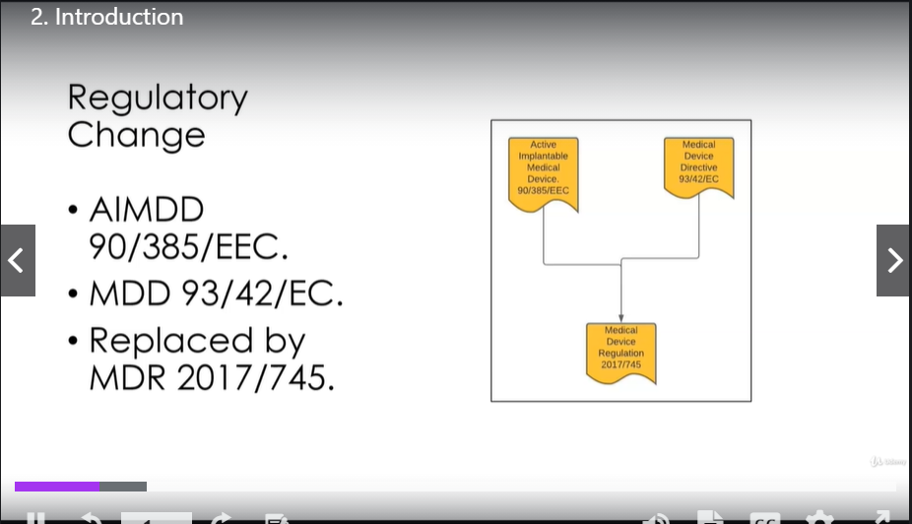

What will the change bring?

Harmonization, once the law regulation is formulated, it becomes law in each member state, **it even**

**overrules existing and national laws.**

The **same rules** will apply for each member state in the European Union for the marketing of medical devices.

The Regulation will improve transparency with **more post market surveillance reporting** from Manufacturers.

The regulation will become more orientated around clinical evidence and **the performance of the device will be continuously assessed.**

Improving product traceability is another change, the implementation of the unique device identification system **UDI** and the new database **EUDAMED** will help with traceability.

During the course of this module, we will go into more detail of harmonization, transparency and traceability.

The medical device regulation, 2017/745 is bigger than the medical device directive.

It consists of:

* 101 Preambles (προοίμιο, εισαγωγή) which is a large introduction to the Regulation
* 123 Articles organized in 10 Chapters
* 17 Annexes
* 175 Pages for the whole document

One reason is that the two directives are now combined to one regulation, but there is more detail

in that regulation.

Remember, in simple terms, this Regulation is communicating the rules, which you must follow if you

want to market your medical device on the European Union marketplace.

During this module, I will break down the regulation into smaller bites so we can understand what is

required.

**The Chapters are broken into the following:**

**Chapter I - SCOPE AND DEFINITIONS**

It explains what the regulation covers and gives us definitions, these definitions are very useful to help us understand the body of the regulation.

**Chapter II – MAKING AVAILABLE ON THE MARKET AND PUTTING INTO SERVICE OF DEVICES, OBLIGATIONS OF ECONOMIC OPERATORS, REPROCESSING, CE MARKING, FREE MOVEMENT**

Obligations of the economic operators

The **economic operator is a new term** which explains the roles and responsibilities of certain players within the medical device industry in Europe. I will explain what is meant by an economic operator during the module.

**Chapter III- IDENTIFICATION AND TRACEABILITY OF DEVICES, REGISTRATION OF DEVICES AND OF ECONOMIC OPERATORS, SUMMARY OF SAFETY AND CLINICAL PERFORMANCE, EUROPEAN DATABASE ON MEDICAL DEVICES**

It covers the new European database for medical device regulation known as EUDAMED.

**Chapter IV – NOTIFIED BODIES**

It explains the role the Notified Body has within the scope of the regulation.

The Notified Body is now under more scrutiny to prove that they can understand the regulation and perform compliance audits.

**Chapter V – CLASSIFICATION AND CONFORMITY ASSESSMENT**

It explains the classification categories of medical devices and the conformity assessment that needs to be carried out according to the level of classification.

The majority of the annexes will help us to understand what conformity assessment should be carried

out. Again, this will be explained during the course.

**Chapter VI – CLINICAL EVALUATION AND CLINICAL INVESTIGATIONS**

It determines how you evaluate your medical device in a clinical trial for safety and efficacy.

**Chapter VII - POST-MARKET SURVEILLANCE, VIGILANCE AND MARKET SURVEILLANCE**

There has been an emphasis on post market surveillance. The directive demands a Manufacturer

To be more proactive in their approach. This will be explained.

**Chapter VIII – COOPERATION BETWEEN MEMBER STATES, MEDICAL DEVICE COORDINATION GROUP, EXPERT LABORATORIES, EXPERT PANELS AND DEVICE REGISTERS**

It explains the communication, perhaps between the competent authorities, European Commission, and the expert groups that can help with compliance. For example, the Medical Device Coordination

Group, MDCG is a collaboration of industry experts and regulators.

They publish guidance documents that help clarify the regulation.

**Chapter IX – CONFIDENTIALITY, DATA PROTECTION, FUNDING AND PENALTIES**

A medical device Manufacturer relies on intellectual property as a huge financial source.

If a Notified Body or a Competent Authority inquire detail about a product or manufacturing, this needs

to be kept confidential.

A regulator primary concern is that the device is marketed in a safe and effective manner.

**Chapter IX – FINAL PROVISIONS**

This is just a tidy up. For example, it explains when the medical device directive shall become void (άκυρη).

**Now, about the Annexes:**

**Annex I - GENERAL SAFETY AND PERFORMANCE REQUIREMENTS (GSPR)**

explains the requirements that the Manufacturer must prove that the device is safe and effective.

**Annex II – TECHNICAL DOCUMENTATION**

**Annex III - TECHNICAL DOCUMENTATION ON POST-MARKET SURVEILLANCE**

Annexes II and II, explain what documented evidence has to go into the technical documentation to prove safety and efficacy.

Notice the technical documentation is new to the medical device regulation.

**Annex IV - EU DECLARATION OF CONFORMITY**

explains how the Manufacturer declares conformity to the regulation.

**Annex V - CE MARKING OF CONFORMITY**

explains how the CE mark is applied. This is simple, but very important.

**Annex VI - INFORMATION TO BE SUBMITTED UPON THE REGISTRATION OF DEVICES AND ECONOMIC**

**OPERATORS IN ACCORDANCE WITH ARTICLES 29(4) AND 31, CORE DATA ELEMENTS TO BE PROVIDED**

**TO THE UDI DATABASE TOGETHER WITH THE UDI-DI IN ACCORDANCE WITH ARTICLES 28 AND 29,**

**AND THE UDI SYSTEM**

gets really interesting as it explains the rules which must be adhered to, for registration of devices in the new European database EUDAMED.

**Annex VII – REQUIREMENTS TO BE MET BY NOTIFIED BODIES**

explains the requirements that notified bodies must meet in order to be able to execute compliance audits.

**Annex VIII – CLASSIFICATION RULES**

this annex explains the definitions and the rules, which must be followed to determine classification of your device. It is interesting to note that there are now 22 rules in the medical device regulation compared to the 18 rules in the medical device directive.

**Annex IX - CONFORMITY ASSESSMENT BASED ON A QUALITY MANAGEMENT SYSTEM AND ON ASSESSMENT OF TECHNICAL DOCUMENTATION**

**Annex X - CONFORMITY ASSESSMENT BASED ON TYPE-EXAMINATION**

**Annex XI - CONFORMITY ASSESSMENT BASED ON PRODUCT CONFORMITY VERIFICATION**

Explains the conformity assessments which must be carried out. The type of assessment that a Notified Body will carry out, depends on the classification of the device.

Again, this will be explained further into this module.

**Annex XII - CERTIFICATES ISSUED BY A NOTIFIED BODY**

explains the format of the certificate once it has been issued.

**Annex XIII - PROCEDURE FOR CUSTOM-MADE DEVICES**

is used to explain the rules that must be adhered to for custom made medical devices.

**Annex XIV - CLINICAL EVALUATION AND POST-MARKET CLINICAL FOLLOW-UP**

One of the changes of the medical device regulation is an emphasis on collecting safety and efficacy

data on the device in the marketplace. This annex explains how Manufacturers need to be more proactive.

**Annex XV - CLINICAL INVESTIGATIONS**

explains the requirements that need to be carried out for a clinical trial of a medical device.

**Annex XVI – CORRELATION TABLE**

this is an interesting annex as it pertains to devices that do not have an intended medical purpose.

For example, contact lenses which may be introduced into the body to change eye color for cosmetic reasons, **they now have to follow the medical device regulation**.

What have we learned?

I've explained the change from the medical device directive to the medical device regulation.

I explained the benefits of the change.

I gave a summary of the chapters and the annexes.

Please remember, this is an introduction of the medical device regulation and the module will go into

more detail to help you understand the regulation further.

## 2 Why change? + Quiz

Hi, welcome to the Medical Device Regulation 2017/745, why change from the medical device directive to the medical device regulation.

What are the learning objectives in this lesson?

I will discuss an example of a case study from a French medical device Manufacturer called PIP.

I will examine how the consequences of this case study and others had an influence on changing the medical device regulation.

I will discuss other considerations that influenced change.

Let's examine the PIP breast implant case study, which first erupted in 2010.

Pip was a French company founded in 1991 that produced silicone gel breast implants.

The French breast implant Manufacturer was accused of inserting a dangerous gel into the chests of nearly 300.000 women across the globe.

The company was found to have used substandard silicone gel rather than medical grade silicone, with the result that many implants ruptured.

Nevertheless, the PIP company, the third ranking producer of prosthetics in the world, had managed

to get its products certified by a well-known certified notified body, TUV Rheinland.

Two very interesting points here.

* The Manufacturer had made a change to the process. The raw material input to the process was changed. Regulation states that all changes to the process must be validated to ensure that there is no risk to the patient.
* The second point is that a certified Notified Body conducted a compliance audit with this company after this change and found no errors.

Consequences:

* The Notified Body was held liable for passing the compliance assessment and awarding a quality management system certificate.
* The founder of the company was jailed for fraud and fined.
* Pip's sale of faulty implants caused a global health scare, which affected about 300.000 women in 65 countries.
* Other former PIP executives were convicted and given lesser sentences.
* There was initial confusion between European competent authorities on the course of action
* The company’s head of quality control received a two-year jail sentence.
* The head of research and development was sentenced to 18 months suspended.

I would like you to think about these consequences.

If you are working for a medical device Manufacturer and you are not compliant with regulation, you

are liable. This can mean that your products could be withdrawn from the European Union marketplace.

It could mean fines or going to jail.

Regulation in the medical device industry needs to be adhered to, it is a very serious discipline.

What action did the European regulation authorities take, how did they react to this case study and

other similar medical scandals?

The European Union wanted to create a better definition for the legal framework governing medical devices. This resulted in the medical device regulation 2017/745.

**The goal of the medical device regulation is primarily and absolutely to make sure that patients are safe.**

The regulation keeps patient safety in mind while not stifling innovation.

The perception is that regulation can prevent new ideas coming to market.

If a medical device company ensures that the regulatory affairs function is involved in product development from the beginning, a lot of obstacles can be overcome.

The medical device industry is very important to the EU, the medical device industry is a major economic player in Europe, employing 575.000 in the EU, achieving 100 billion per year in total sales.

A defined regulation can help to protect this industry.

Mairead McGuinness, member of the Committee on the Environment, Public Health and Safety in 2018 summed it up quite well “The goal of the new regulation is to protect this key sector and most importantly, the health of the many citizens that it serves.”

Learnings that were incorporated into the medical device regulation due to the incidents like the PIP

implant.

* Notified bodies need to have the necessary skills to perform compliance audits.
* Greater scrutiny of the medical device in the marketplace.
* Traceability of the medical devices.
* Better communication between competent authorities notified bodies, economic operators and the EU Commission.

All these points are covered in the medical device regulation 2017/745.

And as we progress through this course, they will be explained in further detail.

Other items to take into consideration: since the 1990s, technology has advanced, this new technology

will be covered in the regulation, for example, medical apps and three D printing.

What have we learned:

* the PIP breast implants case was discussed in detail
* the consequences of not following regulation, which is very important for learners to understand
* the learnings from medical device scandals that help changed regulation
* the influence of new technology on regulation, which cause change in the medical device regulation.

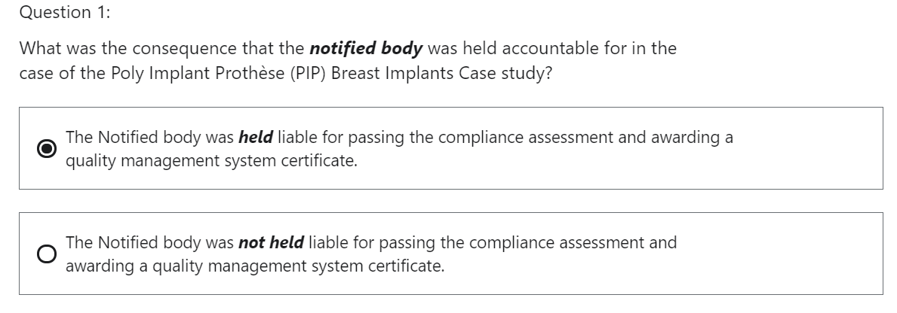

This is correct. It is important to realize this.

In the medical device industry, the Notified Body is held accountable by law to execute their roles and responsibilities.

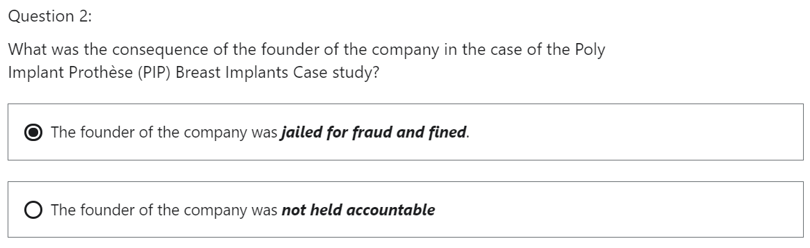

That is correct. One needs to internalize this. If you are Top management in a medical device company, you are held accountable that the company is compliant with medical device regulation.

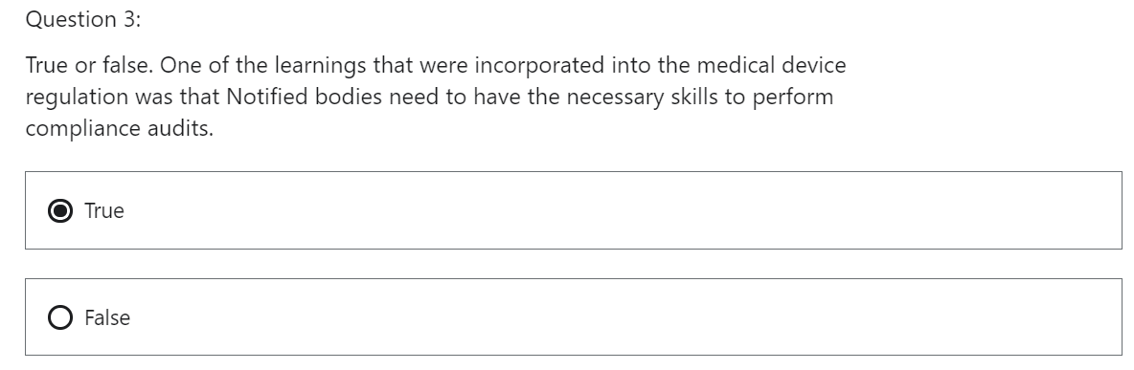

That is correct. There is a lot of changes from the medical device directive to the medical device regulation which the Notify Body must learn.

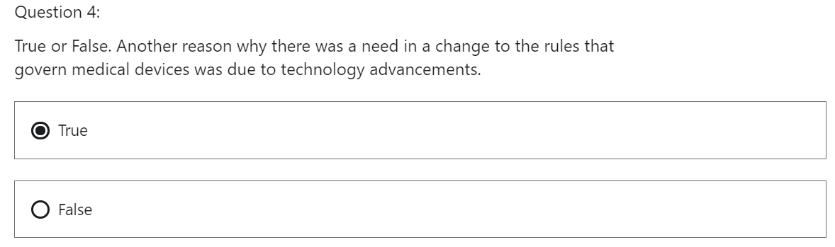

The medical device directives were created in the early 90s and therefore current technologies were not in existence for example 3D printing. Current regulation had to take this into account.

## 3 Timelines + Quiz

Hi, welcome to the Medical Device Regulation 2017/745 lecture on timelines.

What are the timelines for the introduction to the medical device regulation?

Let's have a look.

What are the learning objectives in this lesson:

* understand the times for the transition of the medical device regulation 2017/745
* we will understand which devices take priority to gain certification.

The transitional timelines for the medical device regulation 2017/745 are explained in **Article 120 - Transitional Provisions**.

I will give a summary of the detail.

The regulation is attached as a resource to this module and can be referenced as well.

* The medical device regulation 2017/745 was adopted on the 5th of April 2017 by the European Commission and published in the official Journal of the European Union, May 5th, 2017.
* Once the regulation was published in the official Journal of the European Union, May 5th, 2017, it came into force 20 days later, which in this case was the 25 of May 2017.
* The medical device regulation 2017/745 was to become mandatory for Manufacturers on the

26th of May 2020.

* But due to the covid pandemic, this state was pushed out by one year to the 22nd of May 2021

The European Commission provides good detail around regulation.

This template is a nice example of their guidance is attached as a resource to this lesson.

Let's have a closer look.

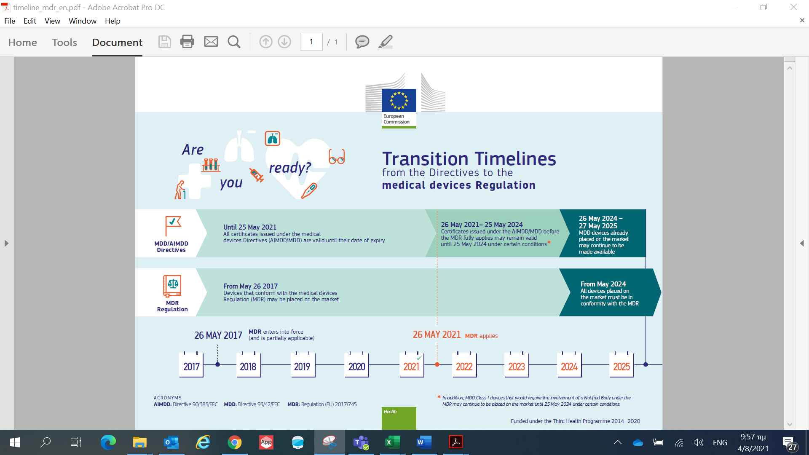

Are you ready?

Let's start with the top left-hand side of the template, the medical device directive MDD and the active implantable medical device directive AIMDD certificates, are valid until their date of expiry.

You can still obtain a certificate of compliance under the directive until that date, i.e. the 25th May

2021.

Now, I want to draw to your attention the bottom left-hand side of the quadrant.

From the 26th of May 2017, devices that conform to the medical device regulations may be placed

on the market.

This would have been challenging to do in the initial period for two reasons.

* There was a bottleneck with the number of notified bodies in the European Union that were certified to carry out complaints, audits adhering to the 2017/745 Regulation.

The notified bodies and the competent authorities were getting trained and familiar with the new regulation.

* The second reason was that the Manufacturer was also learning and getting familiar with the new regulation.

We will discuss this further as we progress through the module, but there were examples of medical device companies in Europe that were certified to the new regulation before the initial May 25th 2020 deadline.

Drawing your attention to the timeline on the bottom of the template, **the medical device regulation**

**applies from the 26th of May 2021.**

Examining the bottom right-hand side of the template, it indicates that **from May 2024, all devices**

**placed on the market must be in conformity with the medical device regulation.**

Looking at the top right-hand side of the quadrant, certificates issued under the active implantable

medical device directive AIMDD or medical device directive MDD before the medical device regulation fully applies, may remain valid until the 25th of May 2024, under certain circumstances, these conditions will be explained on the next slide.

Deadlines for certain classification

Two transition dates,

the first one is “have to happen” by the 26th of May 2021 and the second date has a “transition period”.

Let's clarify the former term.

Some products have to be compliant with the medical device regulation 2017/745 by the 26th of May 2021.

The next slide will clarify further.

**Which Manufacturers have to be compliant with the medical device regulation 2017/745 until the 26th of May 2021 deadline?**

Class I: Self Certification

If the Manufacturer is producing Class I medical devices, then they will have to transition.

Why is this? Class one, medical devices do not have a Notified Body certification audit, they self-certify.

So, for this reason, they need to be compliant with the medical device regulation.

Class I reusable: New classification

This class is a new medical device classification. It means a medical device that is reusable, for example, a reusable, invasive medical device used in a medical procedure.

The fact that it is a new classification means, it does not already have an old compliance certificate, therefore it needs to be compliant by the 26 of May 2021.

New products within scope: New classification

Then we have Annex XVI of the medical device regulation, Annex XVI - LIST OF GROUPS OF PRODUCTS WITHOUT AN INTENDED MEDICAL PURPOSE REFERRED TO IN ARTICLE 1(2).

This annex describes a list of products that have no medical device purpose, so those products also have to transition directly to the medical device regulation.

The reason is because they were not covered by the directive and it is new to the medical device regulation.

An example of this would be the equipment used for liposuction.

Custom made implantable Class III: New classification

Then you have custom made implants that are implantable class II products. This is a **new class** within the new medical device regulation.

Certificates expired by 25 May 2021: Need to follow MDR

The products certified under the directives expired by the 25th May 2021 will need to follow the medical device regulation going forward.

So one common thread here is if the device is new to the scope of the regulation, it would not have

had a certificate. So therefore it needs to have one by the 26th of May 2021.

**What have we learned?**

* We understand the transition period for the medical device regulation, 2017/745.
* We understand the deadline for products to achieve certification.
* We understand which products should be prioritized.

They are products new to the scope of the Medical Device Regulation Class I, medical devices and products whose certificate has expired.

Understand **when** the Medical device regulation 2017/745 becomes mandatory in the European Union.

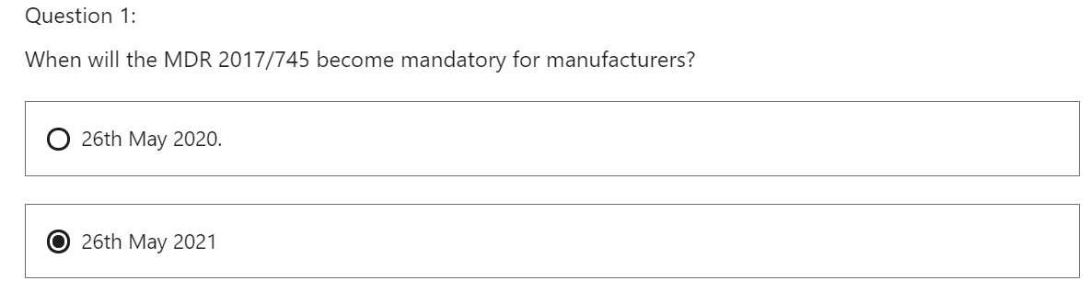

This is correct. The medical device regulation 2017/745 was to become mandatory for Manufacturers on the 26th May 2020 but due to the Covid pandemic this date was pushed out by 1 year to the 26th May 2021.

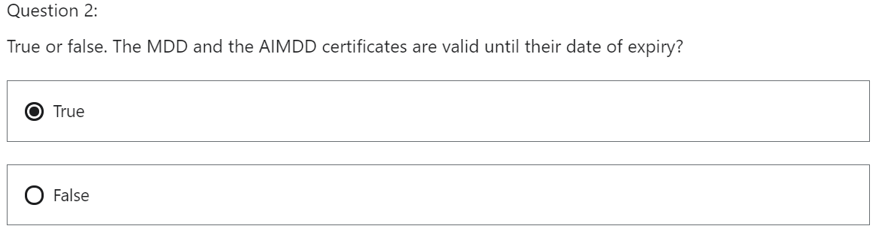

That is correct. You can still obtain a certificate of compliance under the directives until the date of the 25th May 2021.

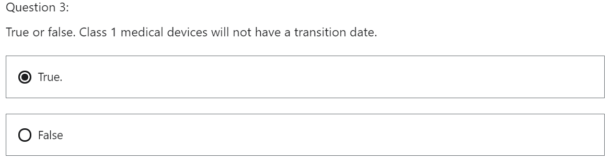

That is correct. Class I medical devices do not have a Notified Body certification audit. The medical device Manufacturer self-certifies. So, for this reason the medical device Manufacturer needs to be compliant with the MDR.

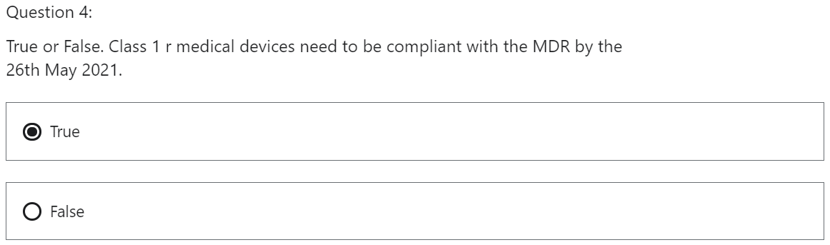

That is correct. Class 1 r is a new medical device classification. The fact that it is a new classification means it does not have a compliance certificate therefore it needs to be compliant by the 26th May 2021.

# Section 2: Economic Operators

## 1 Introduction

Section two economic operators, hi, what will we discuss in this section?

The medical device regulation follows the life cycle of the medical device.

Section two will explain what the economic operator is.

The diagram replicates the module within the EUDAMED system.

I want to reference this process as it replicates the life cycle of the medical device.

The economic operators will be part of the actor registration.

We will discuss the following in this section:

* Economic operators, who they are.
* Economic Operator: The European Authorized Representative, and their obligations.
* Economic Operator: The Distributor, and their obligations.
* Economic Operator: The Importer and their obligations.
* Economic Operator: The Manufacturer and their obligations.
* Economic Operator: Procedure pack & Systems Provider and their obligations.
* Person Responsible for Regulatory Compliance, PRRC who they are and their obligation

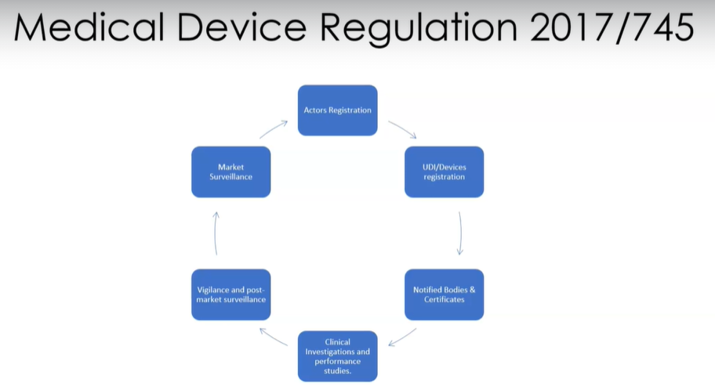

Actors Registration

UDI / Devices Registration

Notified Bodies & Certificates

Clinical Investigation and performance studies

Vigilance and post market surveillance

Market Surveillance

## 2 Economic Operators

Hi, welcome to the Medical Device Regulation 2017/745 lecture on economic operators.

In this lecture, we will discuss who the economic operators are.

What will we learn?

* Who are the economic operators? according to Medical Device Regulation 2017/745
* How do the economic operators correlate to one another?

**ECONOMIC OPERATOR**

Article 2 – “Definitions”:



**Economic Operator** = Manufacturer or/ European Authorized Representative or /Importer or /Distributor or /company that assembles CE marked medical devices or /company that sterilizes medical devices.

Article 22 (1): combines CE marked devices

Article 22 (3): sterilizes systems or procedure packs

**MANUFACTURER**

Article 2 – “Definitions”:



**Manufacturer** = natural or legal person who manufactures a medical device or fully refurbishes a medical device or has a device designed, manufactured or fully refurbished **UNDER ITS NAME OR TRADEMARK.**

++ further distinction between legal Manufacturer and physical Manufacturer.

LM and PM are different: LM creates/is responsible for the technical file and places name on the product, PM manufactures the product

LM and PM is the same: one manufacturer writes the technical file, places its name on the product and also manufactures the product

**EUROPEAN AUTHORIZED REPRESENTATIVE**

Article 2 – “Definitions”:



**European Authorized Representative** = natural or legal person with the EU, that has a written mandate from a Manufacturer outside the EU, to act on the Manufacturers behalf with regard to the Manufacturers obligations according to MDR 2017/745.

**IMPORTER**

Article 2 – “Definitions”:



**Importer** = a natural or legal person that receives a product from outside the EU, and places it in the EU market.

**DISTRIBUTOR**

Article 2 – “Definitions”:



**Distributor** = a natural or legal person **who is not** a Manufacturer or Importer, that ships the product to the End User

**COMPANY THAT COMBINES CE MARK APPROVED MEDICAL DEVICES TOGETHER AS PACKS**

Article 22 – “Systems and procedure packs”, paragraph 1

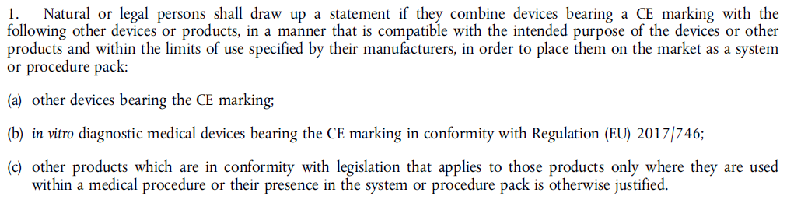

**Company combining CE products into packs** = natural or legal person that combines CE marked products into Systems or Procedure Packs

**COMPANY THAT STERILIZES MEDICAL DEVICES**

Article 22 – “Systems and procedure packs”, paragraph 3

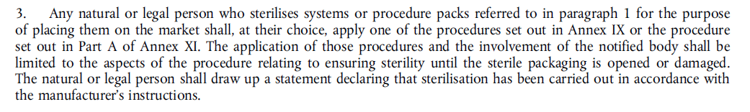

**Company that sterilizes products** = natural or legal person who sterilizes systems or procedure packs

An ECONOMIC OPERATOR means:

1. Manufacturer
2. European Authorized Representative
3. Importer
4. Distributor
5. the persons referred to in Article 22 – “Systems and procedure packs”
   1. companies that combine CE mark approved medical devices together as packs
   2. companies that sterilize medical devices

I will explain who are the persons, mentioned in Article 22 in this lecture.

The first four players are the Manufacturer, the European Authorized Representative, the Importer and the Distributor.

The last two economic operators are defined as systems and procedure pack in the medical device regulation. These are companies that combine CE mark approved medical devices together as packs and companies that sterilize medical devices. (That is what is meant by the persons referred to in Article 22, Section one and two.)

**Example: The Manufacturer produces the product in another country outside the European Union**

Let’s say there is a medical device Manufacturer who produces the product in another country outside the European Union, for example, the USA or India.

To follow the regulation, they will need to import their product to an **Importer** within the European Union who will receive the product.

The Manufacturer outside the European Union will also need an **European Authorized Representative** within the European Union, both the roles and responsibilities of these economic operators will be explained further into the course.

Suffice to say, without these two players, the outside Manufacturer will not be able to market their products on the European Union according to the medical device regulation 2017/745.

Once the Importer and the European Authorized Representative, ensure that the medical devices are compliant with the medical device regulation 2017/745, the medical devices will be passed to the Distributor here.

Once again, the Distributor will need to follow compliance to the medical device regulation 2017/745 to ensure the product is allowed to the end user.

**Example: The Manufacturer produces the product within the European Union**

The Manufacturer within the European Union does not need an Importer or a European Authorized Representative.

They can ship the product to the Distributor.

There are two other economic operators, an entity that will combine several CE approved medical devices together and an entity that will sterilize medical device products within the European Union. These entities need to be compliant with the medical device regulation 2017/745.

Just a reminder, they are referred to in Article 22, Section one and three.

We now understand who the economic operators are:

1. the Manufacturer inside the European Union and outside the European Union,
2. the European Authorized Representative,
3. the Importer,
4. the Distributor,
5. the company that combines marked medical devices as a pack for a medical procedure,
6. the company that sterilizes the medical devices and the packs.

We have an understanding how the economic operators relate to one another.

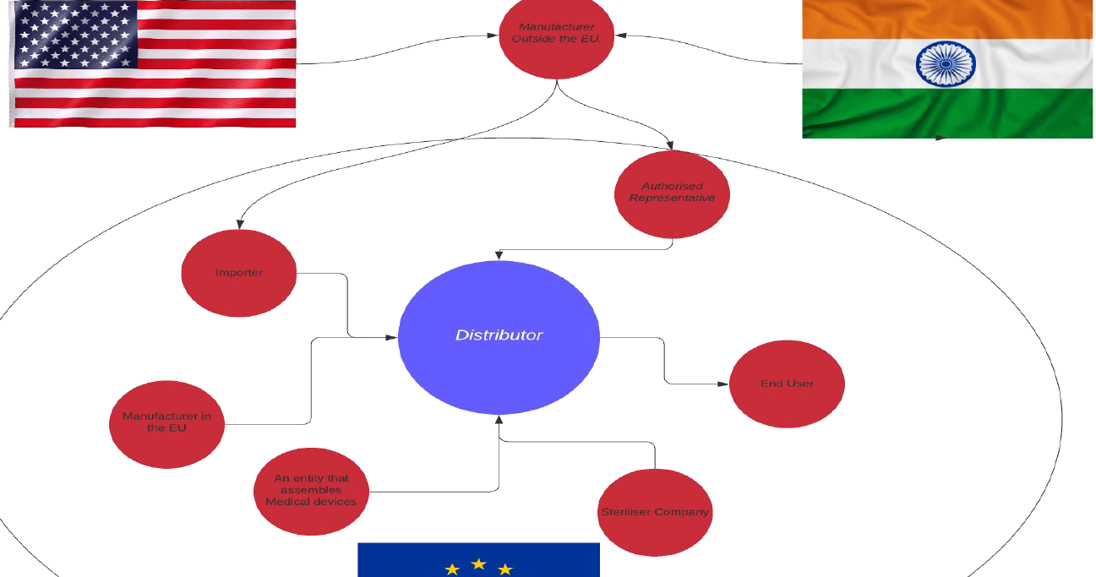

**Manufacturer outside the EU:**

Needs Importer and European Authorized Representative. When these two decide that the product is compliant to MDR 2017/745, the product ships to the Distributor. Then the Distributor sends the product to the End User

**Manufacturer within the EU:**

The Manufacturer ships the product to the Distributor. Then the Distributor sends the product to the End User.

**Company that assembles CE marked products:**

If within the EU, ships the product to the Distributor. Then the Distributor sends the product to the End User.

**Company that sterilizes products:**

If within the EU, ships the product to the Distributor. Then the Distributor sends the product to the End User.

QUIZ

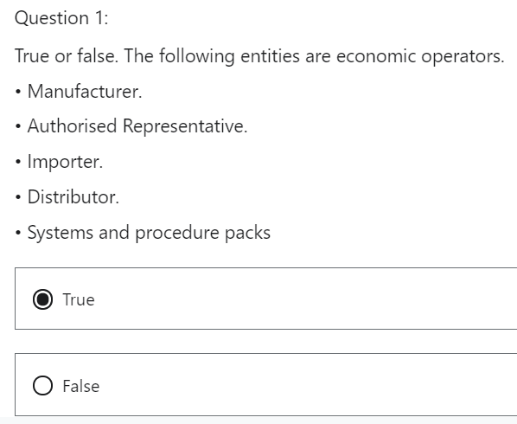

That is correct. The first four players are the Manufacturer, the European authorized representative, the Importer and the Distributor. The last two economic operators are defined as “Systems and procedure pack” in the MDR.

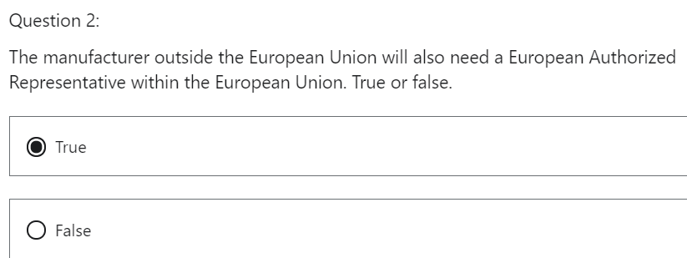

That is correct. In order to follow the regulation, the Manufacturer outside the European Union will need a European Authorized Representative **to act as liaison between the Competent Authority and the Manufacturer.**

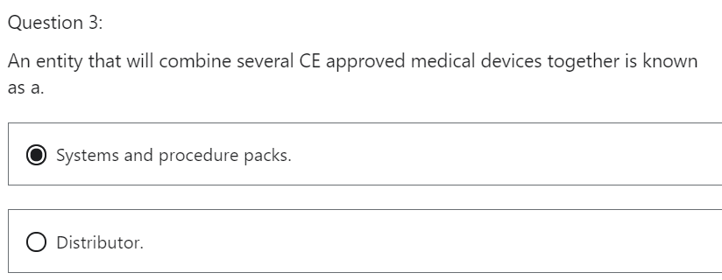

That is correct. These are companies that combine CE marked approved medical devices together as packs.

## 3 Economic Operator: The European Authorized Representative

Hi, welcome to the Medical Device Regulation 2017/745 lecture on Economic operators: European Authorized Representative.

In this lecture, we will discuss what the role of the European Authorized Representative has within the context of the EU regulation 2017/745.

What will we learn?

* We will understand the role and responsibilities of the European Authorized Representative.

The medical device regulation 2017/745 gives a definition of the Authorized Representative

under **Article 2 – “Definitions”**, Section 32.

The Authorized Representative can also be called the European Authorized Representative.



The European Authorized Representative will ensure that the outside EU Manufacturer will be compliant to the medical device regulation EU 2017/745.

Let's keep this diagram in the front of our mind when we are understanding the responsibility of the European Authorized Representative.



The medical device regulation EU 2017/745 gives a definition of the Authorized Representative under Article two definitions Section 32,

“an Authorized Representative means any natural or legal person established within the Union, which means the European Union, who has received and accepted a written mandate from a Manufacturer located outside the Union **to act on the Manufacturer's behalf** in relation to specified tasks with regard to the latter's obligation under this regulation.”

This regulation means the MDR 2017/745.

What does this mean in simple terms?

The EAR, European Authorized Representative will ensure that the outside EU Manufacturer will be compliant to the medical device regulation EU 2017/745.

All outside of EU Manufacturers need a European Authorized Representative.

The obligation of the Authorized Representative is described in

CHAPTER II – MAKING AVAILABLE ON THE MARKET AND PUTTING INTO SERVICE OF DEVICES, OBLIGATIONS OF ECONOMIC OPERATORS, REPROCESSING, CE MARKING, FREE MOVEMENT,

**Article 11** – “Authorized Representative”

* Α Manufacturer outside the European Union has to have an European Authorized Representative, if they want to gain market approval for their products on the European market.

The non-EU Manufacturer must designate a “sole Authorized Representative”.

* The Authorized Representative will have a mandate.

The mandate is a written document drawn up by the Manufacturer outside the European Union, stipulating that this particular Authorized Representative has been chosen by the Manufacturer.

The other economic operators do not have mandates.

* The Authorized Representative will be based in Europe
* The European Authorized Representative verifies that the Manufacturer has a UDI in place.

(obligation of the EAR)

* The European Authorized Representative verifies that the Manufacturer has the declaration of conformity.

It is interesting to note that the European Authorized Representative identification will be written into the declaration of conformity.

(obligation of the EAR)

* The European Authorized Representative verifies that the Manufacturer has the technical documentation.

The paperwork needs to be kept on file by the European Authorized Representative at their European address, as the Competent Authority may want to audit and check this documentation.

The European Authorized Representative needs to cooperate with the Competent Authority when required.

* The European Authorized Representative needs to ensure that the Manufacturer has been registered, with EUDAMED
* The European Authorized Representative needs to ensure that the Manufacturer’s product has been registered in the EUDAMED system.

Again, the EUDAMED system will be explained in this module.

The European Authorized Representative needs to cooperate with the Competent Authority if there is an issue with the product during the vigilance process.

The Authorized Representative **can terminate** the mandate between themselves and the outside of EU Manufacturer if the European Authorized Representative sees an issue with the product

The European Authorized Representative is obligated to contact the Competent Authority to explain **why they terminated the mandate**.

The above, can work the other way as well.

The Manufacturer can change its European Authorized Representative.

The European Authorized Representative **will be liable** if a product is placed on the European market and it is not compliant.

The name of the European Authorized Representative should be on the product.

This will help with accountability and traceability.

A medical device produced outside of the European Union should have the following on the label:

* The name of the Manufacturer and the European Authorized Representative.

Also, you need to have an Importer and a European Authorized Representative if you are an outside European Union Manufacturer, and you want to sell your devices in the European Union marketplace.

Think of the changes to labelling, packaging and the Declaration of Conformity of the medical device when an European Authorized Representative changes, can be a large financial impact.

What have we learned?

* What are the main obligations of an Authorized Representative is under the medical device regulation, MDR 2017/745
* The definition of the Authorized Representative.

QUIZ

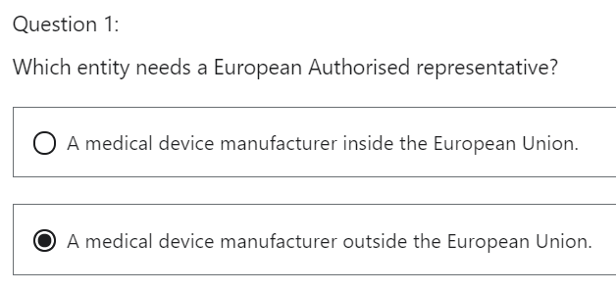

That is correct. The EAR will act on the Manufacturer's behalf in relation to specified tasks regarding the latter's obligations under the MDR.

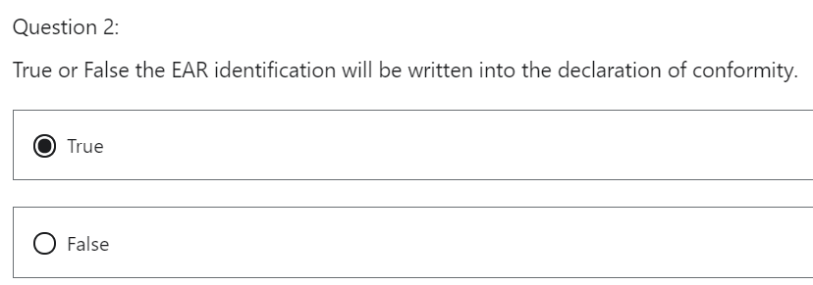

This is correct. The EAR identification will be written into the Declaration of Conformity which will support traceability.

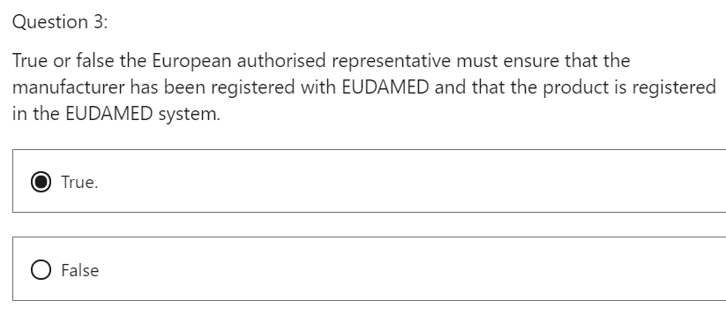

That is correct. One of the EAR roles is to ensure registration of the Manufacturer and the device in the EUDAMED system.

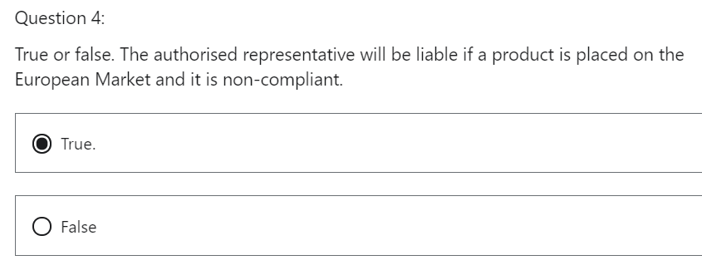

That is correct. The Authorized Representative will be liable if a product is placed on the European Market and it is non-compliant. It is very important to understand if you are an economic operator who will be held accountable to be compliant with this regulation.

## 4 Economic Operator: The Distributor

Hi, welcome to the Medical Device Regulation 2017/745 lecture on Economic Operators: The

Distributor.

In this lecture, we will discuss what the role and responsibility of the Distributor has within the

context of the EU regulation 2017/745.

What will we learn?

* Understand the definition of the Distributor.
* Understand the obligations of the Distributor.

The medical device regulation 2017/745 gives a definition of the Distributor under Article 2 - Definitions, Section 34.



Let's keep this diagram in the forefront of our mind when we are understanding the responsibilities

of the Distributor.



Notice the correlation between the other economic operators and the Distributor.

The medical device regulation, 2017/745 gives a definition of the Distributor under Article 2- Definitions, Section 34.

“Distributor means any natural or legal person in the supply chain, other than the Manufacturer or the

Importer, that makes a device available on the market, up until the point of putting into service.”

We will explain this definition a little further in the next slide.

The Distributor will release the product onto the marketplace to the end user.

Where does the Distributor obtain the medical devices from?

The Distributor can obtain product from:

* the Manufacturer within the European Union.
* the Manufacturer outside the European Union, via the Importer.
* a company that combines medical devices into packs or kits
* a company that sterilizes medical devices.

Again, the diagram in this lecture is a very good reference point.

In CHAPTER II

MAKING AVAILABLE ON THE MARKET AND PUTTING INTO SERVICE OF DEVICES, OBLIGATIONS OF

ECONOMIC OPERATORS, REPROCESSING, CE MARKING, FREE MOVEMENT

**Article 14 – “General obligations of Distributors**”, we can read the obligations of a Distributor.

Obligations of the Distributor

* The Distributor does not put their identity on the label.

If the product comes from outside the European Union, the identity of the Manufacturer, the Importer and the European Authorized Representative is placed on the product.

In this case, the Distributor does not have to do it.

* The Distributor will verify if the label is correct, along with the UDI.
* The Distributor needs to verify the CE mark and the Declaration of Conformity, the verification method is performed by a sampling of the product.

The sampling method needs to be documented.

Who is responsible for ensuring the regulation is followed?

It is the Competent Authority.

The Distributor is audited by the Competent Authority.

If the Distributor believes that a medical device is not conforming to the regulation, they have obligations.

They cannot distribute the device and they must contact the Manufacturer to inform them.

If the Distributor believes that device could be of a risk to the patient or documents are falsified, they need to contact the Manufacturer.

This is a different scenario as it is more serious.

If a Distributor receives complaints from health care professionals, they will collate the complaints.

Collate = collect and arrange,

This data will be fed back to the Manufacturer inside Europe or the outside European Union Manufacturer via the Importer and the European Authorized Representative.

This is a further step to prevent a non-complying product reaching the marketplace.

One can start to appreciate the measures that are taking place with the medical device regulation 2017/745.

The Distributor is responsible for ensuring that the devices are stored correctly.

For example, some devices may need to be stored in refrigerated temperatures.

Distributors, upon request by a Competent Authority, shall provide free samples of the device or when

that is impracticable, to grant access to the device.

The Distributor must show cooperation and flexibility towards the Competent Authority.

What have we learned?

* What the main obligations of a Distributor is under the medical device regulation, 2017/745.
* The definition of the Distributor.

We are starting to understand that deregulation has checkpoints in the supply chain which verifies that the regulation is being followed, which will lead to safer and more effective devices.

QUIZ

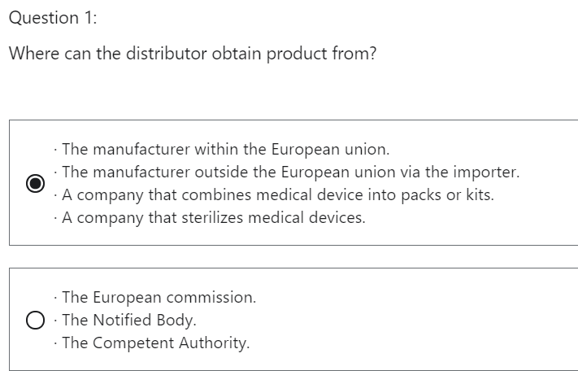

That is correct. Notice how the economic operators feed into the Distributor.

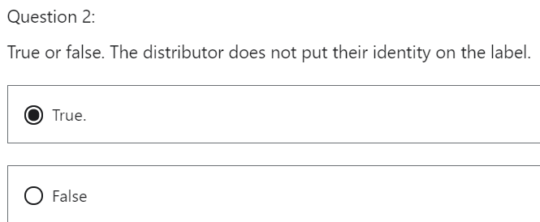

That is correct. The Distributor does not put their identity on the label. If the product comes from outside the EU the identity of the Manufacturer, the Importer and the EAR is place on the product.

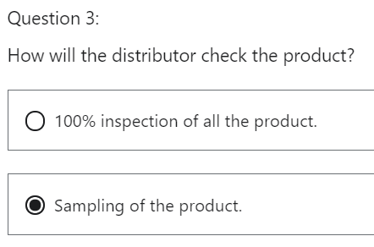

That is correct. The verification method is performed by a sampling of the product. This sampling method needs to be documented.

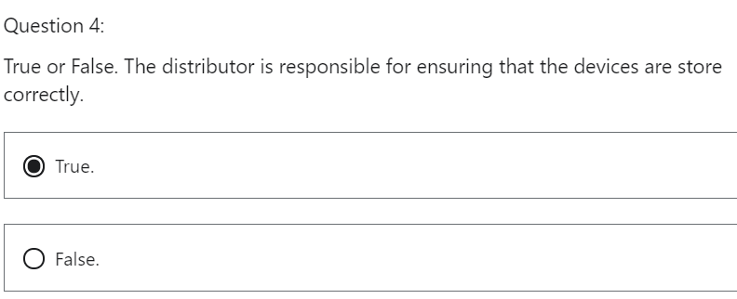

That is correct. For example, some devices may need to be stored in refrigerated temperatures.

## 5 Economic Operator: The Importer

Hi, welcome to the Medical Device Regulation 2017/745 lecture on **Economic Operators: The Importer**.

In this lecture, we will discuss what the role and responsibility of the Importer has within the context of the EU regulation 2017/745.

What will we learn?

* We will understand the role and responsibility of the Importer.
* The definition of the Importer.
* Who audits the Importer.

Keep this diagram in the forefront of our mind when we are understanding the responsibilities of the Importer notice the correlation between the other economic operators and the Importer.



The medical device regulation 2017/745 a **definition of an Importer** under Article two definitions, Section 33.



” Importer means any natural or legal person established within the union that places a device from a third country on the union market”

The Importer will receive medical device goods from a Manufacturer outside the European Union and place those CE marked products on the marketplace.

This will be done via a Distributor.

We now need to look at the **obligations the Importer has** regarding the medical device 2017/745.

The Importer has responsibilities which are listed in Article 13 of the Medical Device Regulation 2017/745.

CHAPTER II

MAKING AVAILABLE ON THE MARKET AND PUTTING INTO SERVICE OF DEVICES, OBLIGATIONS OF

ECONOMIC OPERATORS, REPROCESSING, CE MARKING, FREE MOVEMENT

**Article 13 - General obligations of Importers**

The responsibility of the Importer is to be compliant with the regulation 2017/745.

* The Importer needs to ensure that the imported medical devices have the **CE mark**, which proves conformity to the medical device regulation.
* The Importer needs to establish **who is the European Authorized Representative** for the imported medical devices.

The European Authorized Representative is a liaison for the outside of Europe medical device Manufacturer. Their role is to ensure that the non-EU medical device Manufacturer is compliant with the medical device regulation 2017/745.

The European Authorized Representative has other responsibilities which are explained in this module.

* The Importer needs **proof of the Declaration of Conformity** to the medical device regulation, 2017/745.
* The Importer needs to **ensure label compliance**, for example if the unique device identification UDI is correct. There is currently a transition time of UDI labelling.

For example, Class I should have their UDI on their technical file, it should appear on the package by May 26, 2025.

For Class IIa and Class IIb, it is May 26, 2023

For Class III It is May 26, 2021.

* The Importer needs to check that the **product is** **registered with the EUDAMED database**.
* The Importer needs to **register with the EUDAMED database**.

EUDAMED is the IT system developed by the European Commission to implement traceability.

I will explain EUDAMED in further detail during the course of this module.

* The Importer needs to ensure that the **storage and transport conditions were met** (these conditions are issued by the Manufacturer).
* The Importer needs to **collect data of all non-conformities** and give this information back to the non-EU Manufacturer.

For example, a medical device was transported in the wrong condition or a UDI label was incorrect.

This part of the system is very important as it can highlight issues before it gets to the end user.

This is a good example of how the regulation becomes a beneficial working document and demonstrates that there is a checkpoint in each part of the supply chain.

The Importer **has the right to say, no**, I will not import this product.

If the Importer carries information to prove that the medical devices are non-conforming, they would have to say they will not import the devices in order to be compliant with the medical device regulation 2017/745.

This is a positive thing as it reduces the chance of an unsafe device reaching the end user in the European marketplace.

If the Importer confirms that the product meets the regulation compliance, it can go to the Distributor

and therefore the end user.

Who is responsible to audit the Importer to ensure they are following the regulation?

This is the responsibility of the Competent Authority of the member state where the Importer is located.

For example, if the Importer is located in Ireland, then it will be the Competent Authority that will audit the Importer.

In this case, it will be HPRE, a health product, regulatory authority.

What have we learned?

* We understand what the main obligations of the Importer is within the medical device regulation 2017/745.
* The definition of the Importer
* The Competent Authority will audit the Importer.

QUIZ

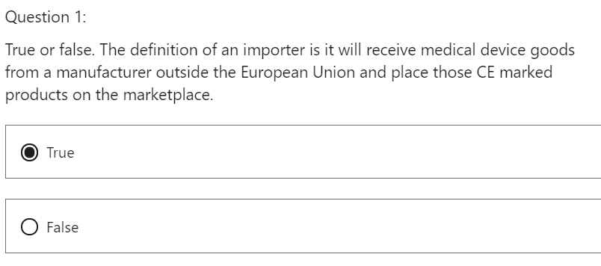

That is correct. The Importer will receive the goods from outside the European Union

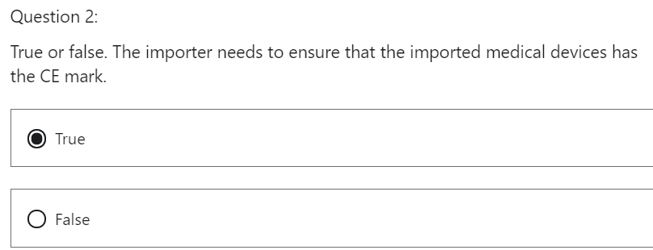

That is correct. This proves conformity to the medical device regulation.

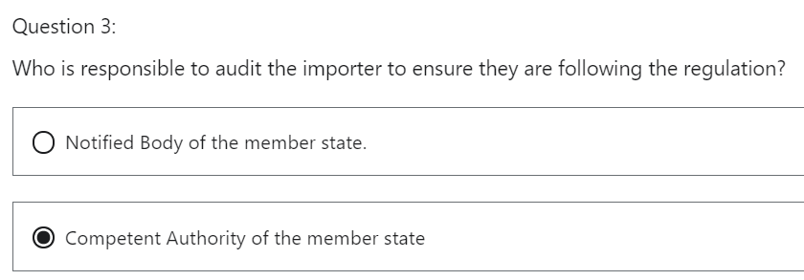

That is correct. For example, if the Importer is in Ireland then it will be the Competent Authority that will audit the Importer. In this case it will be HPRA. Health product regulatory authority

## 6 Economic Operator: The Manufacturer

Hi, welcome to the Medical Device Regulation 2017/745 lecture on **Economic Operators: The Manufacturer.**

In this lecture, we will discuss what the role and responsibility that the Manufacturer has within the context of the EU regulation 2017/745.

What will we learn?

* We will understand the definition of the Manufacturer.
* We will understand the obligations of the Manufacturer.

The medical device regulation 2017/745, gives a definition of the Manufacturer under Article 2 - Definitions, Section 30.



Let's keep this diagram in the forefront of our mind when we are understanding the responsibilities of the Manufacturer.



Notice the correlation between the other economic operators and the Manufacturer.

In this case, we are examining two types of Manufacturer,

* one inside the European Union and the
* other outside the European Union.

The medical device regulation 2017/745 gives a definition of a Manufacturer under Article two definitions, Section 30.

“A Manufacturer means a natural or legal person who manufactures or fully refurbishes a device or has a device designed, manufactured or fully refurbished and markets that device under its name or trademark.”

The Manufacturer designs and manufactures the medical device with the intent of selling it in the European marketplace. Medical device equipment can be refurbished, for example, medical imaging equipment and sold again on the European market.

Foteini note

Refurbish: “Restore device to a condition of safety and effectiveness that is comparable to when new. This includes reconditioning, repair, installation of certain software/hardware updates that do not change the intended use of the original device, and replacement of worn parts.” End of Foteini note.

The company that does this refurbishment is deemed a Manufacturer and will need to follow the EU medical device regulation 2017/745.

The Manufacturer has responsibilities, which is listed in **Article 10** of the medical device regulation 2017/745, the responsibility of the Manufacturer is to be compliant with the regulation 2017/745.

CHAPTER II

MAKING AVAILABLE ON THE MARKET AND PUTTING INTO SERVICE OF DEVICES, OBLIGATIONS OF

ECONOMIC OPERATORS, REPROCESSING, CE MARKING, FREE MOVEMENT

**Article 10 - General obligations of manufacturers**

I would explain some of the responsibilities as laid out in Article 10 of the regulation

* The Manufacturer needs to create a **risk management system** within its organization.

Use of the Risk Management Standard ISO 14971 will ensure that this happens.

* The Manufacturer needs to conduct a **Clinical evaluation** of the device, this means proving effectiveness and safety of the device in clinical trials.

The Manufacturer will need to prove this, before the device is allowed to be sold on the market.

It is a good time to mention that monitoring of the device in the marketplace is an important compliance for the Manufacturer to adhere to.

We talk about this further in post market surveillance.

* The Manufacturer needs to create **technical documentation** for the device.

We will discuss the requirements for technical documentation in this course

* The Manufacturer needs to have written **Declaration of Conformity** to regulation.
* The Manufacturer needs to have a **unique device identification system UDI**.

This is new to that medical device regulation, 2017/745.

It is a requirement for a new standardized system of a labeling medical devices.

In order to create traceability on the marketplace again, we will discuss this in another lecture in this course.

* The Manufacturer is obliged to have a quality management system.

Being certified to the most up to date ISO 13485 standard will satisfy this requirement.

* The Manufacturer is responsible for having a **Person Responsible for Regulatory Compliance, PRRC** for short this person is known as PRRC.

The Person Responsible for Regulatory Compliance, PRRC can be a company employee or a consultant.

If you do not have a dedicated Person Responsible for Regulatory Compliance, PRRC, you are not following the medical device regulation 2017/745.

If you are a Manufacturer outside the European Union, you still need to have a Person Responsible for Regulatory Compliance, PRRC.

***(Article 15 - Person responsible for regulatory compliance)***

* The Manufacturer has to communicate with the other economic operators.

If it does not, the regulation will not work effectively.

By following the regulation MDR 2017/745, process communication will happen

* If an EU Manufacturer has an issue with a product, they must inform the **Distributor**.

The regulation dictates this to happen, and it should be driven by the quality management system, standard operating procedure for field incidences should ensure that this happens.

* If a non-EU Manufacturer has an issue with the product, they must communicate with the **European Authorized Representative and the Importer**.

The regulation calls out for this, and it proves the point that the regulation will not work unless the economic operators are communicating with one another.

* All economic operators should be registered in **EUDAMED**.

The medical device regulation, 2017/745 calls out that the Manufacturer is registered into EUDAMED.

Registration via the European database on medical devices EUDAMED is intended to centralize device information and help improve coordination of information on medical devices on the European market.

What have we learned?

We understand what the main obligations of the Manufacturer are, within the medical device regulation 2017/745:

* create a risk management system,
* obtain information from clinical evaluation, and continue that process when the device is in the marketplace,
* create technical documents for all manufactured devices,
* obtain a Declaration of Conformity for all manufactured devices,
* establish a UDI system for all manufactured devices,
* have a robust quality management system. The standards to obtain is ISO 13485,
* Designate a person who is responsible for regulatory compliance with the manufacturing company
* Ensure communication od non compliance between all economic operators,
* Register, with EUDAMED

As we progress through the course, we will explain these details further.

QUIZ

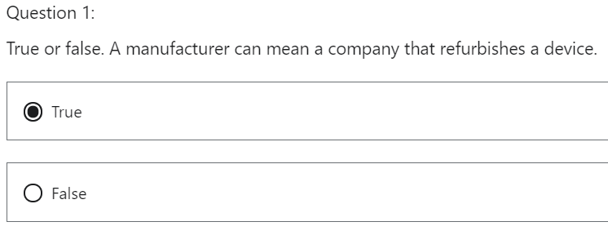

That is correct. The MDR 2017/745 regulation means a manufacturer as a natural or legal person who manufactures or fully refurbishes a device or has a device designed, manufactured or fully refurbished, and markets that device under its name or trademark.

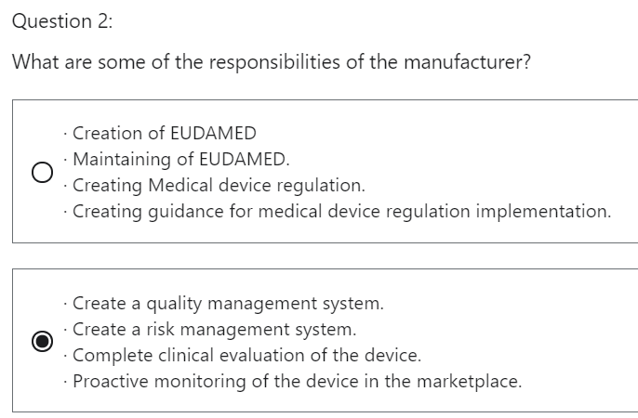

That is correct. These are some of the responsibilities of the manufacturer.

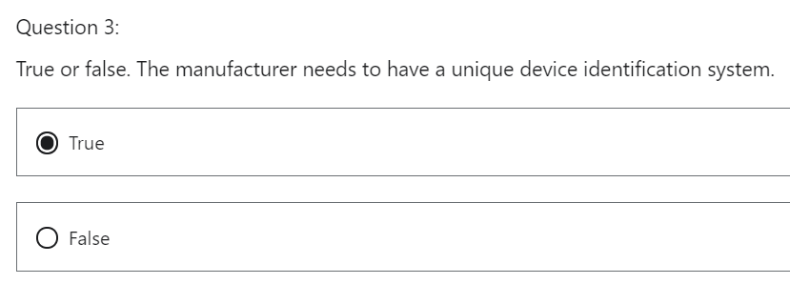

True. That is correct. This is new to the MDR (EU) 2017/745. There is a requirement for a new standardise system of labelling medical devices. In order to create traceability on the marketplace.

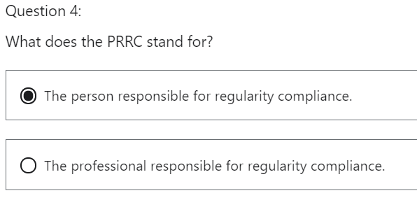

This is correct. The manufacturer is responsible for having a person responsible for regularity compliance.

## 7 Economic Operator: Procedure pack & systems

Hi, welcome to the Medical Device Regulation 2017/745 lecture on **Economic Operators: The Procedure Pack and Systems Providers.**

In this lecture, we will discuss what the role and responsibility of the Procedure Pack and Systems Providers has within the context of the EU regulation 2017/745.

What will we learn?

We will understand:

the definition of the Procedure Pack and Systems Providers

the obligations of that the Procedure Pack and Systems Providers.

the role and responsibility of the Procedure Pack and Systems Providers.

The medical device regulation 2017/745 gives a definition of the Procedure Pack and Systems Providers under **Article 2- Definitions, Section 10 and 11**.

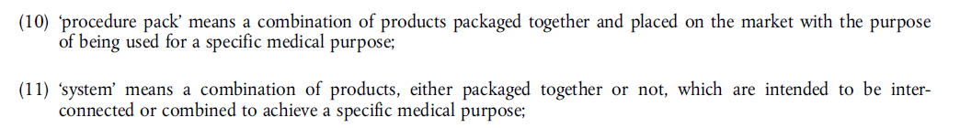

Let's keep this diagram in the forefront of our mind when we are understanding the responsibilities of the entity that assembles medical devices as a pack.



The medical device regulation, 2017/745 gives a definition of that Procedure Pack and Systems Providerss under Article 2 - Definition Section 10 and 11.

“**Procedure pack** means a combination of products packaged together and placed on the market with the purpose of being used for a specific medical purpose.”

**“System** means a combination of products either packaged together or not, which are intended to be interconnected or combined to achieve a specific medical purpose.”

FOTEINI QUESTION

Entity that assembles medical devices =

1 Procedure Pack provider and

2 Systems Provider?

A **Procedure Pack Provider** assembles groups of CE marked medical devices into kits or packs for procedures in the health care industry.

A **Systems Provider** can create interconnected medical device parts for one intended purpose.

There is a difference in definitions.

The obligations of the system provider and a procedure pack entity are explained under Chapter two, Article 22.

CHAPTER II

MAKING AVAILABLE ON THE MARKET AND PUTTING INTO SERVICE OF DEVICES, OBLIGATIONS OF

ECONOMIC OPERATORS, REPROCESSING, CE MARKING, FREE MOVEMENT

**Article 22 - Systems and procedure packs**

* The Procedure Pack and Systems Providers will **combine products that are CE marked** approved.
* These combined products need to be compatible with **one intended purpose**.
* There will be a statement drawn up by the provider.

The Provider needs to ensure that the devices are CE marked and have one intended purpose.

* The provider is obliged to verify **mutual compatibility of the devices** with the Manufacturer’s instruction,

Can the devices work together as a pack or a system?

* The company that provides packs or systems to the end user, needs to ensure that the relevant **information is given to the end user** and how to correctly use the device.

Procedure Pack and Systems Providers = company that provides packs or systems to the end user

* **The combination of the pack or system was verified and validated** by appropriate methods of internal monitoring.

Is the pack safe to use? Is it effective? This needs to be validated and verified by the company's internal monitoring system.

* If a company **sterilizes** the pack or the system, it must be compliant to a quality management system.

A **Notified Body** will audit this company to ensure compliance with the medical device regulation 2017/745.

Notice how the Notified Body is responsible for this duty as opposed to the Competent Authority.

* Verify if the devices have a CE mark.

What have we learned?

* The main obligations of the Procedure Pack and Systems Providers, under the medical device regulation EU 2017/745.
* The definition of the Procedure Pack and Systems Providers
* The Procedure Pack and Systems Providers combine CE marked medical devices, together.
* If a company sterilizes a pack, it must follow medical device EU Regulation 2017/745. It will be audited by a Notified Body.
* The Procedure Pack and Systems Providers verify that all devices are CE marked.

QUIZ

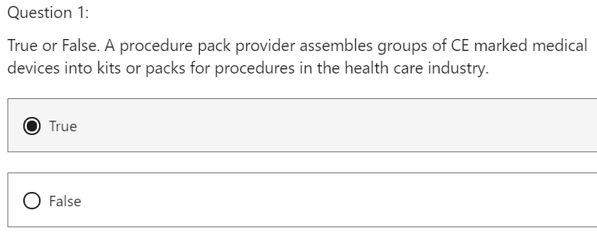

That is correct. A systems provider can create interconnected medical device parts for one intended purpose.

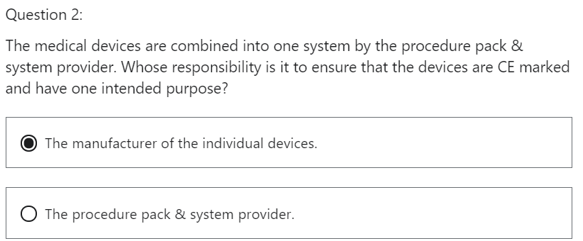

Incorrect answer. Please try again.

That is incorrect. It is the responsibility of the procedure pack & system provider.

The Procedure Pack and Systems Providers combine medical devices. It is their responsibility to ensure that the devices are CE Marked and have one intended purpose

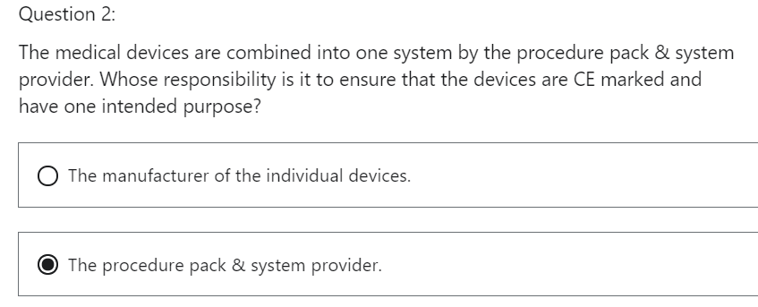

That is correct. The regulation mandates it is the responsibility of the procedure pack & system provider under article 22.

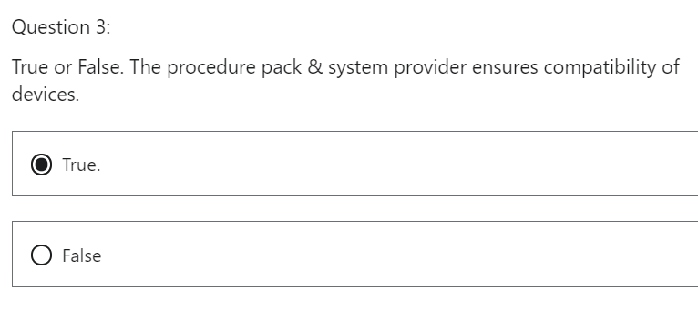

That is correct. The provider is obliged to verify mutual compatibility of the devices with the manufacturer’s instruction.

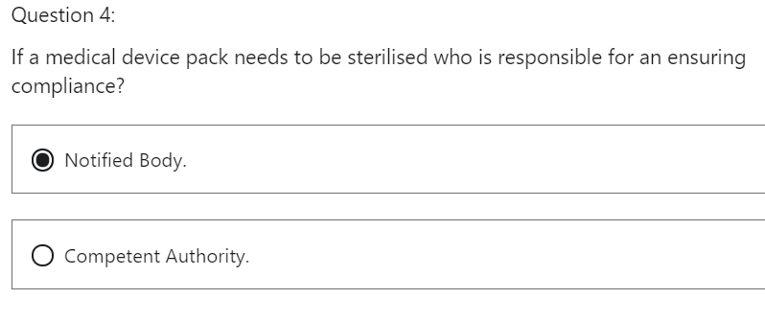

That is correct. The Notified body will perform a conformity assessment on the systems provider quality management system.

## 8 Economic Operator: Obligation change

In this lecture, we will discuss the fact that the Economic Operators **obligations can change**, and therefore their role and responsibility.

What will we learn?

* We will understand **when an economic operator obligation will change to that of a Manufacturer**.

In Article 16 of the medical device regulation, 2017/745, it stipulates that there can be cases in which obligations of Manufacturers apply to Importers, Distributors or other persons.

CHAPTER II

MAKING AVAILABLE ON THE MARKET AND PUTTING INTO SERVICE OF DEVICES, OBLIGATIONS OF

ECONOMIC OPERATORS, REPROCESSING, CE MARKING, FREE MOVEMENT

Article 16 - **Cases in which obligations of manufacturers apply to importers, distributors or other persons**

**WHEN do the obligations of the Manufacturer become obligations of the Importer, Distributor or other?**

An Importer or Distributor or any other natural or legal person **shall assume the obligations incumbent on Manufacturers** if they do any of the following:

**A Distributor, Importer or any other natural or legal person:**

* If they put the product under their own name
* If they change the intended purpose of a device already on the marketplace
* If they modify a device already on the market.

This will mean the regulation compliance of the Manufacturer will now be transposed onto the Importer or the Distributor.

An Importer or Distributor or any other natural or legal person **shall NOT assume the obligations incumbent on Manufacturers** when.

**A Distributor, Importer or any other natural or legal person:**

* If they repackage or translate a label.
* If they place LOGO’s on the devices to show proof of repackaging and translation.

The Importer and Distributor needs to inform the Manufacturer and Competent Authority of changes within **28 days** of releasing the product to the marketplace.

What have we learned:

An Importer and a Distributor can assume Manufacturer’s obligations under the following conditions,

* puts the product under their own name,
* changes their intended purpose of a device already on the market,
* modifies a device already on the market.

An Importer and a Distributor do not assume Manufactures obligations under the following conditions

* if they change repackaging or perform translation.

QUIZ

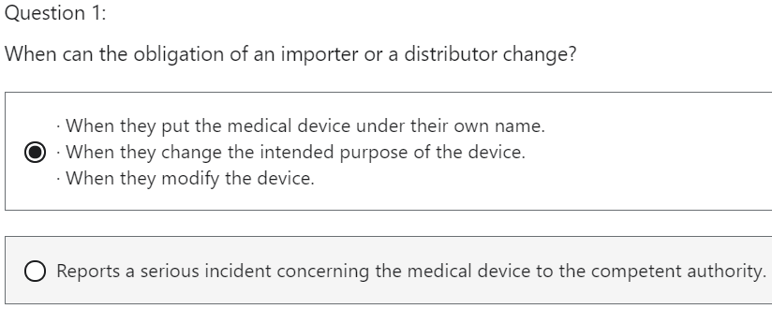

That is correct. If the importer or a distributor makes any of these changes, THEN their obligation changes to that of a manufacturer.

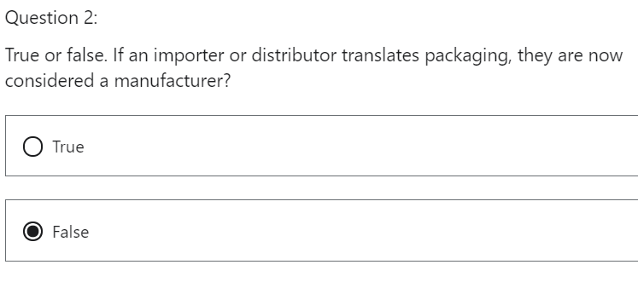  
This is correct. Logos can be placed on the devices to show proof of repackaging and translation. The importer and distributor need to inform the manufacturer and competent authority of changes with 28 days of releasing the product to the marketplace

## 9 Person Responsible for Regulatory Compliance, PRRC

Hi.

In this lecture, we will discuss what the role and responsibility of the person responsible for regulation compliance, PRRC is.

This person is not an economic operator, but works with the economic operator.

I thought this would be a good juncture to discuss this here.

What will we learn,

* Understand the obligations of the person responsible for regulation compliance PRRC.
* Understand the qualifications required to become a PRRC,
* understand the responsibilities of the PRRC.
* Understand who is expected to have a PRRC
* understand when a PRRC can be hired in a consultant role.
* Understand that a PRRC can carry out their work without being disadvantaged.

In Chapter II of the medical device regulation 2017/745, titled Making Available on the Market and putting into service of devices, obligations of economic operators, reprocessing CE Marking Free Movement, there is Article 15, which explains what a person responsible for regulatory compliance is and their roles and responsibilities.

Let's take a closer look.

“Manufacturers shall have available within their organization at least one person responsible for regulatory compliance who possesses the requisite expertise in the field of medical devices.”

The person responsible for regulation compliance is a **new role** within the medical device regulation 2017/745, Article 15 explains the responsibilities of the person responsible for regulating compliance. It is also known as a PRRC.

The PRRC needs to have a certain level of qualification, they need to have a diploma, certificate and an equivalent awarded upon completion of a university degree in the following disciplines.

* In law,
* medicine,
* pharmacy
* engineering
* or another relevant scientific discipline and
* at least one year of professional experience in regulatory affairs or in quality management systems relating to medical devices.

The second criteria is based on experience,

four years of professional experience in regulatory affairs relating to medical devices, or

four years of professional experience in quality management systems relating to medical devices.

The challenge going forward is for a non-EU member state to prove educational equivalency and manufacture outside the EU.

We still need to allocate a PRRC within their company.

Where does a PRRC need to be allocated to be compliant with the medical device regulation 2017/745?

The manufacturer needs to have a located PRC within their organization.

This includes manufacturers inside and outside of Europe.

The European authorized representative needs to have a PRRC.

The medical device coordination group MDCG, published guidance in the European Commission website in June 2019 that the European authorized representative and the PRRC cannot be the same person.

This was due to the fact that a conflict of interest may occur.

As mentioned in Article 16, if a distributor or importer carry out activities that make them behave like a manufacturer, then they need a PRRC.

The Medical Device Coordination Group guidance document is attached as a resource to this lecture.

Article 15 explains,

micro and small enterprises shall not be required to have that person responsible for regulatory compliance within their organization but shall have such person permanently and continuously at their disposal.

What is meant by a micro and small enterprise?

The Medical Device Coordination Group published guidance in the European Commission website in June 2019, explaining that if the manufacturer has less than 50 employees and a turnover of less than 10 million euros, they can be considered a micro or small enterprise.

If greater than 50 employees and more than 10 million euros, then they need to have a PRRC within their organization

Article 15, paragraph three explains what are the responsibilities of the PRC

* compliance with the medical device regulation?
* Ensure the manufacturer is compliant with the medical device regulation 2017/745.
* Technical documentation and a declaration of conformity is drawn up and kept on record
* post market surveillance obligations artier to regions reporting is it to
* PRRC needs to be independent within an organization under paragraph five of Article 15, the person responsible for regulatory compliance shall suffer no disadvantage within the manufacturer’s organization in relation to the proper fulfillment of his or her duties, regardless of whether or not they are employees of the organization.
* The PRRC will enforce regulation and they must be allowed to do so.

There should not be a concern with a conflict of interest.

For example, if a PRRC will not release product from a company due to nonconformance, they cannot be financially penalized for doing so.

What have we learned?

We understand that a manufacturer and authorized representative need a PRRC.

The manufacturer outside of Europe needs a PRRC as well.

We understand the education and experience requirements needed to become a PRRC.

The challenge here is to prove equivalency of education of PRRC’s located outside of Europe.

We understand the responsibility of the PRRC.

The notified body will monitor these responsibilities in external audits.

We understand when a medical device company can hire a consultant PRRC. This case occurs in the company that has less than 50 employees and the turnover is less than 10 million euros per year.

PRRC needs to be able to perform their duty without suffering any disadvantage. If they make a decision to put a product on hold due to a non-conformity, they cannot be punished for performing their responsibilities.

QUIZ PERSON RESPONSIBLE FOR REGULATORY COMPLIANCE PRRC

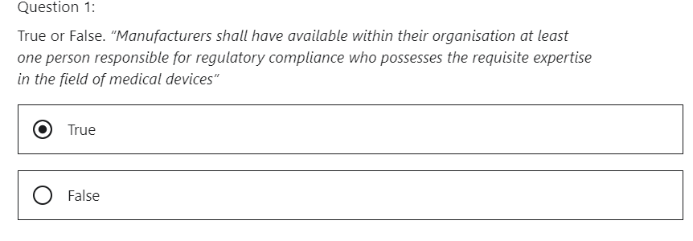

That is correct. The person responsible for regulation compliance is a new role created within the Medical device (EU) regulation 2017/745

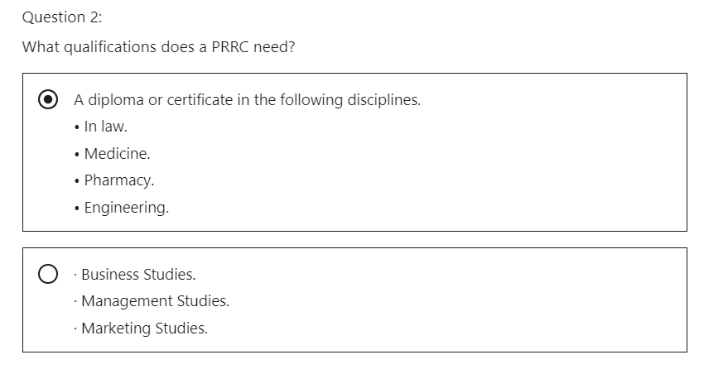

That is correct. And at least one year of professional experience in regulatory affairs or in quality management systems relating to medical devices

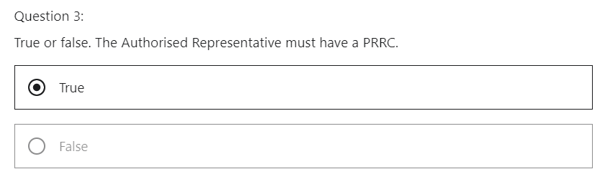

That is correct. The regulation mandates under article 15 that the European Authorised representative needs to have PRRC.

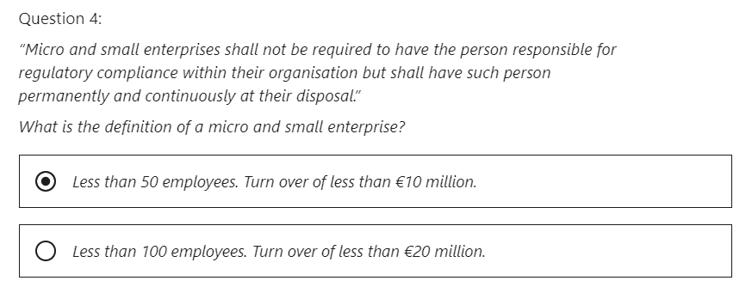

That is correct. This is the direction given by European commission.

# Section 3: EUDAMED

## 1 Introduction

Hi.

What will we discuss in this section?

Section three will explain what the EUDAMED is.

The diagram replicates the EUDAMED system, each block represents a module within the system.

We will discuss the following in the section.

What is EUDAMED?

What is meant by the actors registration?

What are the timelines for the implementation of EUDAMED?

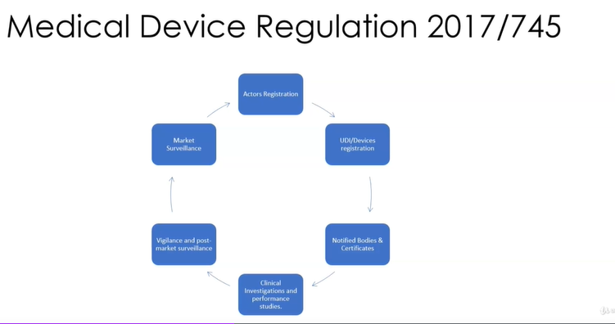

1. Actors registration
2. UDI/devices registration
3. Notified Bodies and Certificates
4. Clinical Investigation and Performance Studies
5. Vigilance and post-market surveillance
6. Market surveillance

Hi, welcome to the Medical Device Regulation 2017/745, EUDAMED an introduction.

What will we learn?

Understand what EUDAMED is

Understand the four main functions of EUDAMED.

Understand the six modules associated with EUDAMED.

The medical device regulation, 2017/745, Article 33 explains what the European database of medical devices is.

**EUDAMED is a European Union database for medical devices.**

The aim is to collect data on the whole lifecycle of a medical device from concept design, clinical trial evaluation, manufacturing and market vigilance.

It is a new requirement mandated in the medical device EU regulation 2017/745.

It will collate data on medical devices that are marketed in the European Union.

The objective is to improve transparency and coordination of information regarding medical devices available on the EU market.

This will ensure safety and efficacy of the device on the marketplace.

**EUDAMED will have four main functions**:

1. a registration system,
2. a collaborative system,
3. a notification system and
4. a system which is open to the public

It will provide health and safety information for medical devices.

It will store and provide access to specific data, including medical device identification, adverse events and certification information.

**EUDAMED consists of six modules** whose aim is to follow the life cycle of the medical device from research and development, clinical trials, manufacturing, gaining market approval and monitoring in the marketplace.

**1 The actor’s registration**, which means it will register the majority of the economic operators.

I will go into more detail on the actors in another lecture in the section

**2 The UDI device registration**.

This is the unique device identification UDI database.

The EU medical device regulation mandates the use of a unique device identification UDI system, which will allow the identification of a device and enable the traceability of devices.

I will go into more detail on this in another lecture

**3 The notified bodies and certificates module**

This regards the corresponding certificates issued by notified bodies.

**4 The critical investigation and performance studies module**

it will record registration of clinical investigations, it will record safety and clinical summaries for medical devices.

**5 The vigilance and post marketing surveillance module**

this will record vigilance, postmarketing surveillance (P and S) and market surveillance data.

I will go into more detail on how the medical device is monitored when it is on the marketplace.

Suffice to say, this is one of the tenets of the medical device regulation.

*Tenet = a belief or idea that is very important to a group*

It wants more follow up on safety and efficacy of the device in the marketplace.

**6 Market surveillance**

The main aim of the new system is to support the medical device regulation, which is transparency,

traceability, safety and proof of efficacy of the medical devices.

What have we learned?

We have a basic understanding of what EUDAMED is we understand the four main functions of EUDAMED.

We understand the six modules associated with EUDAMED.

## 2 Actors registration

Hi, welcome to the Medical Device Regulation 2017/745 on EUDAMED the actors role.

In this lecture, we will discuss who actors are.

What will we learn,

* understand who the actors are in the context of Article 33
* Understand the single registration number, which is also known as the SRN
* an example of a registration,
* the validation process of an actor

Article 33 explains what the European database of medical devices is.

(Article 33 - European database on medical devices)

It explains what will be contained in the database and how that information can be used.

Article 30 explains that there is an electronic system for registration of economic operators.

(Article 30 - Electronic system for registration of economic operators).

Article 31 explains that the economic operators have to register on the EUDAMED system in the actors module.

(Article 31 - Registration of manufacturers, authorised representatives and importers)

Now, the next slide will go into more detail on this.

This is a very useful document created by the European Commission.

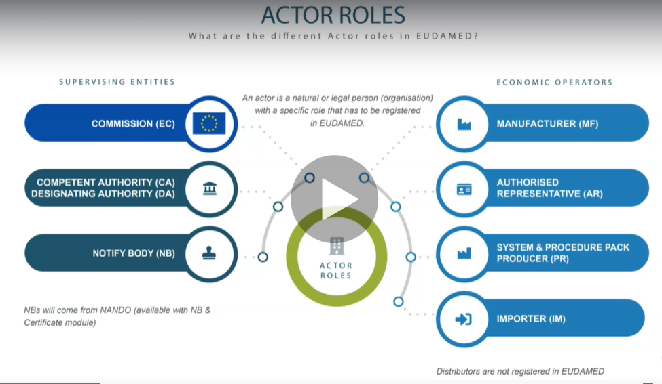

I have attached it as a resource material to this lecture.

**Economic operators that have to register in EUDAMED are:**

Manufacturer (MF)

Authorized representative (AR)

System and Procedure Pack producer (PR)

Importer (IM)

Attention! Distributor is an economic operator, but he does not have to register to EUDAMED

ACTOR ROLES

Let's look at the left hand side.

First, it explains who needs to register as an actor in EUDAMED in regard to monitoring the regulation system.

SUPERVISING ENTITIES

The European Commission

The competent authorities (Who designates to notified body)

The Notified Body.

Notice that Nando is mentioned here as well (Notified Body list)

The acronym stands for New Approach Notified and designated organizations, it is a list of notified

bodies that are compliant to perform medical device regulation, conformity assessments.

**Notification is an act** whereby a member state informs the commission and the other member states that a notified body which fulfills the relevant requirements has been designated to carry out conformity assessments according to a regulation.

Notification of notified bodies and their withdrawal are the responsibility of the notifying member states.

We would discuss and Notified bodies further in this module pertaining to the medical device regulation.

Now, let me draw your attention to the right hand side, who from the economic operators needs to register as an actor in the UNAMID system,

ECONOMIC OPERATORS

the manufacturer, to authorize a representative to system and procedure producer and the importer.

It's interesting to note that the distributor does not need to register.

Continuing with this document, let me explain the SRN, which is the single registration number.

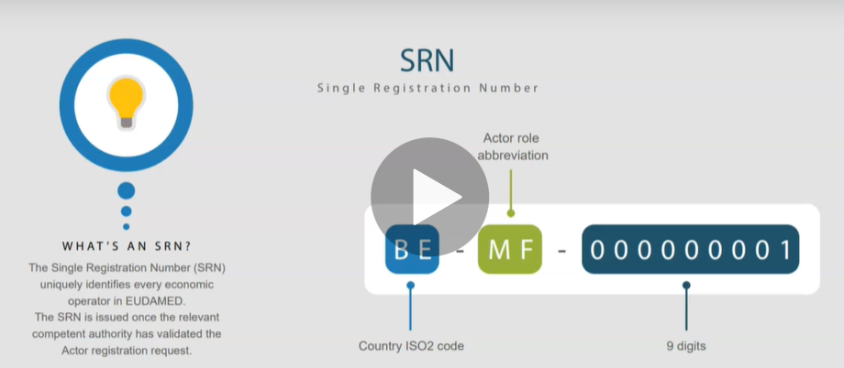

The single registration number, SRN, uniquely identifies every economic operator in EUDAMED

the SRN is issued once the relevant party has validated the actor registration request.

What does this mean?

It is a checklist to be validated.

For example, it can consist of validating the manufacturer's address and that his website exists.

The SRN number with first detail the country in which the actor is located.

In this case, it is represented by BE, which is Belgium, and this is a representation of the ISO 3166 international standard alpha dash to code.

“MF” in this case represents the manufacturer, the previous slide indicates all abbreviations for the

actors.

Finally, the actor obtains a unique nine-digit number.

Now, let's look at the example,

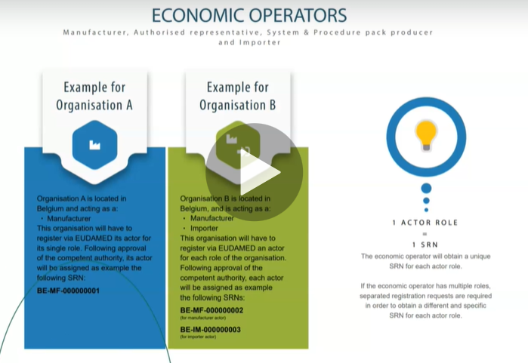

organization A is a medical device manufacturer located in Belgium.

The manufacturer will register via EUDAMED, its actor, as a single role

once the composite authority in Belgium validates the manufacturer's registration details, it will give the manufacturer a single registration number.

Now, let's consider the same Belgium manufacturer.

It is also an importer of medical devices outside of the European Union.

The organization will have to register an actor for each role of the organization.

So let's have a overview how the general validation process works.

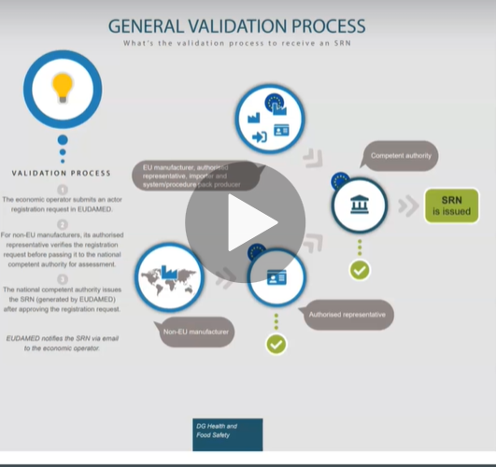

STEP ONE, the economic operator submits an actor registration request in EUDAMED

STEP TWO for non-EU manufacturers, the European Authorized Representative of the non EU manufacturer verifies the registration request before passing it to the national competent authority.

Interesting to note that this is a responsibility of the European Authorized Representative.

STEP THREE, the national competent authority issues the single registration number, which will be

generated by the EUDAMED system after they have approved the registration request.

STEP FOUR, EUDAMED issues, the SRN via email to the economic operator.

What have we learned?

We know who the actors are.

We know how the SRN is created.

We know the validation process of an actor.

TEST on Actor’s Registration to EUDAMED

Understand who the Actors are within EUDAMED.

**Question 1:**

**Which economic operator does not need to register as an actor on EUDAMED?**

The Manufacturer (MF)

The Distributor

Answer: The Distributor

That is correct. The regulation does NOT mandate that the distributor register’s as an actor on EUDAMED.

**Question 2:**

**True or false. The Single registration number (SRN) uniquely identifies every economic operator in EUDAMED.**

Answer: True

That is correct. The SRN is issued once the relevant competent authority has validated the actor registration request.

**Question 3:**

**The image is an example of a single registration number. What does “BE” represent?**

BE – MF - 000000001

The country where the economic operator is located

The economic operator

Answer: the country

That is correct. The SRN number will 1st detail the country in which the actor is located. In this case it is represented by “BE” which is Belgium, and this is a representation of the ISO 3166 international standard alpha-2 code.

**Question 4:**

**True or false. It is the responsibility of the authorised representative to verify a non-EU manufacturer before registration in EUDAMED.**

Answer: True

That is correct. For non-EU manufacturers its authorized representative verifies the registration request before passing it to the national competent authority. Interesting to note that this is a responsibility of the EAR.

## 3 EUDAMED Timelines

Hi, welcome to the Medical Device Regulation 2017/745 lecture on EUDAMED timelines.

In this lecture, we will discuss the timelines associated with the introduction of the EUDAMED system.

What will we learn?

We will understand the timelines associated with the implementation of EUDAMED.

Article 34 explains how the European Commission will detail the functionality of the EUDAMED system with the support of the medical device coordination group (MDCG).

(article 34 - Functionality of Eudamed)

The aim here is to ensure that the EUDAMED will meet all of the user requirements specifications, which is as follows

actor registration

UDI or device registration.

UDIand device registration.

Notified body and certificates, registration

clinical investigation and performance studies, data collection,

monitoring the medical device in the marketplace and recording that data.

Public access to data on medical devices

the ability of the supervisors to monitor regulation

This is the current update of their timelines as published on the EU Commission website.

**The development and implementation of EUDAMED is the responsibility of the EU commission, as outlined in Article 33 and 34**.

The development and implementation of EUDAMED is a high priority for the Comission.

**That commission will work with the medical device coordination group to release the modules on a gradual basis.**

The commission, in agreement with the MDCG (Medical Device Coordination Group), is going to make available the different modules on a gradual basis as soon as they are functional.

**The module on Actor Registration was made available in December 2020.**

The module on Actor Registration, will be the first module made available. Deployment of the module is planned for December 2020.

**The next two module's UDI device registration and certificates and notified bodies will become available the second half of 2021.**

The module on UDI/device registration (second module) and the module on Certificates and Notified Bodies (third module) will become available by the second half of 2021.

Afterwards, the remaining modules will be displayed as soon as they are functional.

There have been delays on the initial release of the EUDAMED.

Article 123 (Entry into force and date of application) takes this into consideration and allows the commission extra time.

The main objective is to get the function of the database working correctly.

Medical device regulation becomes applicable as of May 2021.

Even though the other modules will not be available in EUDAMED as a manufacturer of medical devices,

you need to be compliant with the medical device regulation 2017/745.

The official web address of the EUDAMED public website will be “ec.europa.eu/tools/eudamed”

What have we learned?

* The Actors module was released December 2020.
* The next two modules, UDI/device registration and Certificates and Notified Bodies will become available the second half of 2021.
* Remaining modules will be displayed as soon as they are functional.
* The commission has made considerations for delays of the system location of the huge made public website.
* Location of the EUDAMED website.

TEST eudamed timelines

Understand when each Module within the EUDAMED base will come on line.

Question 1:

When did the 1st Module in EUDAMED come online?

Dec 2020

Dec 2021

Answer: 2020

Correct. The module on actor registration was made available in Dec 2020.

Question 2:

When will the next modules become available?

May 2021

May 2022

Answer: 2021

Correct. The next two modules UDI/device registration and Certificates and NBs will be become available by May 2021. Afterwards, the remaining modules will be displayed as soon as they are functional. One caveat here is the timelines can change and this the current timeline as 2020 Dec.

# Section 4: UDI / Registration

Hi, welcome to Section four, UDI Registration.

What we discuss in this section.

Section 4 will explain what the unique device identification and device registration is.

UDI device registration will be registered in the EUDAMED system.

We will discuss the following in the section.

UDI, part one, an introduction to what a unique device identification is,

UDI part two explains how to create a UDI.

UDI, part three, understand who is credited with creating a UDI for the medical device market in the

European Union

UDI Timelines, what the Transitional timelines for UDR.

## 1 UDI, Part 1, Introduction

Hi, welcome to the Medical Device Regulation 2017/745, UDI unique device identification, an introduction.

What will we learn?

We will understand where the UDI is primarily mentioned within the regulation.

We will understand what the unique device identification database is.

We will learn what a basic unique device identifier is.

So let's get some basics out of the way.

**Where in the regulation do we primarily mention unique device identification?**

Article 27 – Unique Device Identification System

explains the UDI system and explains what the system is.

Article 28 – UDI Database

explains the UDI database.

Article 29 – Registration of devices

explains how devices need to be registered before being placed on the marketplace.

Annex VI – Information to be submitted

explains the information to be submitted upon registration of the device.

**What is the Unique Device Identification**

The unique device identifier enables traceability of the medical device, this UDI will be recorded in the UDI database.

The medical device EU Regulation 2017/745 mandates the use of a unique device identification UDI system in Article 27. **This means it is compulsory**.

The benefits of a unique identification system are as follows:

UDI will enhance patient safety as transparency and traceability will be evident.

UDI will allow more accurate reports of adverse events.

The adverse event can be attributed to the UDI, this will allow more efficient follow up investigation.

The UDI will allow more effective management of medical device recalls and reduction of medical errors.

**What is the UDI Database Article 28**

The UDI database is part of the EUDAMED system.

UDI / Devices Registration is one of the six modules in the EUDAMED database

The UDI database will be accessible to the public to allow transparency.

The general data protection regulation will also be compliant.

The economic operators will be able to upload their UDI information into the UDI devices registration

module.

**What is the basic UDI-DI Annex VI**

The basic UDI - DI is unique to the E.U.

The FDA requires a UDI, but it does not have a basic UDI-DI, which stands for Unique Device Identifier, Device Identifier.

It is a static number defining a group of products.

If you have a group of products with the same intended use the same classification, then they are classified as the same basic UDI-DI

let's say the medical device is a coronary artery stent, stents can come in different lengths, for example, ranges from 8 millimeter to 38 millimeter in length.

In this case, it is the same model of stent.

It just comes in different lengths to accommodate the size of the occlusion.

Therefor this category can have the same basic UDI_DI

What is the basic unique device identifier, device identifier, basic UDI-DI?

It is explained in Annex VI, Part A of the medical device regulation EU 2017/745.

The basic UDI-DI will not appear on the products

The basic UDI-DI will be on the certification form from the notified body

The basic UDI-DI will be on the declaration of conformity.

The basic UDI-DI will be on the technical documentation.

The basic UDI-DI will be on the summary of safety and clinical investigation data.

The creation of the basic UDI-DI code must be done by the medical device manufacturer or authorized representative, before that product can be submitted for market registration or approval to the competent authorities.

What have we learned?

We understand the primary locations within the regulation where UDI is mentioned.

We understand what the unique device identifier database is.

It will give all medical devices that are intended for the European Union marketplace a unique identification.

This will allow for an efficient system with regard to safety and traceability.

We understand the basic UDI.

This is unique to the European Union.

It allows some category medical devices to have the same identifier.

TEST UDI Part 1, introduction

Introduction to what the Unique Device Identification is

**Question 1:**

**What is the primary function of the unique device Identifier?**

The UDI enables better market share for medical devices

The UDI, enables traceability

Answer: The UDI, enables traceability

That is correct. That is one of the purposes of the MDR 2017/745. It provides efficient traceability of medical devices in the European Market.

**Question 2:**

**True or false. Some of the benefits of the UDI system will be:**

**· The UDI will enhance patient safety.**

**· The UDI will allow more accurate reports of adverse events.**

**· The UDI will allow more effective management of medical device recalls and reduction of medical errors.**

Answer: True

That is correct. The regulation mandates for the UDI system but these benefits are very useful especially for post market surveillance.

**Question 3:**

**True or false. Basic UDI-DI will not appear on the product.**

Answer: True

This is correct. It will be on the certification form from the notified body.

**Question 4:**

**Who creates the Basic UDI-DI code?**

The manufacturer

The Competent Authority

Answer: The manufacturer

That is correct. It is mandated in the regulation under Annex VI.

## 2 UDI, Part 2, How to create a UDI

Hi, welcome to the Medical Device Regulation 2017/745, a lecture on UDI unique device identification, part two.

What will we learn

how is the unique device identification created

understand the unique device identification carrier

What is the system used to create the code, understand the AIDC ”Automatic identification and data capture” the machine readable part of the identification code.

Understand the HRI “human readable interpretation” the readable part of the code

Understand that unique device identification device identifier, which is called the UDI DI.

Understand that unique device identification production identifier, which is called the UDI - PI.

Companies accredited with creating a unique device identification carriers

which companies have been approved by the EU Commission to create the carrier I.D

**The medical device regulation 2017/745 Annex VI explains the core data elements to be provided to the UDI database.**

The unique device identification is new to the medical device regulation in Europe.

The FDA has a UDI system in place since 2013.

Medical device manufacturers in Europe, that market devices in the U.S. have to adhere to this regulation.

It is interesting to note that there has been EU medical device manufacturers making products since 2013 that are adhering to the FDA requirements to create a unique device identifications.

It is mandated in the medical device, a regulation 2017/745.

This UDI will appear on the label or on the device itself

The unique device identification system will identify medical devices marketed in the European Union.

The unique identification system will facilitate traceability of medical devices marketed in the European Union.

The unique identification system is covered under article 27 of the MDR (EU) 2017/745 and Annex VI part C.

**Article 27 and Annex VI Part C, of MDR**

**The unique device identifier is broken into two parts.**

**1) The unique device identifier device identifier UDI – DI**

this is the primary identifier of a device model.

**2) The unique device identifier production identifier, UDI - PI.**

It is a numeric or alphanumeric code that identifies the unit of the voice production attributes, these attributes are, for example

when was the product made?

When will the product expire?

What is the batch or LOT number and the serial number?

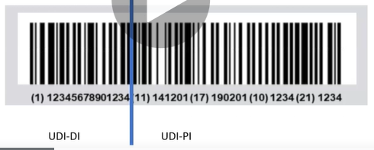

The top part of the label will be machine readable.

This is called the Automatic Identification and data capture. (AIDC)

In our example, it is a one dimensional barcode.

The bottom part of the label is the human readable interpretation HRI.

The UDI carrier is the means of conveying the UDI by using automatic identification and data capture and if applicable, its human readable interpretation.

**Automatic identification and data capture, AIDC.**

AIDC is a technology used to automatically capture data.

AIDC technologies include barcodes, smart cards, biometrics and RFID’s.

Human readable interpretation HRI

HRI is a legible interpretation of the data characters encoded in the UDI carrier.

**UDI-DI is the device identifier.**

Every device has its own UDI DLT.

Unique to the company and the device, it will provide a link to the UDI database, which is one of

the modules of EUDAMED.

The UDI device identifier will be referenced in relevant certificates and declarations of conformity.

It is termed static as it will stay the same.

As you can see in the example it is represented in the left hand side of the bar code, which is the automatic identification and data capture part of the carrier. The human readable interpretation HRI is represented by one and then the number.

UDI-PI

UDI-PI it is the unique device identifier production identifier

it is specific to the production you are running

it is a dynamic part of the UDI, this means it will always be changing as you make different batches of the same product.

The UDI-PI can include a serial number, a LOT number or a batch number, software identification and

manufacturing date, expiry date or both types of dates.

As you can see in the example, is represented on the right hand side of the barcode, which is the automatic identification and data capture part of the carrier.

The human readable interpretation HRI is represented by the numbers to the right of the division line, UDI-PI

In this example, each identification number has a meaning.

This example is taken from GS1, which is one of the accredited companies in the medical device

EU regulation 2017/745 that can produce carriers for medical devices in Europe.

(11) signifies the manufacturing

(17) signifies the expiration date

(10) signifies the batch or LOT number

(21) signifies the serial number.

The automatic identification and data capture technology (AIDC technology) can be very efficient to prevent human errors.

Scanning a code can prevent input errors if the code cannot be machine readable due to damage, the human readable interpretation is a convenient method for inputting data.

**We can see two examples of automatic identification and data capture technology (AIDC technology):**

The first example is a one dimensional barcode created by GS1

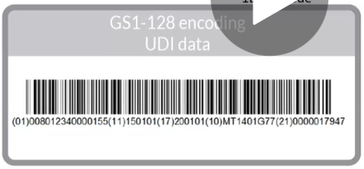

The second example is a two dimensional barcode.



**Which companies are accredited with issuing the unique device identification?**

the EU have allocated companies to issue UDI codes

The names are under Article 120, paragraph 12 in the medical device EU regulation, 2017/745.

The companies are GS1, HIBCC and ICCBBA

There is now a fourth company accredited. It is the first European company, IFA Gmbh

What have we learned

the FDA in the US have regulated their medical devices with a unique device identification since 2013,

we have learned what a UDI carrier is.

It is the means of producing the unique device identification.

We have learned that a UDI carrier consists of an automatic identification and data capture, which allows the UDI carrier to be machine read.

We learned that a UDII carrier consists of a human readable interpretation which allows the UDI to be read by a person which is a good idea in case the machine readable part of the UDI carrier cannot be read.

We have learned that the UDI carrier is broken into two sections the UDI Device Identifier and the UDI Production Identifier.

The UDI-DI device identifier is static and identifies the device type.

The UDI-PI production identifier is dynamic and identifies the production details.

We know there are four companies that are currently accredited with producing UDI carriers for the

medical device market in the European Union.

GS1, HIBCC and ICCBBA and IFA Gmbh

TEST UDI, part 2, How to create a UDI

Question 1:

What part of the UDI does the blue box encompass.

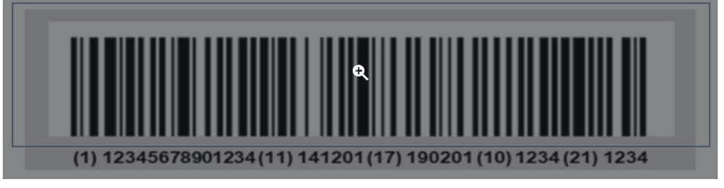

It is the Automatic identification and Data Capture (AIDC)

It is the Human Readable Interpretation (HRI)

Answer: AIDC

That is correct. It is the machine-readable part of the label. In this example it is 1 Dimensional bar code.

**Question 2:**

**What part of the UDI does the blue box encompass.**

It is the Automatic identification and Data Capture (AIDC)

It is the Human Readable Interpretation (HRI)

Answer: HRI

That is correct. HRI is a legible interpretation of the data characters encoded in the UDI carrier.

**Question 3:**

**What section of the unique device identifier carrier is highlighted in the picture?**

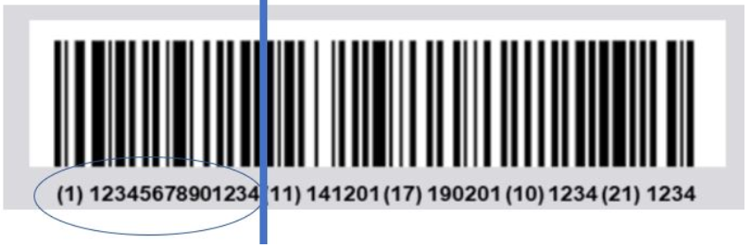

The UDI DI, device identifier

The UDI PI, production identifier

Answer: udi di

That is correct. This is the device identifier.

Question 4:

What section of the unique device identifier carrier is highlighted in the picture?

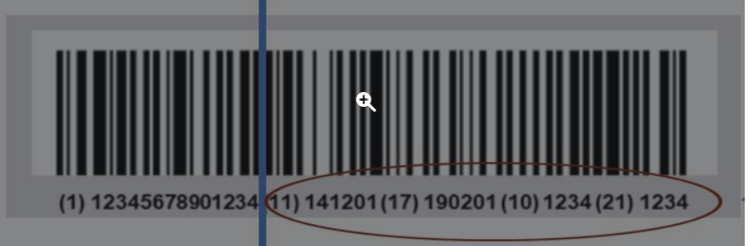

The UDI DI, device identifier

The UDI PI, production identifier

Answer: udi pi

That is correct. It is a numeric or alphanumeric code that identifies the unit of device production attributes. These attributes are for example, when was the product made, when will the product expire, what is the batch/lot number and the serial number.

## 3 UDI, Part 3, who is accredited to create a UDI in the EU

Hi, welcome to the medical device regulation 2017/745 lecture on unique device identification, part three.

What will we learn?

We will understand a little about who the current accredited organizations are that can create a unique device identification carrier standard.

These organizations have been approved by the European Commission

an introduction to their standards,

the role and responsibilities of the accredited organizations within the regulation.

**Introduction**

There are four companies that are accredited with creating unique ID carriers in the European Union.

They are GS1, HIBCC, ICCBBA and IFA Gmbh

Each company has their own standards but are recognized by the European Commission.

We will examine that in a short summary, each company's standard.

Under Article 120 titled Transitional Provisions, Paragraph 12 within the medical device EU Regulation 2017/745, the commission has picked three organizations that can create unique device identification carriers.

The EU Commission have designated IFA Gmbh. an issuing entity for unique device identification since June 16, 2019.

This now brings four players into the system

**Unique device identification, Article 27, paragraph 2**

The details on how the commission decides to choose an organization to create UDI carriers is in Article 27, paragraph two.

The commission will choose organizations that can operate a system for assignment of UDI’s.

The company needs to be able to create a UDI

Its system for the assignment of UDI’s is adequate to identify a device throughout its distribution and use in accordance with the requirements of this regulation.

This means the system that the company creates is able to create effective basic UDI’s, the UDI DI and the UDI PI.

The companies in this case are GS1, HIBCC, ICCBBA and IFA Gmbh.

Each system for the assignments of UDI’s conforms to the relevant international standards.

These standards are associated with correct and labeling

the entity gives access to its system for the assignment of U.D. to all interested users in accordance with a set of predetermined and transparent terms and conditions.

The entity is the company that creates the UDIcarriers.

They must be willing to be audited in order to ensure transparency and that standards are maintained.

The entity undertakes to do the following again, the entity is the company creating the UDI carriers.

In our case it is GS1, HIBCC, ICCBBA and IFA Gmbh.

The entities undertake to do the following:

Operate its system for the assignment of UDI’s for at least 10 years after its designation.

This ensures that there is supply of service for a period of time and gives the EU Commission a chance to arrange for other organizations to provide the service.

Make available to the commission and to the member states upon request, information concerning its system for the assignment of UDI’s.

This allows transparency and follow up that may need to be adhered to

Remain in compliance with the criteria for designation and the terms of designation.

This will mean auditing at regular intervals and ensuring that all standards are kept up to date.

Here is the GS1 standard format that is allowed to create a human readable interpretation system.

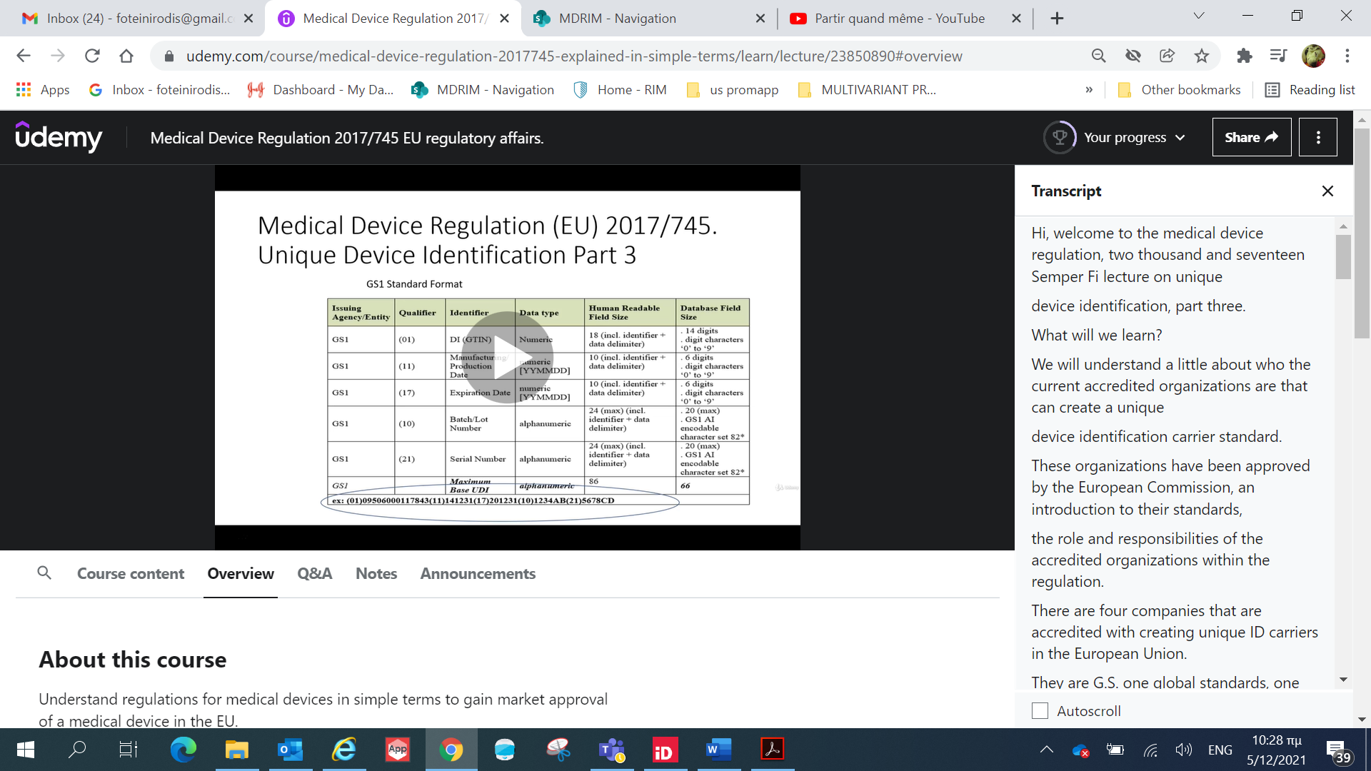

Notice the example at the bottom of the page.

Refer to the lecture on medical device regulation UDI Part two for a more detailed explanation.

Here is an example of the GS1 format, which includes the human readable interpretation and the AIDC automatic identification and data capture.

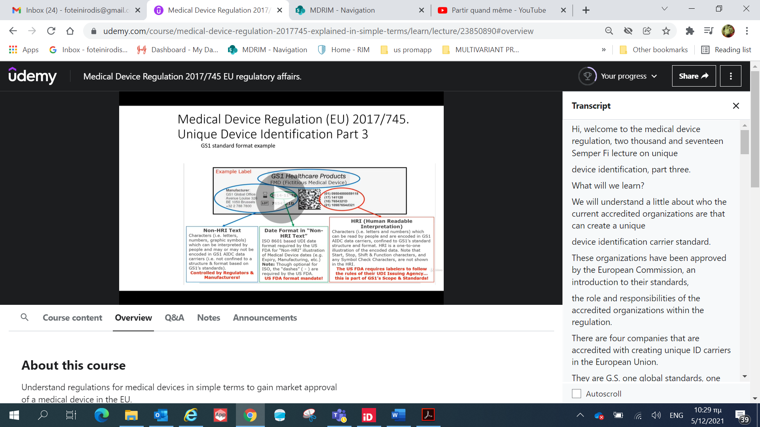

Here is the HIBCC standard format, that is to allow to create a human readable interpretation system.

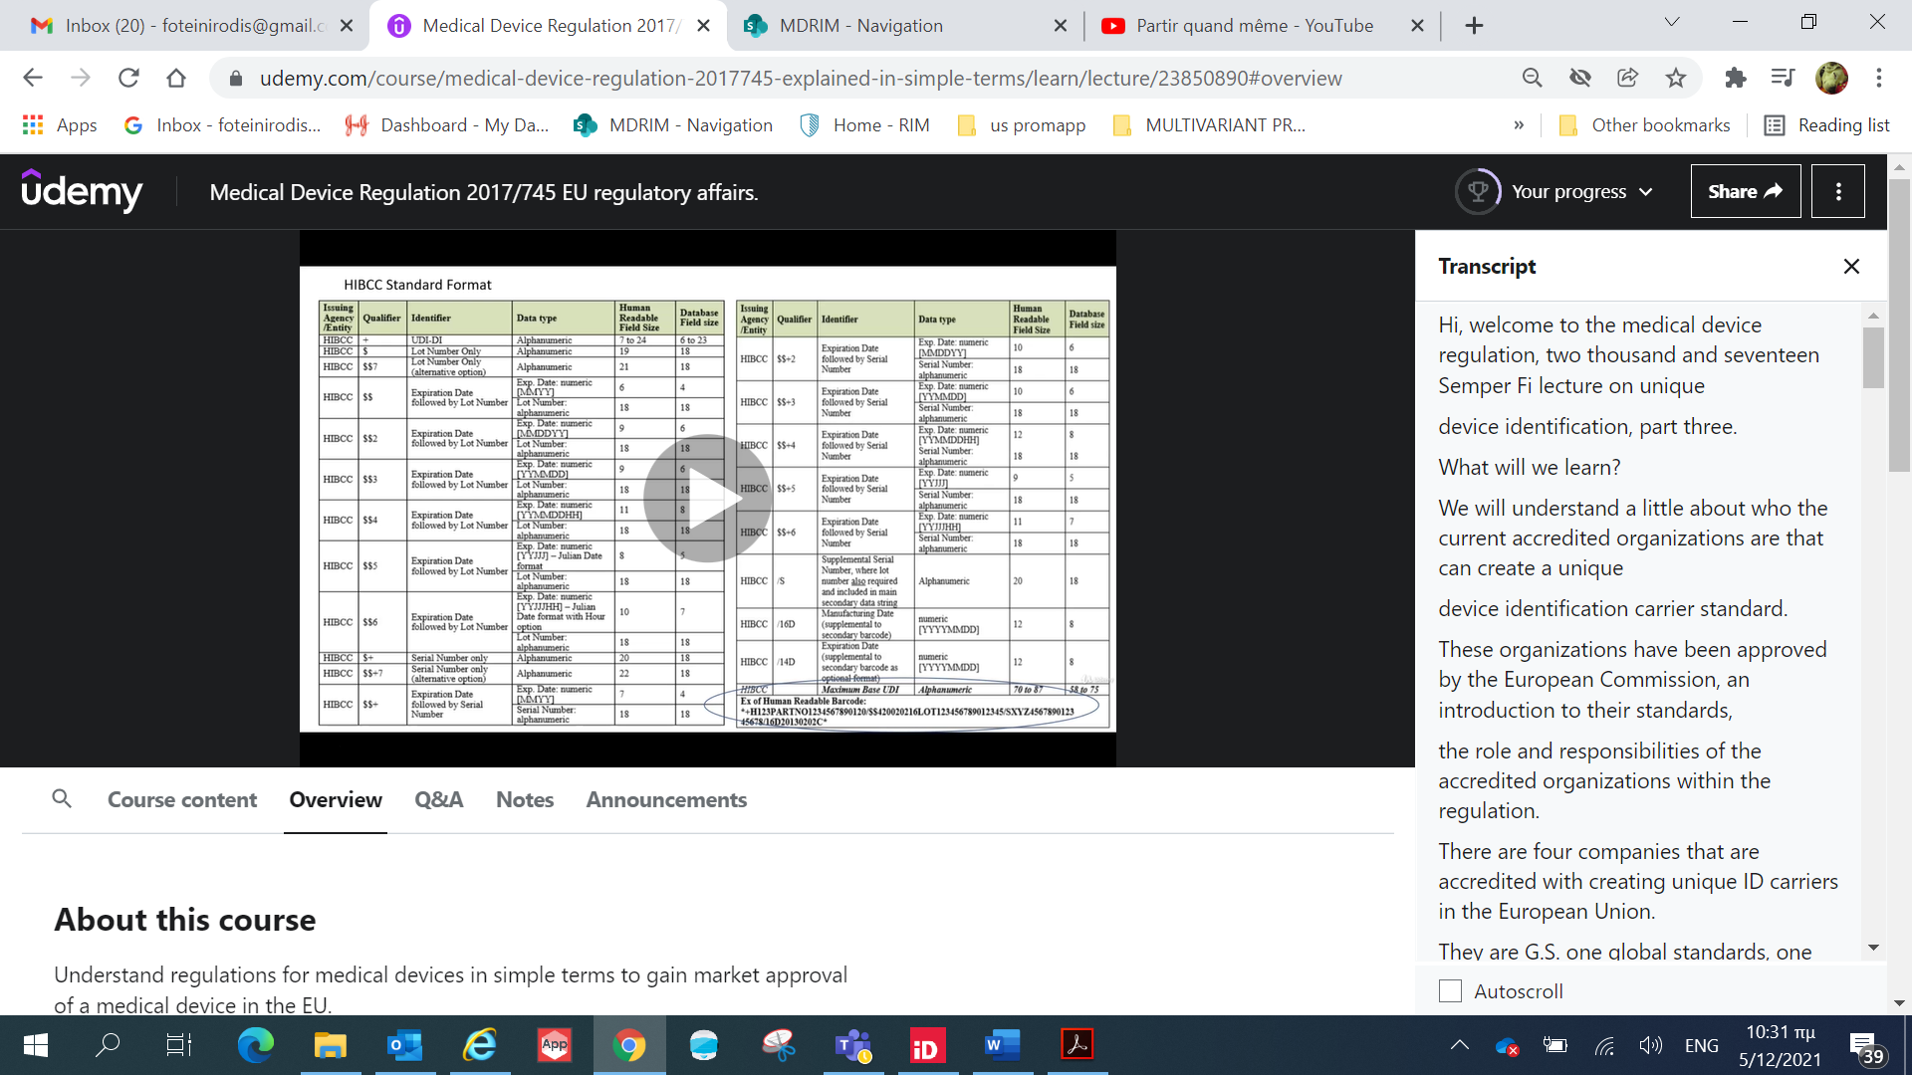

Notice the example at the bottom of the page, it is interesting to note that it looks different compared to GS1 HRI, but this standard will be acceptable to use as a UDI carrier under the scope of

the medical device EU regulation, 2017/745.

Here is an example of the HIBCC format, which includes the human readable interpretation HRI and the automatic identification and data capture AIDC.

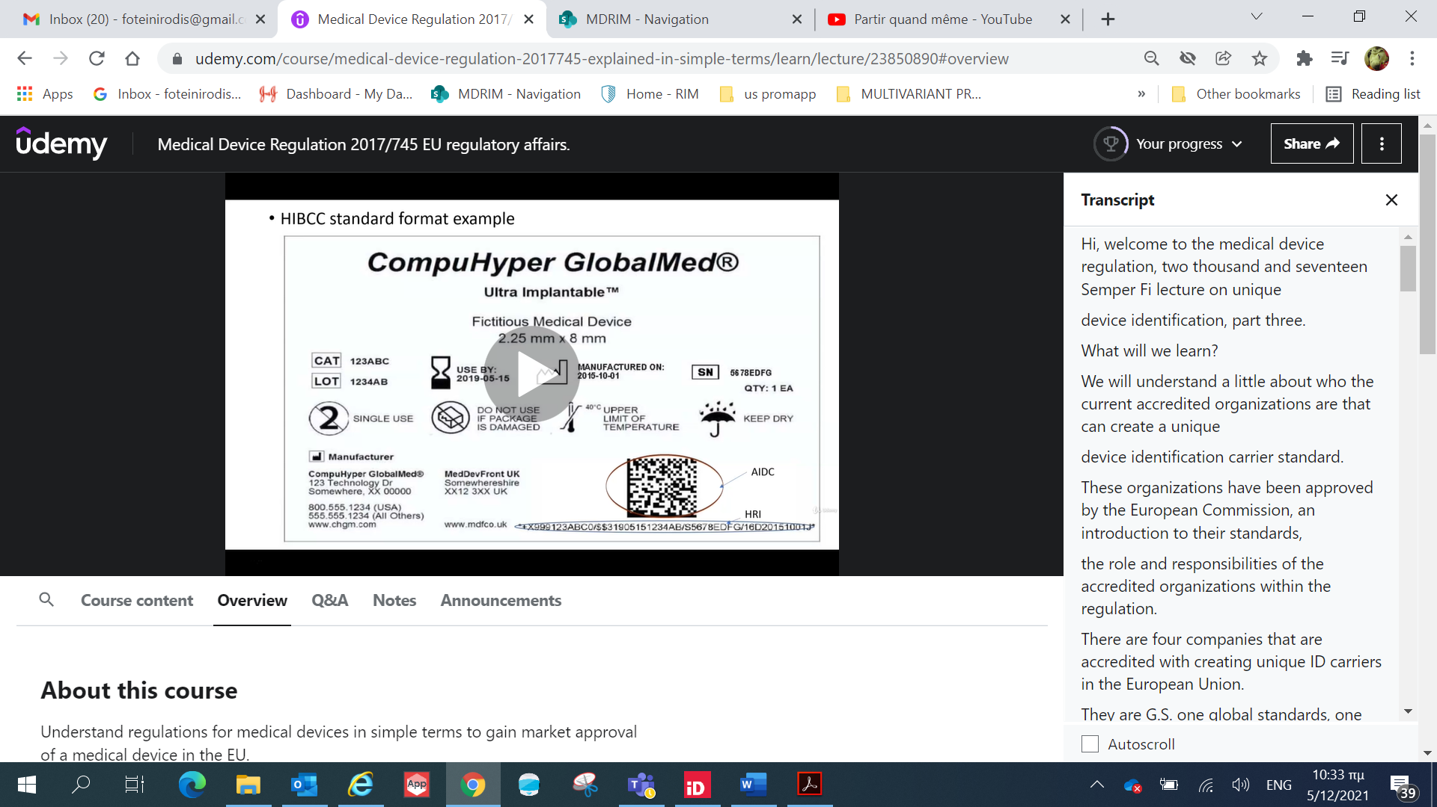

In this case, it is a two dimensional barcode.

Here is the IFA standard format that is allowed to create a human readable interpretation system.

The human readable interpretation standard will be acceptable to use as a UDI carrier under the scope of the medical device EU regulation 2017/745

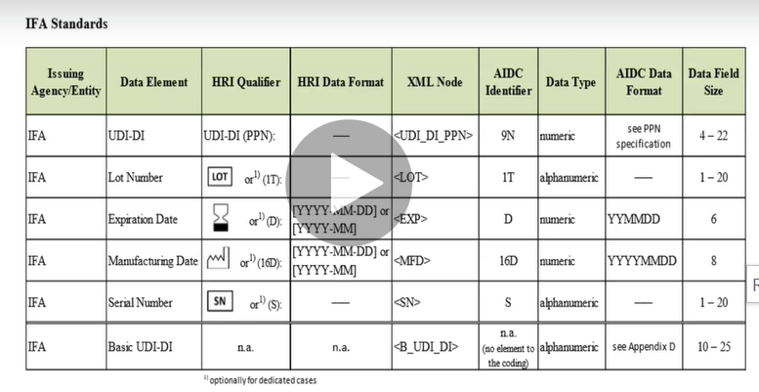

Here is an example of the IMF, a standard format, which includes the human readable interpretation

for the unique device identification.

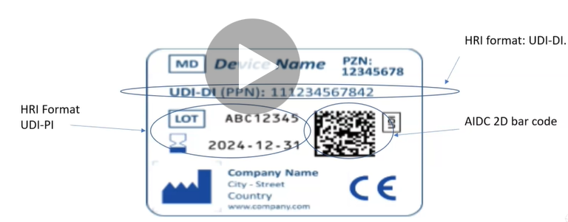

Device identifier and the AIDC automatic identification and data capture.

in this case, it is a two dimensional barcode.

Here is an example of the ICBBA standard format, which includes the human readable interpretation for

the unique device identification device identifier and

the unique device identification production identifier.

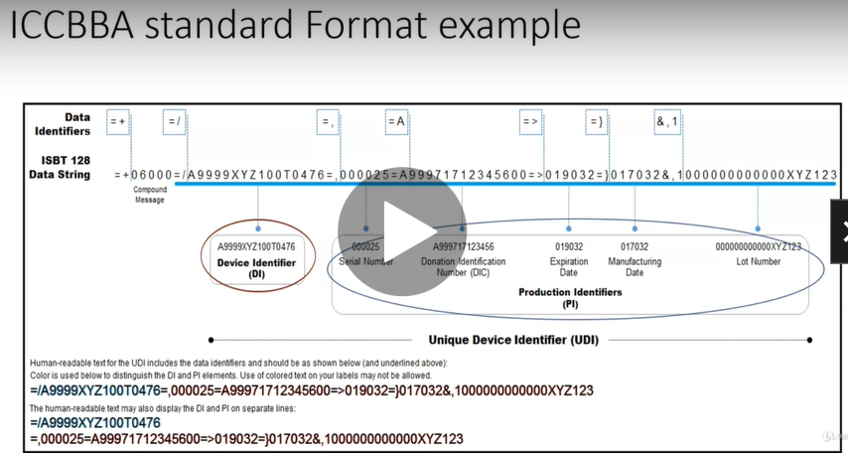

This standard is acceptable under the medical device, EU Regulation 2017/745.

What have we learned

there are four organizations chosen by the European Commission to create a unique device, identification carriers for the medical devices that are to be marketed in the European Union.

These four organizations are GS1, HIBCC, ICCBBA and IFA Gmbh.

Each system has their own standards and identification systems.

We demonstrated examples of each standard for their human interpretively interface and their automatic identification and data capture (HRI and AIDC)

Each unique device identification carrier is recognized by the EUDAMED system and can be colorated to the medical device.

TEST UDI Part 3

Understand the current four accredited organisations which create Unique Identification carriers in the European Union.

**Question 1:**

**The EU Commission has accredited 4 organisations with creating Unique Identification carriers in the European Union. Which one is a European based organisation?**

GS1,

HIBCC,

ICCBBA and

IFA Gmbh.

Answer: only IFA Gmbh.

Correct. This is the 1st European based labeling organisation which was accredited by EU commission. This occurred in June 2019.

**Question 2:**

**The company that supplies the UDI must have an operating system for at least how long?**

10 years

20 years

Answer: 10

That is correct. Under article 27 the UDI provider needs to operate its system for the assignment of UDIs for at least 10 years after its designation

Question 3:

True or false. The provider to the Unique device identification system must allow the Commission and the competent authority access to their system.

Answer: True

That is correct. Article 27 mandates the unique device identification provider makes available to the Commission and to the Member States, upon request, information concerning its system for the assignment of UDIs. This allows transparency and any follow up that may need to be adhered to.

## 4 UDI Timelines

Hi, welcome to the Medical Device Regulation 2017 /745 lecture on Unique Device Identification Timeline's.

What will we learn?

We will understand the UDI transition period.

This is an excerpt from a frequently asked question document produced by the European Commission.

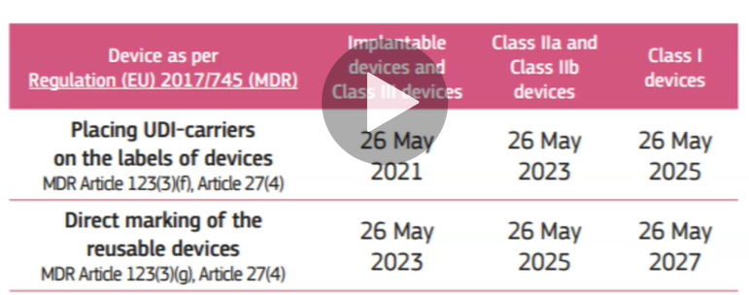

I have attached it as a resource to this lecture.

UDI transition priority has been governed by the risk device level.

Placing UDI carriers on the labels of implantable devices and Class II devices need to occur by the 26 of May 2021.

Placing UDI carriers on the labels of Class IIa and Class IIb devices need to occur by the 26 of May 2023.

Placing UDI carriers on the labels of Class One devices need to occur by the 26th of May 2025.

Also, direct marking of reusable devices take place as follows:

If you are going to use a medical device that is reusable, it makes sense that there is direct marking

of the UDI on the product.

Implantable devices and Class II devices need to occur by the 26 of May 2023.

Class IIa and Class IIb devices need to occur by 26 of May 2025.

Class I needs to occur by 26 of May 2027.

What have we learned?

UDI transition times have been prioritized according to classification

we know the UDI timelines for each classification.

TEST UDI timelines

Understand when the medical device regulation mandates an UDI needs to be applied to the packaging of a device.

Question 1:

When do medical device manufacturers need to place an UDI carrier onto the label of a class III device?

26 May 2022

26 May 2021

Answer: 2021

Correct. Notice how the higher classification devices need to be complete sooner.

Question 2:

When do medical device manufacturers need to place an UDI carrier onto the label of a class IIa and class IIb medical device?

26 May 2023

26 May 2024

Answer: 2023

Correct

When do medical device manufacturers need to place an UDI carrier onto the label of a class I medical device?

26 May 2025

26 May 2026

Answer 2025

correct

# Section 5: Classification of medical devices

## 1 Introduction

Hi, welcome to the Medical Device Regulation 2017/745, **Section 5: Classification of medical devices**.

What will we discuss in this section?

Section five will explain how medical devices are classified according to the rules of the medical device

regulation, 2017/745.

We will discuss the following in this section.

* An introduction to classification of medical devices.
* Qualification of a medical device.
* Is the manufacturer making a medical device?
* Medical device definitions will be explained.
* Medical device classification rules will be understood.
* How we can apply medical device rules.

Qualification = Αξιολόγηση, προσόν, πιστοποιητικό

Hi, welcome to the Medical Device Regulation 2017/745 lecture classification of a medical device introduction.

Medical device classification introduction, what we learn, what is meant by the classification, the medical device regulation calls out **three primary principles** are you making a medical device we will

deemed as qualification.

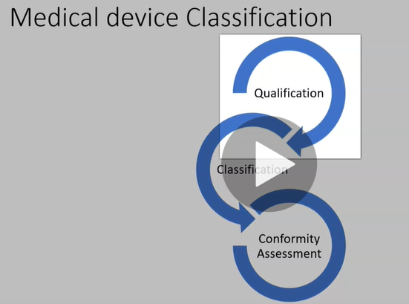

**One** examines the definition of a medical device in the medical device regulation 2017/745 regulation, which allows us to determine if we are making a medical device.

**Two** If you are making medical device, then how risky is the device to the patient? This is termed classification.

**Three** Once we understand what level of classification we know, what level of conformity assessment must be carried out.

The classification rules are based on different criteria, such as

* the duration of contact with the patient,
* the degree of invasiveness and
* the part of the body affected by the use of the device.

We will explain this in further detail during this section of the module.

Chapter 5, Article 51 calls out that devices shall be divided into classes, I, IIa, IIb and III taking into account the intended purpose of the devices and their inherent risks.

Classification shall be carried out in accordance with Annex VIII.

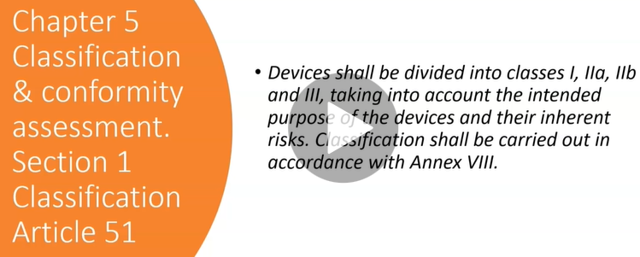

This explains that medical devices are classified according to the risk associated to the patient, the higher risk, the higher the classification.

Annex VIII contains 22 rules, which allows us to define the classification.

The medical device directive contained 18 rules, we will look at these rules in another lecture.

Once you have identified that your product is a medical device, you need to classify it, the classifications are Class I, IIa, IIb, III.

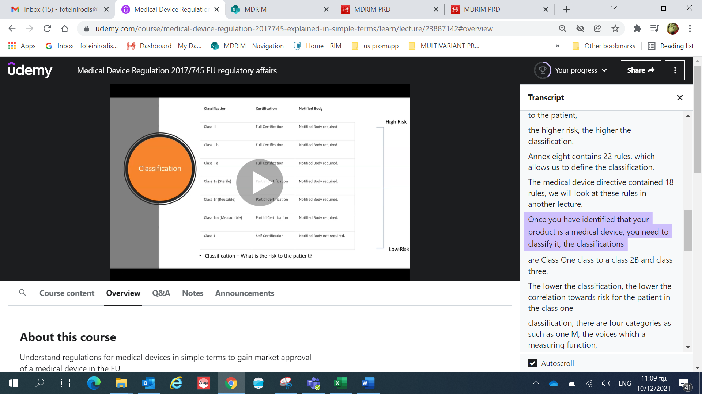

The lower the classification, the lower the correlation towards risk for the patient.

In the Class I classification, there are four categories as such as

* Class I Measuring, devices which a measuring function,
* Class I Sterile devices placed on the market in sterile conditions
* Class I Reusable, reusable surgical instruments

This is new to the medical device regulation 2017/745.

It was not in the medical device directive.

* Class I

Class I medical devices can be self certified by the manufacturer and a notified body is not required.

Please remember a competent authority can audit a manufacturer of a Class I medical device and audit the self-certification.

Class I Measuring, Class I Sterile, Class I Reusable medical devices require partial certification by a notified body, the notified body will certify the specific requirements of the product.

For example, Class I Sterile devices.

The notified body will ensure that the manufacturer is compliant with the sterilization process.

Class IIa, Class IIb and Class III need full certification and the notified body is required to do this.

What have we learned?

The classifications are divided into three classes (Class I, Class II and Class III)

To be in Class III, classification hierarchy depends on a risk to the patient.

Class I has three other categories:

Class I Measuring

Class I Sterile

Class I Reusable

Class I

Class I Reusable is a new category to the medical device regulation 2017/745.

QUIZ Classification of medical devices Introduction

classification of a medical device as mandated by the medical device regulation.

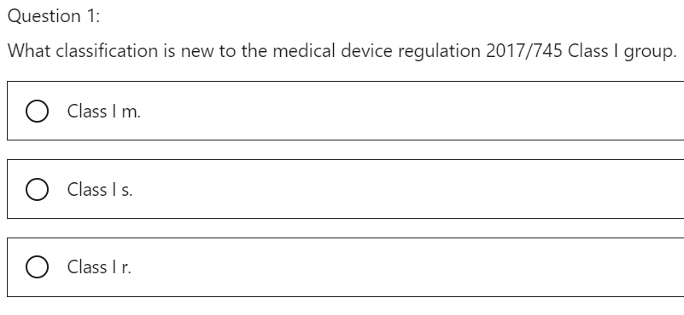

Correct. This is a class I device that will be reused. For example, a scalpel for a surgery. This class I category is new to the medical device regulation.

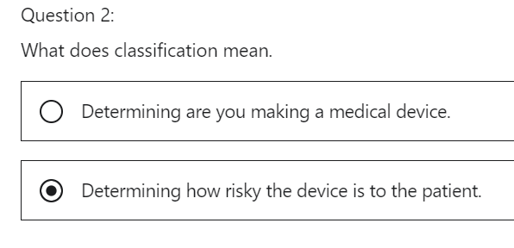

Correct. This is how we classify a device. The higher the risk the more detailed the conformity assessment will be

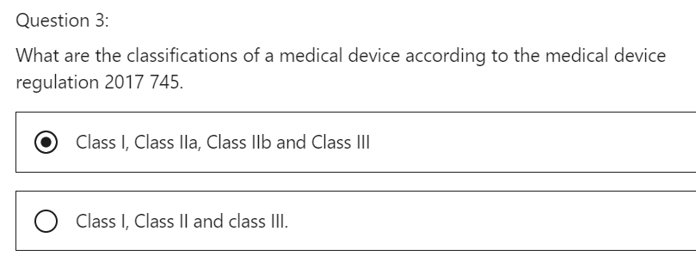

Correct. Class I medical devices are further divided into Class I m, Class I r and Class I s.

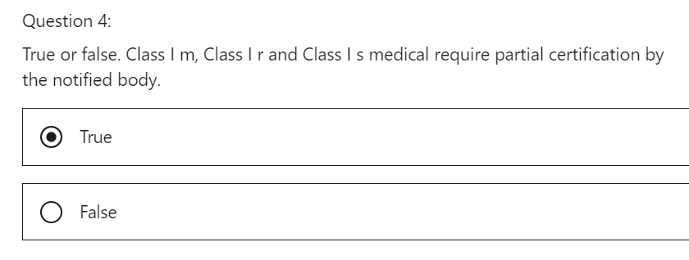

Class I m, class I r and class I s medical device requires partial certification by a notified body. The NB will certify the specific requirement of the product. For example class I s device. The NB will ensure that the manufacturer is compliant with the sterilisation process.

## 2 Qualification of a medical device

Hi, welcome to the medical device regulation, 2017/745 lecture on qualification of a medical device.

Medical device qualification, what will we learn,

determine if we are making a medical device,

the medical device regulation calls out **three primary principles**.

**Qualification**

Are you making a medical device?

We will deem this qualification in a lecture.

We will concentrate on this point.

**Classification**

Next, if you are making a medical device, then how risky is the device to the patient?

This is termed classification.

**Conformity Assessment**

Once we understand what level of classification we know what level of conformity assessment must be carried out.

Let's look at the definition of a medical device.

Which is in Chapter 1, Scope and definitions of the medical device regulation 2017/745 under Article 2 -Definitions.

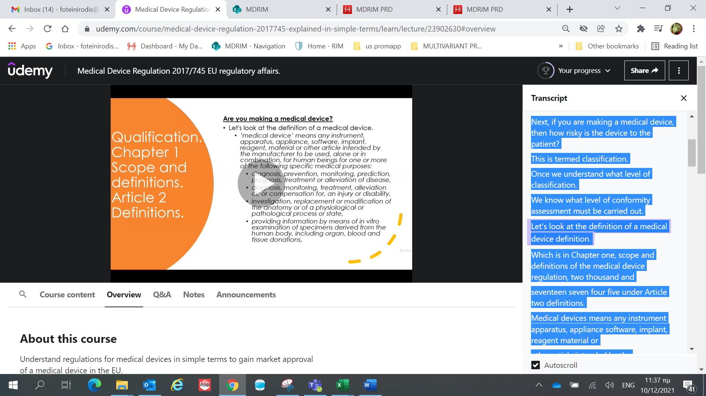

Medical devices means any instrument apparatus, appliance software, implant, reagent material or other article intended by the manufacturer to be used alone or in combination, for human beings, for one or more of the following specific medical purposes.

When you are deciding if you are making a medical device, you need to examine each definition and compare it with your medical device or products.

Next, decide if your device does the following.

* Diagnosis, prevention, monitoring, prediction, prognosis, treatment or alleviation of disease.
* Diagnosis, monitoring, treatment, alleviation of or compensation for an injury or disability.
* Investigation, replacement or modification of the anatomy or of a physiological or pathological process or state
* Providing information by means of in vitro examination of specimens derived from the human body, including organ blood and tissue donations.

This may sound like common sense, but one must remember that it is very important to decide from the beginning if it is a medical device you are making, if you are not, it is not necessary to be compliant with the medical device regulation, which will come at a cost.

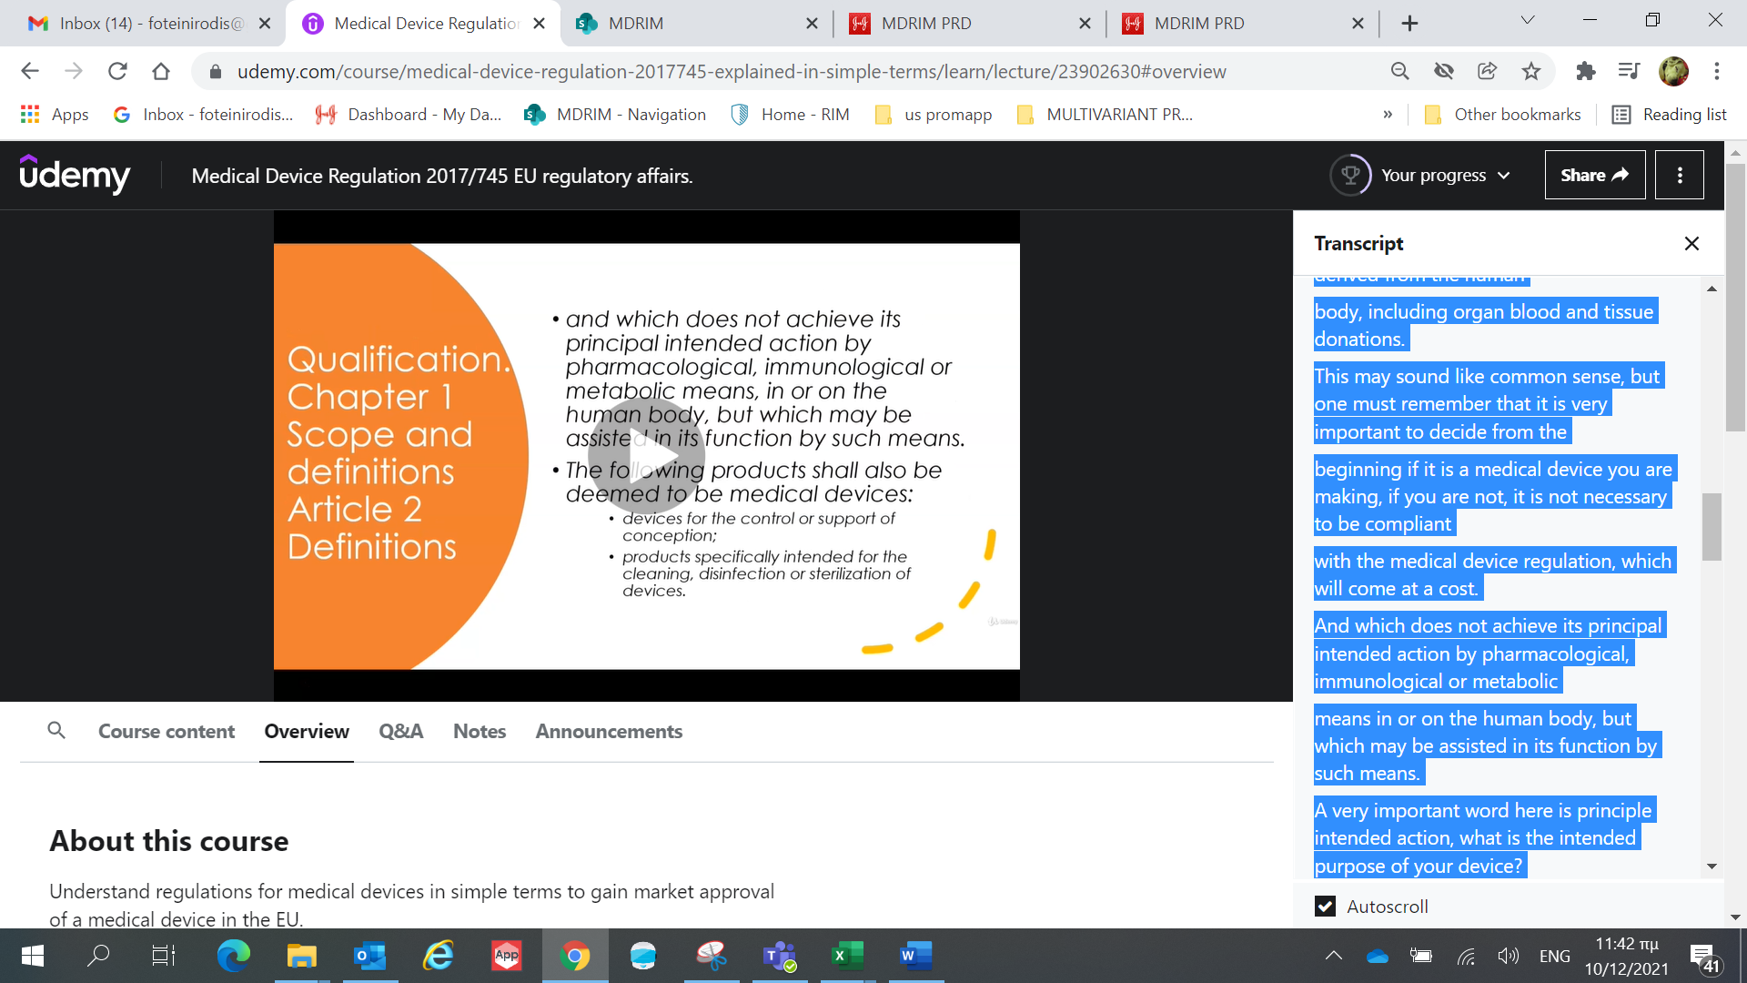

* And which **does not achieve its principal intended action** by pharmacological, immunological or metabolic means in or on the human body, but which may be assisted in its function by such means.

A very important word here is **principle intended action**, what is the intended purpose of your device?

The reason I highlight this point, as you need to determine

if the product is pharmaceutical or a medical device,

if the manufacturer determines the product is a pharmaceutical, they will need to follow the regulation associated with pharmaceuticals.

* The following products shall also be deemed to be medical devices:
  + devices for the support or control of conception
  + products specifically intended for the cleaning, disinfection or sterilization of devices.

A STENT is a medical device that is implanted into the coronary artery when there is an occlusion.

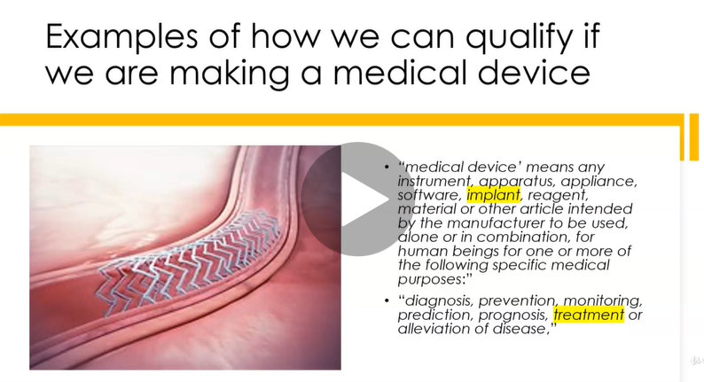

Simply put, there is a blockage that needs to be opened to allow blood to circulate to the muscles of the heart.

Let's examine the definition of a medical device under Article 2 in the medical device regulation 2017/745.

*Medical device means any instruments, apparatus, appliance, software, implant, reagent, material or other article intended by the manufacturer to be used alone or in combination for human beings for one or more of the following specific medical purposes.*

So in this case, we can say it is an implant

Let's look at the next part of the definition diagnosis, prevention, monitoring, prediction, prognosis, treatment or alleviation of disease.

In the example of the stent, it is treating the disease, which is coronary artery disease.

**HIP JOINT it is an implant**

Due to wear and tear and old age hip joints may need to be replaced.

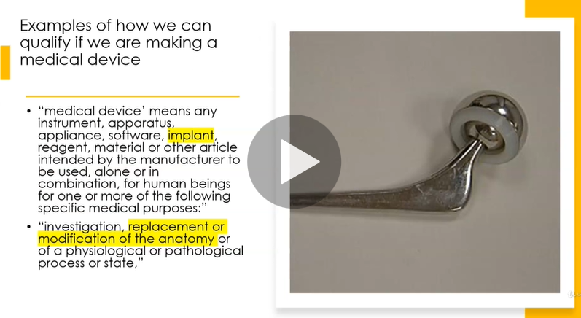

So let's look at the definition again.

*Medical devices means any instrument, apparatus, appliance, software, implant, reagent, material or other article intended by the manufacturer to be used alone or in combination for human beings for one or more of the following specific medical purposes.*

In this case, it is an implant.

Investigation, replacement or modification of the anatomy or of a physiological or pathological process or state.

In this case, it is replacing the anatomy.

HEARING AID it is an appliance

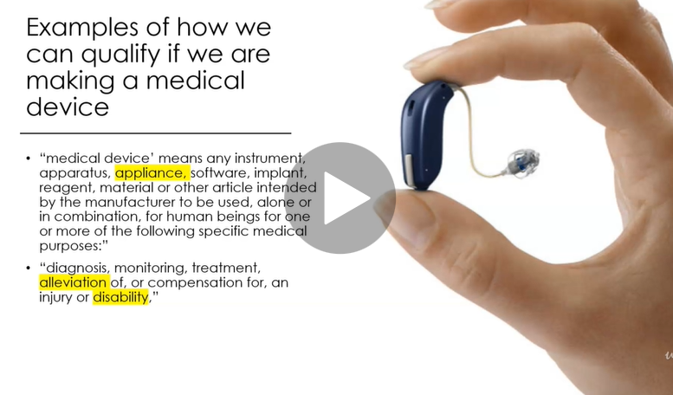

Hearing impairment or deafness is when your hearing is affected by a disease, disorder or injury which creates the disability.

Looking at the definition again,

*medical device means any instruments, apparatus, appliance software, implant, reagents, material or other article intended by the manufacturer to be used alone or in combination for human beings for one or more of the following specific medical purposes.*

So, in this example, it is an appliance.

It will alleviate the disability, which in this case is hearing impairment.

What have we learned?

There are three parts to determine when we are deciding what part of the qualification, we must be compliant to.

1. Qualification
2. classification,
3. conformity assessment

we understand how to decompose the definition of a medical device to decide if our product is a medical device.

QUIZ Qualification of a medical device

Understand how the manufacturer determines if they are making a medical device or not. We call this qualification.

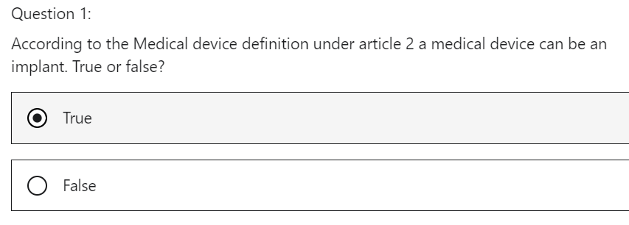

That is correct. ‘medical device’ means any instrument, apparatus, appliance, software, implant, reagent, material or other article intended by the manufacturer to be used, alone or in combination, for human beings for one or more of the following specific medical purposes

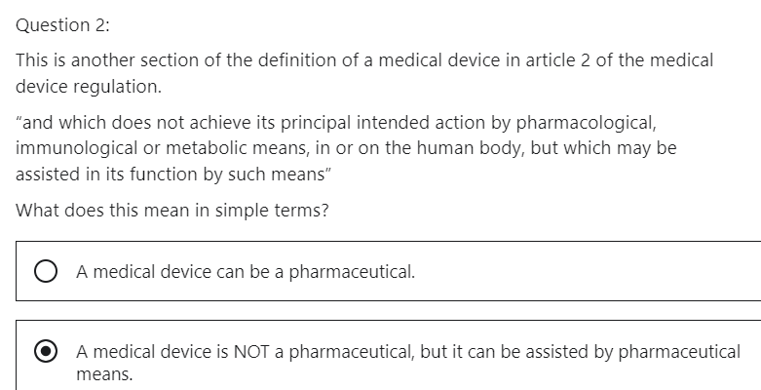

That is correct. A very important concept in the definition is principal intended action. The manufacturer needs to determine if the product is a pharmaceutical or a medical device. If the manufacturer determines the product is a pharmaceutical, they will need to follow the regulation associated with pharmaceuticals.

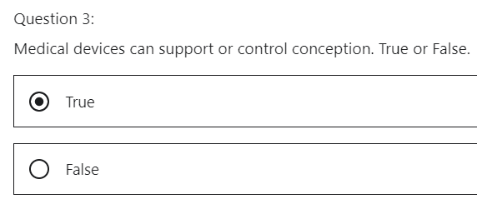

That is correct. It is stated in the definition of a medical device under article 2.

## 3 Medical Device definitions

Welcome to the Medical Device Regulation 2017/745 Lecture on definitions of medical devices.

Medical device, a definition, what will we learn?

We will understand the definitions that will help us to classify medical devices into their classification levels.

For us to be able to classify a medical device, we need to be able to understand certain definitions in relation to medical device use. These definitions will allow you to determine the classification of a medical device.

The definitions can be found in

ANNEX VIII - CLASSIFICATION RULES, CHAPTER I - DEFINITIONS SPECIFIC TO CLASSIFICATION RULES.

The first set of definitions are the **length of time the medical device will be used by the patient**

*1. DURATION OF USE*

*1.1. ‘Transient’ means normally intended for continuous use for less than 60 minutes.*

*1.2. ‘Short term’ means normally intended for continuous use for between 60 minutes and 30 days.*

*1.3. ‘Long term’ means normally intended for continuous use for more than 30 days.*

**Transient** means normally intended for continuous use for less than 60 Minutes.

An example would be a stethoscope.

**Short term**, it means normally intended for continuous use between 60 Minutes and 30 days.

An example of a short-term use would be a blood bag.

**Long term** means normally intended for continuous use for more than 30 days.

An example of a long term use medical device would be glasses.

Think about it for a second, maybe the length of time a medical device is used by a patient may affect the well-being and safety of the patient.

Therefore, there may be a correlation between the length of time and risk.

*2. INVASIVE AND ACTIVE DEVICES*

*2.1. ‘Body orifice’ means any natural opening in the body, as well as the external surface of the eyeball, or any permanent artificial opening, such as a stoma.*

*2.2. ‘Surgically invasive device’ means:*

*(a)* ***an invasive device*** *which penetrates inside the body through the surface of the body, including through mucous membranes of body orifices with the aid or in the context of a surgical operation; and*

*(b) a device which produces penetration other than through a body orifice.*

*2.3. ‘Reusable surgical instrument’ means an instrument intended for surgical use in cutting, drilling, sawing, scratching, scraping, clamping, retracting, clipping or similar procedures, without a connection to an active device and which is intended by the manufacturer to be reused after appropriate procedures such as cleaning, disinfection and sterilisation have been carried out.*

*2.4. ‘Active therapeutic device’ means any active device used, whether alone or in combination with other devices, to support, modify, replace or restore biological functions or structures with a view to treatment or alleviation of an illness, injury or disability.*

*2.5. ‘Active device intended for diagnosis and monitoring’ means any active device used, whether alone or in combination with other devices, to supply information for detecting, diagnosing, monitoring or treating physiological conditions, states of health, illnesses or congenital deformities.*

*2.6. ‘Central circulatory system’ means the following blood vessels: arteriae pulmonales, aorta ascendens, arcus aortae, aorta descendens to the bifurcatio aortae, arteriae coronariae, arteria carotis communis, arteria carotis externa, arteria carotis interna, arteriae cerebrales, truncus brachiocephalicus, venae cordis, venae pulmonales, vena cava superior and vena cava inferior.*

*2.7. ‘Central nervous system’ means the brain, meninges and spinal cord.*

*2.8. ‘Injured skin or mucous membrane’ means an area of skin or a mucous membrane presenting a pathological change or change following disease or a wound.*

What is meant by an **invasive device** which in whole or in part penetrates inside the body either through a body orifice or through the surface of the body?

A handheld dentists' mirror would be an example of an invasive medical device.

What is the definition of an **active medical device**?

any medical device operation of which depends on a source of electrical energy or any source of power other than that directly generated by the human body or gravity, and which acts by converting this energy.

An example of this would be a muscle simulator.

What is the definition of a **body orifice**?

A body orifice means any natural opening in the body as well as the external surface of the eyeball or any permanent artificial opening such as a stoma as demonstrated in the diagram an artificial opening can be made into the trachea for treatment of a disease.

What is the definition of a **surgically invasive device?**

an invasive device which penetrates inside the body through the surface of the body, including through mucous membranes of body orifices with the aid or in the context of a surgical operation and a device which produces penetration other than through a body orifice.

For example, cardiovascular catheters, which acts as a delivery mechanism for stents and balloons.

What is the definition of a **reusable surgical instrument?**

It means an instrument intended for surgical use and cutting, drilling, sawing, scratching, scraping, clamping, retracting, clipping or similar procedures without a connection to an active device and which is intended by the manufacturer to be reused after appropriate procedures such as cleaning, disinfection and sterilization have been carried out.

An example is a scalpel that is used in surgery to make an incision.

Once this medical device is used, it needs to be cleaned, disinfected and made sterile.

The medical device regulation 2017/745 has created a new subcategory called **Class I R**, which means reusable.

**Active therapeutic device**

means any active device used, whether alone or in combination with other devices to support, modify, replace, or restore biological functions or structures with a view to treatment or alleviation of an illness, injury or disability.

An external defibrillator would be an example of an active therapeutic device

Devices classified by this rule, are mostly electrical equipment used in surgery such as lasers and surgical generators.

In addition, there are devices for specialized treatment, such as radiation treatment.

Another category consists of simulation devices, although not all of them can be considered as delivering dangerous levels of energy considering the tissue involved.

**Active device intended for diagnosis and monitoring means**

any active device used, whether alone or in combination with other devices, to supply information for detecting, diagnosing, monitoring, or treating physiological conditions, states of health illnesses or congenital deformities.

This primarily covers a whole range of widely used equipment in various fields, for example, ultrasound diagnosis, capture of physiological signs and therapeutic and diagnostic radiology.

The **central circulatory** system means the following blood vessels.

It is the highway of blood vessels used to transport deoxygenated blood to the heart and lungs to get fresh oxygen, and the same system is used to take that blood rich in oxygen to the rest of the body.

The central nervous system means the brain, meninges and spinal cord

Injured skin or mucus membrane means an area of skin or a mucus membrane presenting a pathological change or change following a disease or a wound.

A mucous membrane, also known as a mucosa, is a layer of cells that surrounds body organs and body orifices. It is made from ecto dermal tissue.

As demonstrated, the mucosa membrane is in the nasal cavity, mouth, esophagus and the bronchi in the lung.

Another term for us to understand is **Continuous Use**, this will be another input to help us decide the medical device classification.

Continuous use means and uninterrupted actual use of the device of the intended purpose.

However, where usage of a device is discontinued in order for the device to be replaced immediately by the same or an identical device, this shall be considered as an extension of the continuous use of the device.

For example, a scalpel may be used on the same patient throughout an operation that may last for several hours.

The uninterrupted use for an intended purpose, i.e., cutting tissue will normally not last for more than a few seconds at a time. Therefore, a scalpel is a **transient use** device, however, where usage of a device is discontinued in order for the device to be replaced immediately by the same or an identical device example replacement of a ureter catheter, this shall be considered an extension of the continuous use

of the device.

**Intended purpose** means the use for which the device is intended, according to the data supplied by the manufacturer on the labeling, in the instructions and/or in promotional material.

The European Commission has published the Medical Device Guidance Document - Classification of Medical Devices, **MEDDEV 2.4/1 Rev.9**

This is an excellent document which is given as a resource material.

This document is correlated with the medical device directive MDD, but still is a great aid for the medical device regulation in terms of the definitions.

What have we learned

Annex VIII of the MDR explains medical device definitions,

MEDDEV 2.4/1 Rev.9 gives clarification on these definitions.

We now understand what is meant by **duration of use**.

We now understand what is meant by **continuous use**.

We now have a better understanding of the definitions within the Annex VIII by virtue of examples.

QUIZ Medical Device Definitions

This will quiz will help the learner to understand the definitions of a medical device. This will help the learner to understand how to classify a medical device.

Question 1:

True or False. Transient means normally intended for continuous use for less than 60 minutes.

True

This is correct. An example would be a stethoscope.

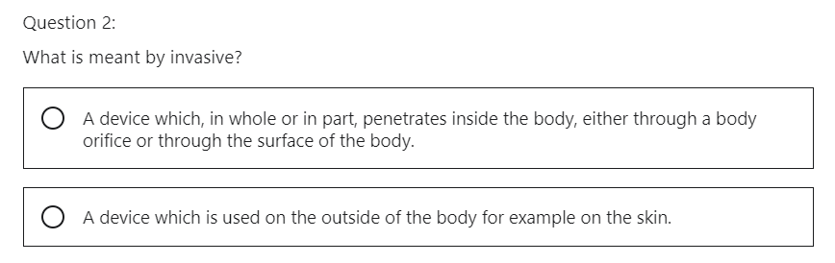

Device which penetrates inside the body

Correct. This is another important definition that must be understood to determine the classification of a medical device.

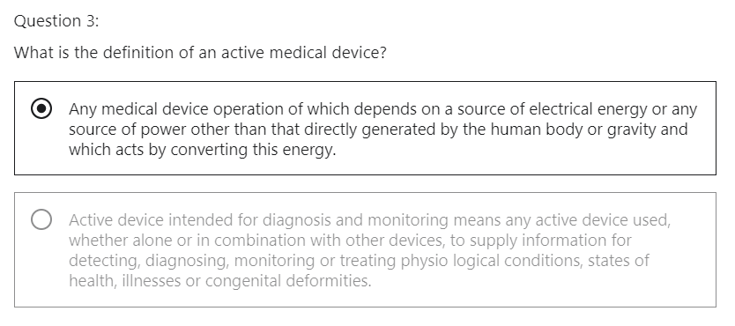

**‘Active device’** means any device, the operation of which depends on a source of energy other than that generated by the human body for that purpose, or by gravity, and which acts by changing the density of or converting that energy. Devices intended to transmit energy, substances or other elements between an active device and the patient, without any significant change, shall not be deemed to be active devices.

Software shall also be deemed to be an active device;

An example of this would be a pacemaker.

**‘Active therapeutic device’** means any active device used, whether alone or in combination with other devices, to support, modify, replace or restore biological functions or structures with a view to treatment or alleviation of an illness, injury or disability.

An external defibrillator would be an example of an active therapeutic device

Devices classified by this rule, are mostly electrical equipment used in surgery such as lasers and surgical generators.

**‘Active device intended for diagnosis and monitoring’** means any active device used, whether alone or in combination with other devices, to supply information for detecting, diagnosing, monitoring or treating physiological conditions, states of health, illnesses or congenital deformities.

This primarily covers a whole range of widely used equipment in various fields, for example, ultrasound diagnosis, capture of physiological signs and therapeutic and diagnostic radiology.

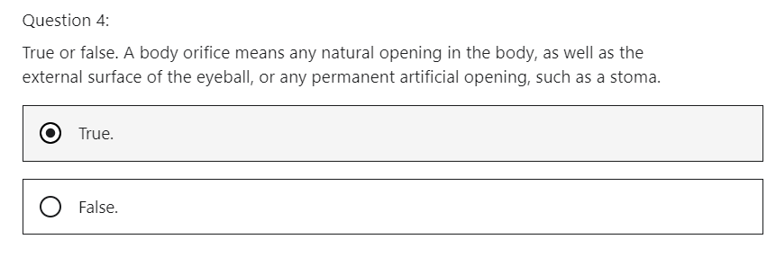

Correct. An example would an artificial opening for the trachea.

## 4 Medical Device Classification rules

Hi, welcome to the medical device regulation 2017/745, a lecture on Rules of medical device classification.

What will we learn?

We will

* understand the difference between the medical device directive MDD and the medical device regulation MDR with regard to the number of rules,
* understand the implementation of the rules.

The medical device regulation MDR calls out three primary principles in order to get the medical device certified so it can be marketed.

**Is my product a medical device? Qualification**

Are you making a medical device? we will deem this qualification.

**How risky is my medical device to the patient? Classification**

Next, if you are making a medical device, then how risky is the device to the patient? This is termed classification.

**What level of conformity assessment? Conformity Assessment**

Once we understand what is the level of classification, we know what level of conformity assessment must be carried out.

The Medical Device Directive 93/42 MDD, had **18 rules** which allowed the manufacturer to determine the classification of the medical device.

**MDD directive**

Non Invasive devices, rules 1,2,3,4

Invasive devices, rules 5,6,7,8

Active devices, rules 9,10,11,12

Special rules, rules 13, 14, 15, 16, 17, 18

The medical device regulation 2017/745 MDR, has **22 rules**, these rules can be found in Annex VIII, in CHAPTER III CLASSIFICATION RULES.

**MDR regulation**

Non Invasive devices, rules 1,2,3,4

Invasive devices, rules 5,6,7,8

Active devices, rules 9,10,11,12, 13

Special rules, rules 14, 15, 16, 17, 18, 19, 20, 21, 22

In Annex VIII, Chapter III, the rules have increased due to the fact that the medical device directive 93/42 EEC and the Medical Device Directive 90/385/EEC now come under the medical device regulation 2017/745 MDR.

New rules have been added due to

* advancements in technology and
* inclusion of devices that were not covered in the directives.

We will examine these points as we make our way through this section.

Annex VIII, Chapter II is titled Implementing Rules

* it is the responsibility of the manufacturer to classify the medical device (the MF needs to fo the classification without the NB)
* The manufacturer needs to understand the intended purpose of the medical device.

Is it a wheelchair? How does it work? What does it do?

The manufacturer needs to interpret that from the regulation.

The regulation will not tell the MF for example that a wheelchair is a Class I medical device.

* If the device works with other devices, each of them should be classified separately.
* If the device works with a novel device*, the manufacturer needs to break it up and classify each part separately.

Annex XVI explains what the novel devices are, this means *devices without an intended medical purpose.

* If it is a software that drives the device, it is the **classification of the device** and not the software that determines the classification.

If the device is Class IIa classification and it is driven by a piece of software, then the software is Class IIa.

A fluoroscope has software that drives this.

The fluoroscope falls under rule 17, which means it is a Class IIa a device.

The software that controls the fluoroscope is therefore Class IIa.

* If it is the software itself that is the medical device, then that is what gets classified.

For example, software for apps that will monitor a patient's atrial fibrillation, the most critical use of the device should be used to classify it.

* You should choose the rule with the highest risk when you determine which classification your product falls under, this will define your rules.
* When you determine which classification your product falls under, this will define the route you need to follow to submit your product for CE approval.

What have we learned

* there were18 rules in the medical device directive MDD
* the medical device regulation MDR has 22 rules
* It is the responsibility of the manufacturer to determine the classification.
* If there is a combination of devices, then each device needs to be classified.
* The classification will determine the conformity assessment route.

In this section, we have a lecture on examples of how to classify medical devices, which will illustrate

the classification process.

QUIZ MDR Rules of Medical device classification

Understand how the rules work, regarding medical device classification

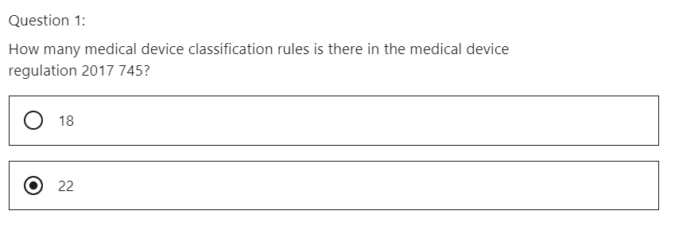

Correct. The MDR 2017/745 has 22 rules. These rules can be found in Annex VIII under chapter 3. The rules have increase because the MDD 90/385/EEC and MDD 93/42/EC now come under the MDR 2017/745. New rules have been added due to advancement in technology and inclusion of devices that were not covered in the directives

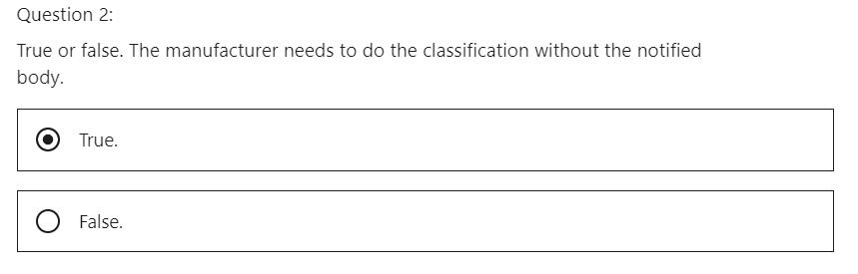

Correct. It is the responsibility of the manufacturer to classify the medical device. The manufacturer needs to understand the intended purpose of the medical device.

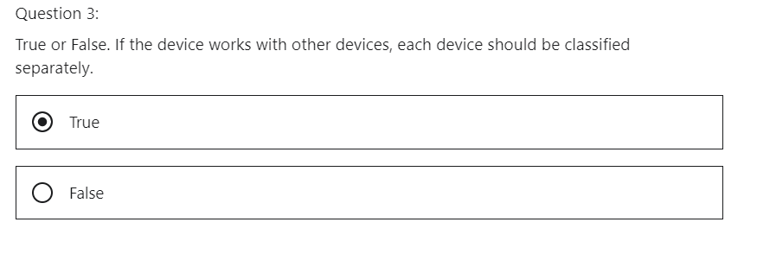

Correct. Each device would need to follow the conformity assessment according to their classification

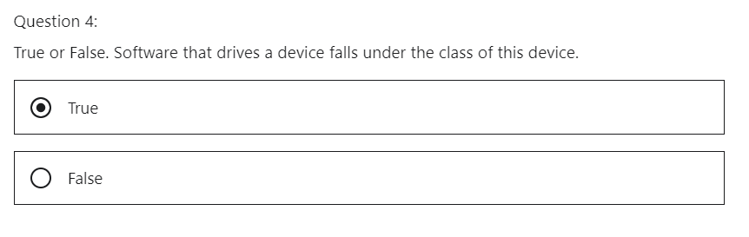

Correct. If the software drives the device and the device is a Class II a then the software is class II a.

## 5 Apply Medical Device Classification rules

Hi, welcome to the Medical Device Regulation 2017/745 lecture on applying the rules of medical device classification.

**What will we learn?**

* We will identify some products and demonstrate how to classify them.
* We will see how guidance documents can help.

The classification rules are divided into four sections

1. Non Invasive
2. Invasive
3. Active
4. Special

Go through each rule as you classify your device.

You may think you have found your answer, but continue to the rules, the point of view can change as you read through each rule.

The medical device documents kind of help, even though it is associated with the medical device directive MDD, it can be of great benefit to help classify medical devices.

This is attached as a resource document in the medical device definitions lecture in Section five.

I would remind you to open the 2017/745 MDR regulation. It is a resource material in Section one.

I would also recommend to open the medical device guidance documents as a reference point in this lecture.

**Example 1- glasses**

A pair of glasses will alleviate a disability, therefore it is a medical device.

The question is what classification of medical device is it?

A pair of glasses is non-invasive, it is the opposite of the invasive definition, which is an invasive device which penetrates inside the body through the surface of the body, including to mucous membranes of body orifices with the aid or in the context of a surgical operation and a device which produces penetration other than to a body orifice.

If a person is myopic, that means they are nearsighted.

They will wear their glasses every day.

So, it is termed long term.

Rule 1, Class I applies here, you do not need a notified body, it is a self-certification.

You can sell it to an optician who can sell it to the patient.

**Example 2 - stethoscope**

What is a stethoscope?

It is a medical instrument for listening to the action of someone's heart or breathing.

Typically having a small disc shaped resonator that is placed against the chest and two tubes connected to earpieces

The question is what classification of medical device is it?

Stethoscope is **non-invasive**, a stethoscope will be used for less than 60 minutes, so therefore it is **transient**.

So in this case, Rule 1, Class I applies, you do not need a notified body, it is a self-certification.

**Example 3 -blood bag**

A blood bag is a bag that is prefilled with blood, it is used to transfer blood into a body.

This can take one to four hours, so therefore it is **short term use**.

The blood bag is **non-invasive**.

It follows Rule.

It is classed as Class IIb, in this case, the rule calls it out:

*All non-invasive devices intended for storing blood for the purpose of eventual infusion administration or introduction into the body are classified as Class IIa if they are intended for use for channeling or storing blood or other body liquids or for storing organs, parts of organs or body cells and tissues except for blood bags.*

Blood bags are classified as Class IIb.

**Example 4 – X ray machine**

What is the intended use?

X ray machines are used to take pictures of dense tissue such as bones and teeth for diagnosis, purpose, transient use, usually less than 60 Minutes.

They fall under the special rules.

This time the rule is very specific and does little in the way of how we interpret the rule.

Rule 17: devices specifically intended for recording of diagnostic images generated by X-ray radiation are classified as Class IIa.

**Example 5 – prefilled syringe not a medical device!**

The pharmaceutical within the syringe is to treat the disease, that is the intended purpose of this device.

The syringe is the medium for the pharmaceutical.

Therefore, in this case, it is not a medical device.

So you need to follow a different regulation, you must submit a dossier to the competent authority for a drug, you need to follow Article 117 amendment to Directive 2001/83 EEC.

**Example 6 – wound irrigation solution, it is a medical device!**

**W**ound irrigation solution containing anti-microbial agents.

Now, this is an interesting classification.

I would think it is a pharmaceutical because it is a solution with an anti-microbial agents.

Let's look carefully.

It is invasive as it enters an opening into the body, and it would be transient as one would use it for less than 60 Minutes.

I would like to introduce another document: **Manual on borderline and classification in the community**

**Regulatory framework for medical devices** to help us classify the products.

The special rules apply in this case.

***8.20. Wound irrigation solutions containing antimicrobial agents***

*- Background*

*Irrigation solutions intended for mechanical rinsing are regarded as being medical devices. Topical disinfectants for use on humans are not considered to be medical devices but rather medicinal products. A number of irrigation solutions intended for mechanical rinsing contain ingredients such as chlorhexidine, cetrimide, iodine, hypochlorous acid (HOCl), free chlorine (chlorine/chloride ion Cl2/Cl-), hydrogen peroxide, hypochlorous acid, hydrogen peroxide, chlorine dioxide, sodium hydroxide, sodium chloride and sodium carbonate. Many of these ingredients have an antimicrobial effect on the body. A question arose with regard to the qualification of these products as medical devices and their classification.*

***- Outcome***

*MEDDEV 2.1/3 rev.3 states that irrigation solutions for mechanical rinsing are considered to be medical devices unless the principle intended purpose is to provide a local antimicrobial effect. The majority of wound irrigation solutions with antimicrobial action are intended primarily as wound irrigation solutions to mechanically rinse the wound whilst also reducing the bacterial load. The antimicrobial effect may be considered as an ancillary action.*

*Antimicrobial agents or substances are generally considered to be medicinal substances when intended for a medical purpose. Therefore, a wound irrigation solution containing an antimicrobial agent, irrespective of the amount of the antimicrobial substance liable to act on the body, will be considered to be* ***Class III*** *according to classification rule 13.*

*This is an excellent guidance, documents supplied by one of the working groups, borderline and classification of the Medical Device Coordination Group, MDCG working with the European Commission.*

This document is attached as a resource material.

It is a guidance document used for classification and to distinguish if a medical device is borderline to be classified higher or lower.

If we look at Section 8.20 on this guidance document, we have the following guidance,

at Section 8.20, anti-microbial agents or substances are generally considered to be medicinal substances when intended for a medical purpose.

Therefore, a wound irrigation solution containing an anti-microbial agent, irrespective of the amount of the anti-microbial substance liable to act on the body, will be considered to be Class III, according to classification rule 13, which is now rule 14 in the medical device regulation.

Guidance documents are being upgraded to correlate with the medical device regulation, they are still fantastic tools that can be used.

Rule 14 states, all devices incorporating as an integral part, a substance which, if used separately, can be considered to be a medicinal product as defined in point two of Article one of Directive 2001/83 EC, including a medicinal product derived from human blood or human plasma, as defined in point 10 of Article one of that directive.

And that has an action ancillary to that of the devices are classified as Class III.

The main idea is to wash out the wound, to irrigate the wound.

**The mechanical notion of washing the wound is the main intended purpose.**

The anti-microbial substance is an aid (ancillary).

**Example 7 – mobile application to detect heart failure**

Active

Long term use

Rule 11 and Class IIb.

In the medical device directive MDD, software was generally classified as Class I, it now has graduated to a higher level due to the advancements of software in the medical device industry.

Software can now potentially damage the health of the person.

So, software is more risky to the patients.

Understanding the intended use is very important here.

**Example 8 – coronary stent**

A stent is a collapsible mesh tube to open an occlusion in the coronary artery.

The stent is covered with an anticoagulant. The anticoagulant prevents the buildup of stenosis.

It is invasive.

It is used continuously for greater than 30 days. So it is long term use.

In this case, Rule 8 applies as it is to be used in direct contact with the heart, the central circulatory system, or the central nervous system, in which case they are Class III.

**Example 9 – anti-acid**

This was a Class I product, according to the medical device directive MDD.

It is now a Class III device.

An anti-acid creates a barrier at the top of the stomach.

So therefore, termed not a pharmacological transaction, which sees it as a medical device, and the medical device regulation applies Rule 21, class III applies as it enters the body via a body orifice, and its intended purpose is in the stomach.

The product of metabolism is systematically absorbed by the human body.

***Rule 21***

*Devices that are composed of substances or of combinations of substances that are intended to be introduced*

*into the human body via a body orifice or applied to the skin and that are absorbed by or locally dispersed in the*

*human body are classified as:*

*— class III if they, or their products of metabolism, are systemically absorbed by the human body in order to*

*achieve the intended purpose;*

*— class III if they achieve their intended purpose in the stomach or lower gastrointestinal tract and they, or their*

*products of metabolism, are systemically absorbed by the human body;*

*— class IIa if they are applied to the skin or if they are applied in the nasal or oral cavity as far as the pharynx,*

*and achieve their intended purpose on those cavities; and*

*— class IIb in all other cases.*

**Example 10 - a handheld dental mirror**

It is invasive as it enters the mouth, which is a body orifice.

It is transient as it is usually used for less than 60 minutes of continuous use.

So in this case.

Rule 5 applies, and it is a Class I device.

What have we learned?

* We have an understanding how the classification work.
* There are two documents that can help us with classification

1. MANUAL ON BORDERLINE AND CLASSIFICATION IN THE COMMUNITY REGULATORY FRAMEWORK FOR MEDICAL DEVICES
2. MEDICAL DEVICES: Guidance document - Classification of medical devices

QUIZ

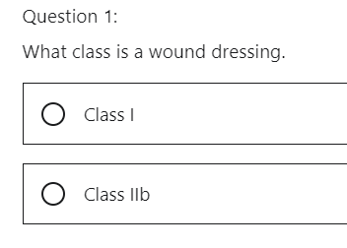

Invasive

Long term

Rule 5

Class IIb

It follows rule 4. All non-invasive devices which come into contact with injured skin: - are in Class I if they are intended to be used as a mechanical barrier, for compression or for absorption of exudates.

A wound dressing is Class I.

Correct. Rule 4. All non-invasive devices which come into contact with injured skin: - are in Class I if they are intended to be used as a mechanical barrier, for compression or for absorption of exudates.

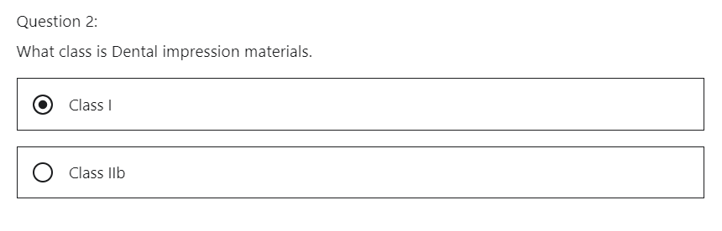

Correct. Rule 5. All invasive devices with respect to body orifices, other than surgically invasive devices and which are not intended for connection to an active medical device or which are intended for connection to an active medical device in Class I: are in Class I if they are intended for transient use for example dental impression materials.

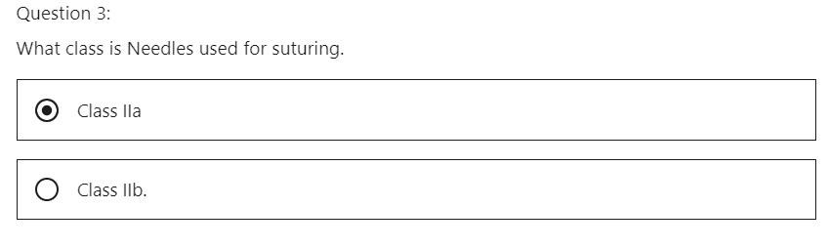

Correct. Rule 6 - Surgically invasive devices intended for transient use (< 60 minutes). All surgically invasive devices intended for transient use are in Class IIa.

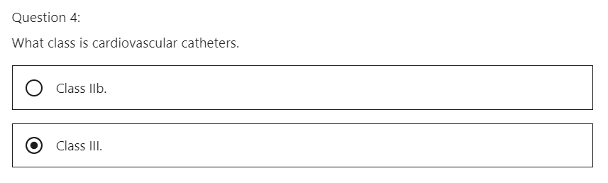

Correct. Rule 7 - Surgically invasive devices intended for short-term use (>60 minutes, <30 days). All surgically invasive devices intended for short term use are in Class IIa unless they are intended: either specifically to control, diagnose, monitor or correct a defect of the heart or of the central circulatory system through direct contact with these parts of the body, in which case they are in Class III,

# Section 6: Conformity assessment

## 1 Introduction

Hi, what will we discuss in this section?

In Section six, we will explain the annexes that the manufacturer needs to be compliant with, for all class medical devices.

We discuss the following in the section.

I will explain **the assessment routes the manufacturer must take** in accordance with the classification

of the medical device.

## 2 Class I - Conformity Assessment Path

Hi, welcome to the medical device regulation 2017/745 lecture on conformity assessment path for a Class I medical device.

What will we learn?

We will understand the conformity assessment routes to be taken for a Class I medical device.

What conformity assessments do Class I medical devices need to comply with?

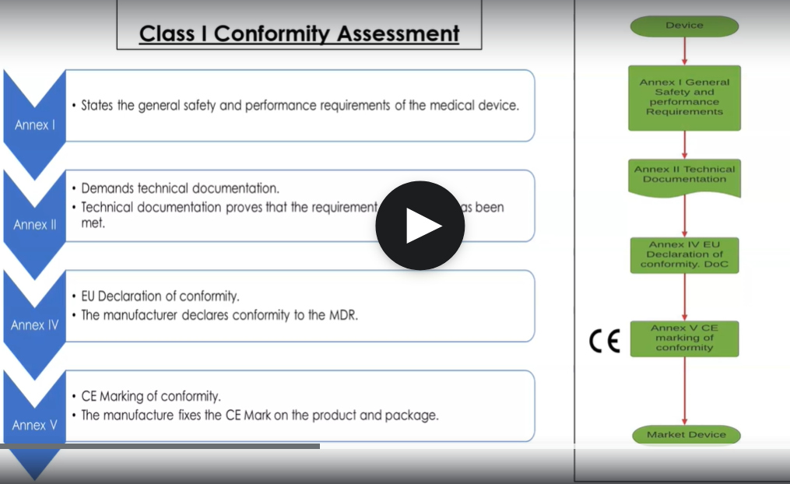

**Class I conformity assessment path**

**Step1**

Fulfill requirements of Annex I – General Safety and Performance Requirements (GSPR)

**Step 2**

Fulfill requirements of Annex II – Technical documentation, which proves the requirements of Annex I are met

**Step 3**

Sign the Declaration of Conformity DoC, Annex IV – EU Declaration of Conformity

**Step 4**

Place the CE mark on the device. No number in CE mark as a notified body is not involved

Class I, medical devices need to follow Annex I.

This states the General Safety and Performance Requirements (GSPR) of the medical device.

Annex I explains that safety and efficacy requirements must be demonstrated.

The manufacturer must prove that the device is safe, and it can perform the function that the manufacturer specifies.

Annex II demands technical documentation in the medical device directive.

This was a technical file which consisted of a design and development, a file and a medical device file.

Technical documentation proves that the requirement from Annex I has been met.

I will explain in further detail **what technical documentation consists of**, but if you can consider the following simple concepts.

1. Understand what the product is
2. understand how it works.
3. Understand how it is made
4. understand how it is compliant.

If you take those four boxes, you have a good technical document.

**Annex IV, EU Declaration of conformity**, the manufacturer declares conformity to the medical device regulation. This is known as self-certification. It is a formal statement that the product complies with the regulation. The manufacturer produces the declaration of conformity themselves. It is their responsibility that they are stating that they are compliant with the medical device regulation of **Class I medical devices**, it is signed by a responsible person within the organization.

It should be a person who understands the technical documentation of the device and knows that the device is safe and effective.

**Annex VI CE marking of conformity**, the manufacturer fixes the CE mark on the packaging.

A Class I medical device, does not need a notified body to do an assessment.

For this reason, it is known as a self-certification and there will not be a notified body number in the CE marking.

Remember, a competent authority can perform an audit of a manufacture of Class I medical devices, you need to ensure that your technical documentation is correct as you do not want your product removed from the marketplace.

**What have we learned?**

We understand the conformity assessment route for a Class I medical device.

Quiz - Understand the conformity assessment route for class I medical devices.

1 True or False. Class I medical devices are self-certified

True

Correct. The manufacturer declares conformity to the MDR. This is known as self-certification. It is a formal statement that the product complies with the regulation.

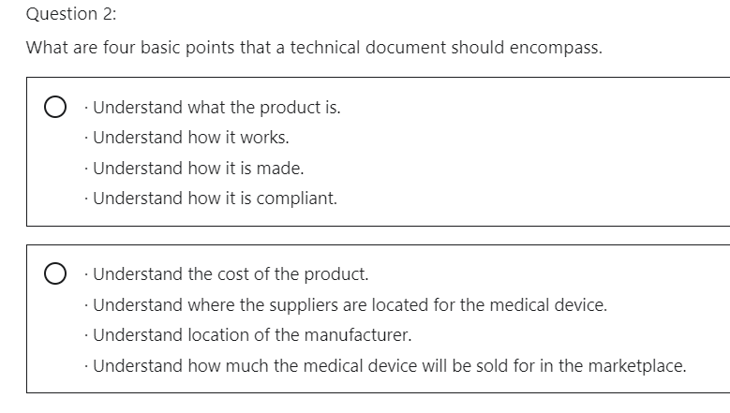

Correct. If a technical document encompasses these points the manufacturers technical document will satisfy a large portion on the regulation.

Question 3:

True or false. The CE mark for a class I medical device will have a notify body number.

False

Correct. The manufacture fixes the CE Mark on the packaging. A class 1 medical device does not need a notified body to do an assessment. For this reason, it is known as a self-certification and there will not be a notified body number on the CE Marking.

## 3 Class I (Sterile, Measuring, Reusable) - Conformity Assessment Path

Hi, welcome to the Medical Device Regulation 2017/745 Lecture on Conformity Assessment Path for Class I

* Sterile,
* Measuring,
* Reusable

medical devices.

What will we learn?

We will understand the conformity assessment route to be taken for a Class I Sterile, Measuring, Reusable device.

What conformity assessments do a Class I Sterile, Measuring, Reusable medical devices need to comply with?

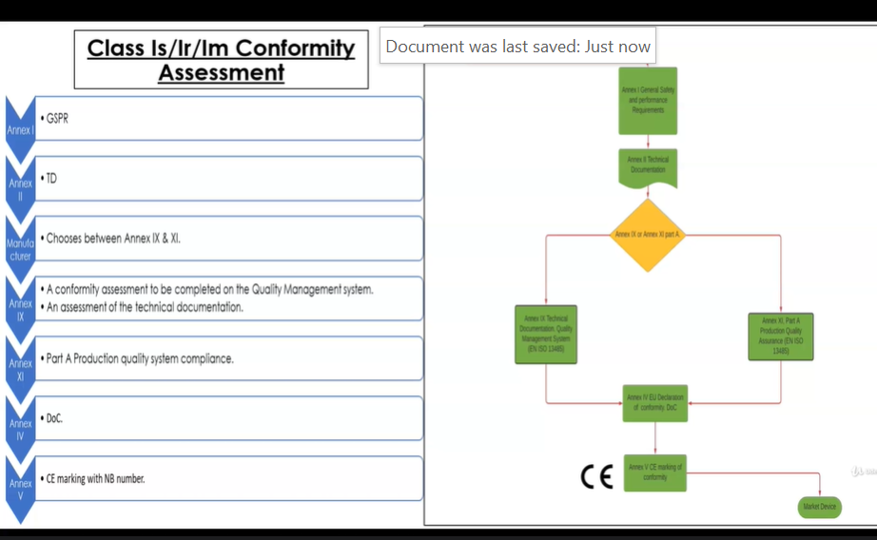

**Class I (sterile, measuring, reusable) conformity assessment path**

**Step1**

Fulfill requirements of Annex I – General Safety and Performance Requirements (GSPR) GSPR

**Step 2**

Fulfill requirements of Annex II – Technical documentation, which proves the requirements of Annex I are met

**Step 3**

Choose between Annex IX and XI

If Annex IX is chosen:

Assessment of the QMS according to ISO 13485*

Assessment of the Technical Documentation*

* only for sterile, measuring, reusable aspects!

If Annex XI is chosen:

Assessment of the production quality system (Annex XI, Part A)

**Step 4**

Sign the Declaration of Conformity DoC, Annex IV – EU Declaration of Conformity after the Notified Body inspection

**Step 4**

Place the CE mark on the device. CE mark has a number as a notified body is involved now

They need to follow Annex I and Annex II, which we have already discussed.

ANNEX I: **GENERAL SAFETY AND PERFORMANCE REQUIREMENTS (GSPR)**

ANNEX II: **TECHNICAL DOCUMENTATION**

In this case, the manufacturer can choose between:

* Annex IX (chapter I – Quality Management System and chapter III – Administrative Provisions)
* Annex XI (Part A – Production Quality Assurance)

**OPTION 1**

**What is involved in Annex IX?**

Annex IX, a conformity assessment will have to be completed on the quality management system.

* Notified body assesses the QMS according to ISO 13485

If a notified body deems that a manufacturers' quality management system is compliant to the harmonized standard ISO 13485 a certificate will be awarded.

* Notified body assesses the technical documentation

The notified body will also carry out an assessment of the technical documentation.

However, the involvement of the notified body for Class I Sterile, Measuring, Reusable medical devices procedures **shall be limited** to the aspects relating to

* Class I Sterile

establishing, securing and maintaining sterile conditions,

* Class I Measuring

to the aspects relating to the conformity of the devices, with the metrological requirements,

* Class I Reusable

to the aspects relating to the reuse of the device, in particular, clean disinfection, sterilization, maintenance and functional testing and the related instructions for use (IFU).

OPTION 2

**What is involved in Annex XI?**

The manufacturer can opt for Annex XI, Part A.

The manufacturer can mandate the notified body to assess their production quality system to ensure compliance to the medical device regulation.

The production quality system audit, would not include an audit of the design and verification of the product.

If the manufacturer passes the conformity assessment, they will obtain an annex certificate.

**Annex IV - EU, declaration of conformity**

in this case is different than a Class I device

For Class Is, Class Im, Class Ir, the notified body is involved in the process of conformity.

A prerequisite of declaring conformity is to have obtained an annex certification **or** the ISO 13485 Certification.

The manufacturer will declare declaration of conformity to the Medical Device Regulation Annex IX or Annex XI, depending on what the manufacturer mandated the notified body to do.

**Annex V CE marking**

the manufacturer will fix the CE Mark on the product and the package, this time the notified body number will be attached to the CE Mark, as the notified body will have to perform a conformity assessment based on the specificity of the class one product (sterile, measuring or reusable)

What have we learned?

We understand the conformity assessment route for

Class I Sterile medical device

Class I Measuring medical device

Class I Reusable medical device

QUIZ MDR Class Ir, Class I m, Class r conformity assessment route

Understand the assessment route that must be taken for Class I r, Class I m and Class I s medical devices.

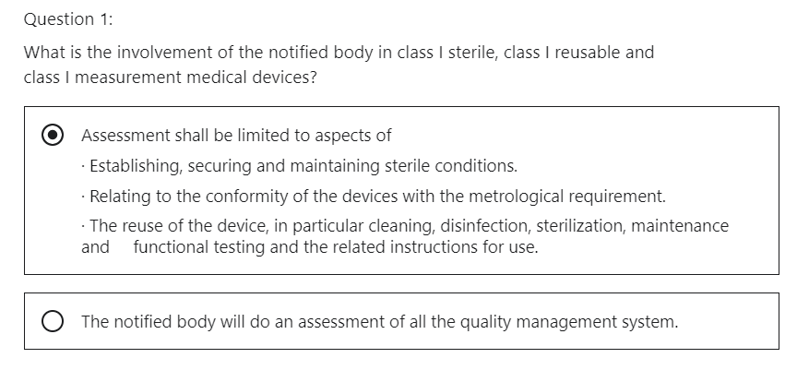

That is correct. The notified body is only concerned with these aspects.

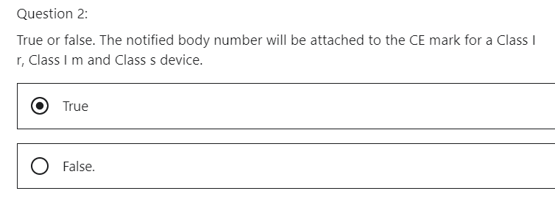

That is correct. The notified body number will be attached to the CE mark.

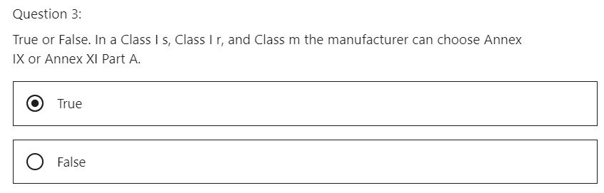

That is correct. The manufacturer can mandate the notified body to choose Annex IX or Annex XI Part A.

## 4 Class IIa- Conformity Assessment Path

Hi, welcome to the medical device regulation, 2017/745 lecture on conformity assessment path for a Class IIa medical device.

What will we learn?

We will understand that conformity assessment routes to be taken for a Class IIa medical device.

What conformity assessment do a Class IIa medical device need to comply with?

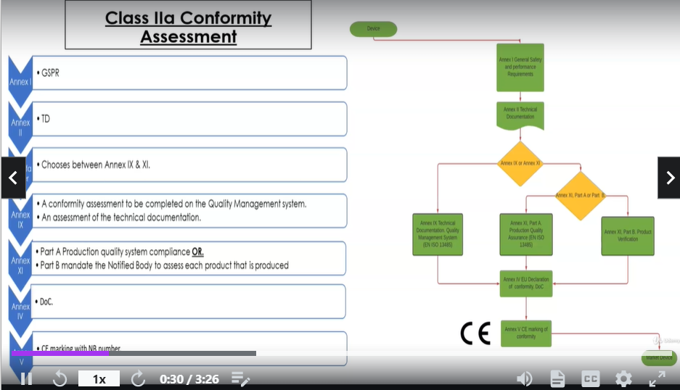

**Class IIa conformity assessment path**

**Step1**

Fulfill requirements of Annex I – General Safety and Performance Requirements (GSPR) GSPR

**Step 2**

Fulfill requirements of Annex II – Technical documentation, which proves the requirements of Annex I are met

**Step 3**

Choose between Annex IX, XI Part A, XI Part B

If Annex IX is chosen:

Assessment of the QMS according to ISO 13485*

Assessment of the Technical Documentation*

* Only for sterile, measuring, reusable aspects!

If Annex XI Part A is chosen:

Assessment of the production quality system (Annex XI, Part A)

If Annex XI Part B is chosen:

Assessment of each product that is produced

**Step 4**

Sign the Declaration of Conformity DoC, Annex IV – EU Declaration of Conformity after the Notified Body inspection

**Step 4**

Place the CE mark on the device. CE mark has a number as a notified body is involved now

They need to follow Annex one and Annex two, which we have already discussed.

Next, the manufacturer can choose between

* Annex IX or
* Annex XI.

**OPTION 1**

**Annex IX**

a conformity assessment will have to be completed on the quality management system.

If a notified body deems that a manufacturers' quality management system is compliant with the harmonized standard ISO 13485, a certificate will be awarded.

The notified body will also carry out an assessment of the technical documentation

**OPTION 2**

**Annex XI**

a conformity assessment based on product conformity verification.

This is an interesting one.

The annex is broken up into two parts, part A and Part B.

Option 2 Part A

The manufacturer can mandate the notified body to assess their production quality system to ensure compliance to the medical device regulation, which is part A.

The production quality system audit would not include an audit of the design and verification of the product.

Option 2 Part B

The manufacturer can choose Part B of the annex, the manufacturer can mandate **the notified body to assess each product that is produced**.

This would not be effective in a high-volume manufacturing environment.

This may be realized in a one-off batch or very low volume manufacturing scenario.

If the manufacturer passes the conformity assessment, they will obtain an annex certificate.

**Annex IV - EU Declaration of Conformity**

The manufacturer will declare a declaration of conformity to the medical device regulation Annex IX or Annex XI, depending on what the manufacturer mandated the notified body to do.

**Annex V - CE marking**

The manufacturer will fix the CE mark on the product and the package, the notified body number will be attached to the CE mark as the notified body will have to perform a conformity assessment.

What have we learned?

We understand the conformity assessment route for a Class IIa medical device.

QUIZ Understand the assessment route a class II a medical device must conform to

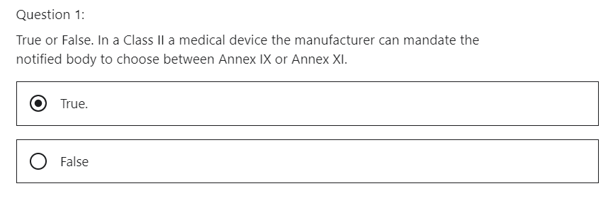

That is correct.

**Annex IX** is a conformity assessment of the **quality management system** will have to be carried out. The NB will also carry out an assessment of the **technical documentation**.

**Annex XI** is a conformity assessment based on **product conformity verification**.

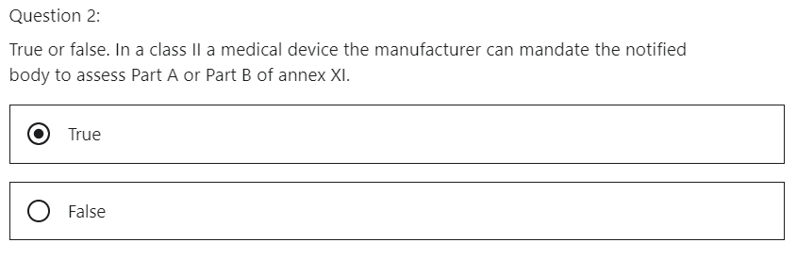

That is correct. The annex is broken up into two parts. Part A and Part B. The manufacturer can mandate the notified body to assess either part.

Part A the notified body assesses the production quality system

Part B the notified body assesses each product that is produced.

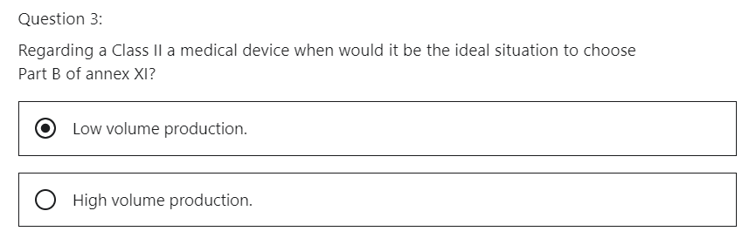

That is correct. This would not be effective in a high-volume manufacturing environment. As this part of the annex mandates the notified body to assess each product that is produced. This may be realised in a one-off batch or very low volume manufacturing scenario.

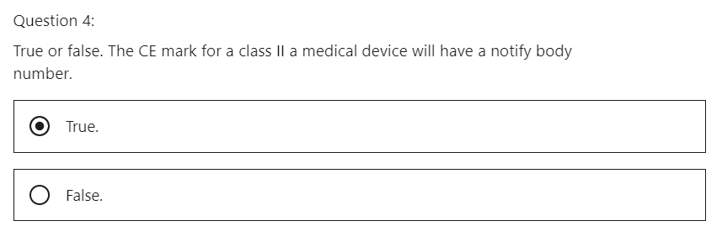

Correct. The manufacturer fixes the CE Mark on the packaging which will have the NB number who completed the conformity assessment as mandated by the manufacturer. For example, the BSI notified body number is 0086.

## 5 Class IIb- Conformity Assessment

Hi, welcome to the Medical Device Regulation 2017/745 lecture on Conformity Assessment Path for a Class IIb medical device.

**What will we learn?**

We will understand that conformity assessment route to be taken for a Class IIb medical device.

What conformity assessments do Class IIb medical devices need to conform with?

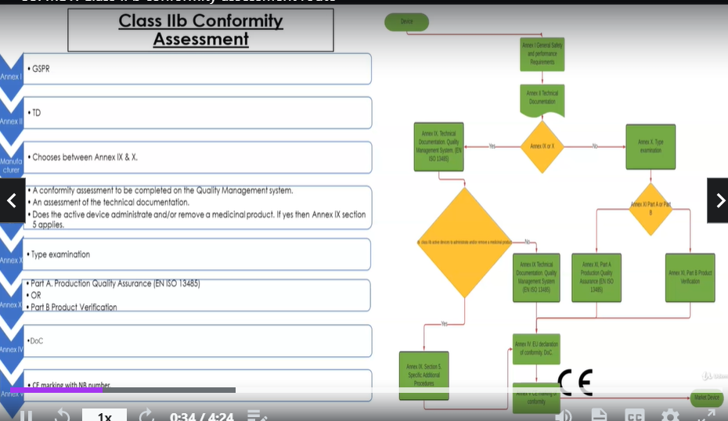

**Class IIb conformity assessment path**

**Step1**

Fulfill requirements of Annex I – General Safety and Performance Requirements (GSPR) GSPR

**Step 2**

Fulfill requirements of Annex II – Technical documentation, which proves the requirements of Annex I are met

**Step 3**

Choose between Annex IX, X, XI Part A, XI Part B

If Annex IX is chosen:

Assessment of the QMS according to ISO 13485

Assessment of the Technical Documentation

Also, if active device delivers or removes medicinal product then Annex IX, Section 5 applies

If Annex X is chosen:

EU Type Examination

If Annex XI Part A is chosen:

Assessment of the production quality system (Annex XI, Part A, ISO 13485)

If Annex XI Part B is chosen:

Assessment of each product that is produced

**Step 4**

Sign the Declaration of Conformity DoC, Annex IV – EU Declaration of Conformity after the Notified Body inspection

**Step 4**

Place the CE mark on the device. CE mark has a number as a notified body is involved now

They need to follow Annex one and Annex two, which we have already discussed.

Class IIb medical devices will need to be compliant with

1. Annex IX, assess Quality management system, assess Technical documentation
2. Annex X , EU-Type examination (Technical Documentation and representative sample of the device)
3. Annex XI, assess Product conformity.

**OPTION 1 annex IX**

the manufacturer can opt for Annex IX.

A conformity assessment will have to be completed on the quality management system.

If a notified body deems that the manufacturer’s quality management system is compliant, the harmonized Standard ISO 13485 certificates will be awarded.

The notified body will also carry out an assessment of the technical documentation.

If the Class IIb medical device is active and it administrates or removes a medicinal product, then Section five of Annex IX applies.

Assessment of quality management system according to ISO 13485

Assessment of technical documentation

OPTION 2

**Annex X is known as a conformity assessment by type examination.**

Annex X will be a certificate issued by the notified body.

That production is audited and a representative sample of that production is tested by the notified body in addition to the technical file review.

There is no audit of the development process, just the results.

OPTION 3

**Annex XI, which is a conformity assessment based on product conformity, verification.**

This is an interesting one.

The annex is broken up into two parts Part A and Part B

Option 3 Part A

The manufacturer mandates the notified body to assess their **production quality system** to ensure compliance to the medical device regulation, which is part A.

The production quality system audit would not include an audit of the design and verification of the products.

Option 3 Part B

The manufacturer can choose Part B of the annex.

The manufacturer can mandate the notified body to **assess each product that is produced**.

This would not be effective in a high-volume manufacturing environment.

This may be realized in a one-off batch or very low volume manufacturing scenario.

If the manufacturer passes the conformity assessments, they will obtain an annex certificate

**Annex IV - Declaration of conformity**

in Class IIb the notified body is involved in the process of conformity, the manufacturer will declare a declaration of conformity to the medical device regulation.

**Annex V - CE marking**

The manufacturer will place the CE Mark on the product and package, this time the notified body number will be attached to the CE Mark as the notified body will have to perform a conformity assessment.

**What have we learned?**

We understand the conformity assessment route for Class IIb medical device.

QUIZ

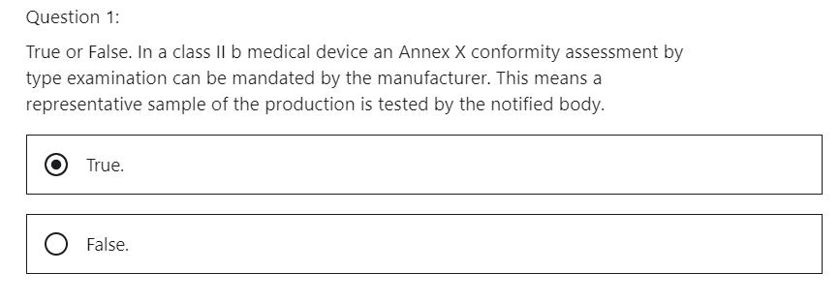

That is correct. Annex X will be a certificate issued by the Notified Body. What does this mean? The production is audited, and a representative sample of the production is tested by the notified body in additional to the technical file review. There is no audit of the development process just the result.

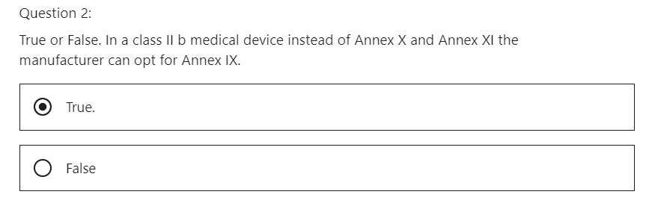

That is correct. A conformity assessment will have to be completed on the Quality Management system. If a notified body deems that a manufacturers QMS is compliant the harmonised standard ISO 13485 certificate will be awarded. The NB will also carry out an assessment of the technical documentation.

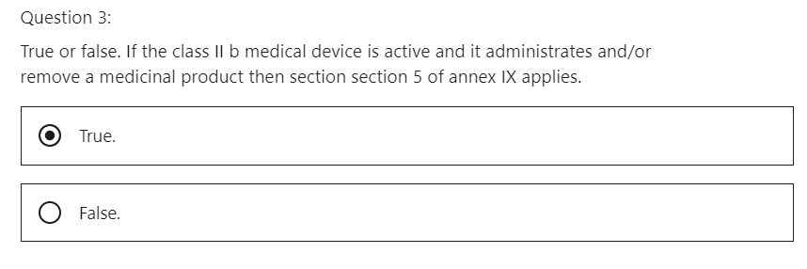

That is correct. An expert panel will be needed to help the NB to review scientific clinical evidence in their field to evaluate clinical data. The primary objective is to ensure that device is safe.

## 6 Class III- Conformity Assessment

Hi, welcome to the medical device regulation 2017/745 lecture on conformity assessment path for Class II medical devices.

**What will we learn?**

We will understand that conformity assessment route to be taken for a Class III medical device.

**What conformity assessments do Class III medical devices need to conform with?**

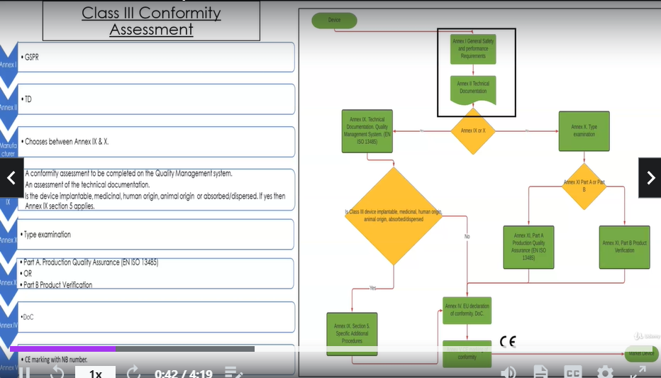

**Class III conformity assessment path**

**Step1**

Fulfill requirements of Annex I – General Safety and Performance Requirements (GSPR) GSPR

**Step 2**

Fulfill requirements of Annex II – Technical documentation, which proves the requirements of Annex I are met

**Step 3**

Choose between Annex IX, X, XI Part A, XI Part B

If Annex IX is chosen:

Assessment of the QMS according to ISO 13485

Assessment of the Technical Documentation

Also, if device is implantable, is medicinal, is of human origin, is absorbed/dispersed then Annex IX, Section 5 applies.

If Annex X is chosen:

EU Type Examination

If Annex XI Part A is chosen:

Assessment of the production quality system (Annex XI, Part A, ISO 13485)

If Annex XI Part B is chosen:

Assessment of each product that is produced

**Step 4**

Sign the Declaration of Conformity DoC, Annex IV – EU Declaration of Conformity after the Notified Body inspection

**Step 4**

Place the CE mark on the device. CE mark has a number as a notified body is involved now

They need to follow Annex one and Annex two, which we have already discussed.

Class III medical devices will need to be compliant with

* Annex IX or
* Annex X or
* Annex XI

**Annex IX**

a conformity assessment will have to be completed on the quality management system if a notified body deems that a manufacturer's quality management system is compliant, the Harmonized Standard ISO 13485 certificate will be awarded.

The notified body will also carry out an assessment of the technical documentation.

If a Class III medical device is implantable, medicinal, human origin, animal origin, or absorbed or dispersed then Section 5 of Annex IX applies, which is specific Additional procedures.

**Annex X is known as a conformity assessment by type examination.**

Annex X will be a certificate issued by the notified body.

What does this mean?

That production is audited and a representative sample of that production is tested by the notified body in addition to the technical review, there is no audit of the development process, just the results.

**Annex XI, which is a conformity assessment based on verification of product conformity.**

The annex is broken up into two parts, Part A and Part B.

The manufacturer can mandate the notified body to assess their production quality system to ensure compliance to the medical device regulation, which is part A.

The production quality system audit would not include an audit of the design and verification of the product.

The manufacturer can choose Part B of the annex XI.

The manufacturer can mandate the notified body to assess each product that is produced.

This would not be effective in a high-volume manufacturing environment.

This may be realized in a one-off patch or very low volume manufacturing scenario.

If the manufacturer passes the conformity assessments, they will obtain an Annex XI certificate.

**Annex IV - EU declaration of conformity DoC**

For Class III devices the notified body is involved in the process of conformity.

The manufacturer will declare a declaration of conformity to the medical device regulation.

**Annex V - CE marking**

the manufacturer will fix the CE mark on the product and package, this time the notified body number will be attached to the CE Mark as a notified body will have to perform a conformity assessment.

What have we learned?

We understand the conformity assessment rules for a Class III medical device.

QUIZ Understand the conformity assessment route for a class III medical device.

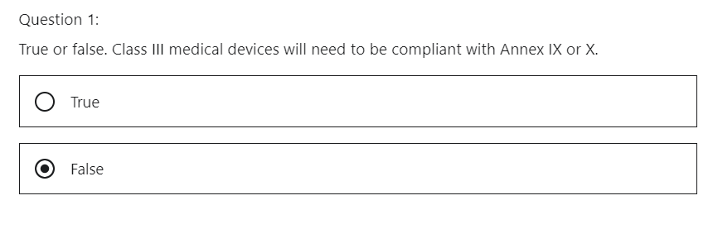

True !!

That is correct. Class III is the highest risk category product so conformity assessment will be more detailed.

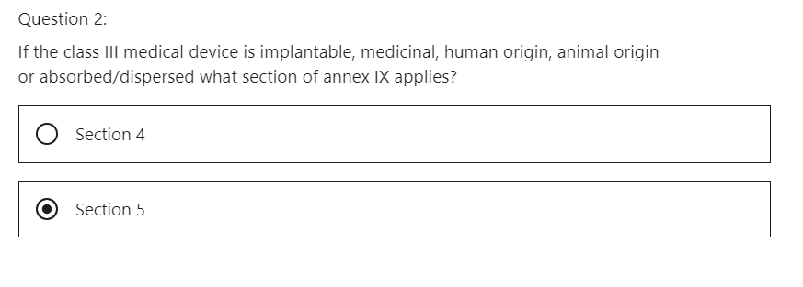

That is correct. Section 5 of annex IX applies which is “specific additional procedures". It demands support from an expert panel. The expert panel will have a competence in implantable, medicinal, human origin, animal origin medical devices.

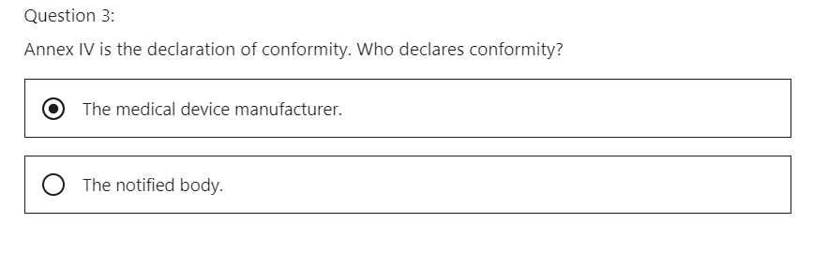

That is correct. The manufacturer will declare declaration of conformity to the Medical device regulation after the manufacturer has passed the conformity assessment via the notified body.

# Section 7: Sufficient Clinical Data

## 1 Introduction

Hi, what will we discuss in this section, we will discuss **sufficient clinical data**.

Section seven will explain what is sufficient clinical data, how does the manufacturer prove that the device is safe and effective?

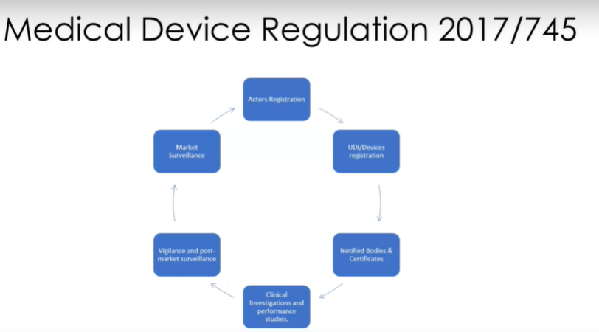

Actors Registration

UDI/Devices Registration

Notified Bodies & Certificates

Clinical investigation and Performance studies

Vigilance and Post Market Surveillance

Market Surveillance

This is done by preclinical studies and continuing to collect clinical data while the medical device is in the marketplace.

The learner will understand

* what **General Safety and Performance Requirements (GSPR)** mean regarding compliance to the medical device regulation 2017/745
* what the **intended purpose** is and how this is broken up into certain sections.
* **Sufficient clinical data, clinical evaluation**, what clinical evaluation is.
* **Sufficient clinical data, Post market, clinical follow up**, this means collecting clinical data on the medical device while it is in the marketplace.

## 2 General Safety and Performance Requirements (GSPR)

Hi, welcome to the MDR 2017/745 lecture on the General Safety and Performance Requirements (GSPR).

What will we learn?

* Understand Annex I GSPR

which is the General Safety and Performance Requirements (GSPR) that the regulation mandates of the medical device.

* Understand Annex I, Chapter I, General Requirements.
* Understand Annex I, Chapter II, Design and Manufacturing.
* Understand Annex I, Chapter III, Labels and instructions for use (IFU).
* Understand how Standards and Guidelines support the manufacturer to comply with the General Safety and Performance Requirements (GSPR)

The General Safety Performance Requirements, (GSPR) are located in Annex I of the MDR 2017/745.

**What is Annex I, GSPR?**

It is really a list of requirements that the medical device needs to comply with, formally called the essential requirements from the MDD.

The MDR 2017/745 has 23 topics to comply with.

The MDD 93/42 had 13 essential requirements

The AIMDD 90/385 had 16 essential requirements.

When you consider that the MDD and the AIMDD have merged into the MDR, one could consider there are less requirements. This is not necessarily true, as there were a lot of the requirements that were common in the directives.

The **Annex I, GSPR is the foundation of compliance** which a medical device manufacturer must be compliant with.

The manufacturer needs to prove compliance to the General Safety and Performance Requirements (GSPR) to gain CE marking.

In this lesson, we would examine some of the requirements.

The manufacturer cannot take the essential requirements from the MDD and transfer them to the medical device regulation MDR. One must begin again.

The manufacturer must take each point in the Annex I General Safety Performance Requirements, (GSPR), like a checklist and ensure they are complying to each point.

**The General Safety Performance Requirements, (GSPR) is the beginning point to see if you are compliant with the medical device regulation.**

**The Annex I, General Safety and Performance Requirements (GSPR) is broken into three chapters.**

* Annex I GSPR, CHAPTER I, GENERAL REQUIREMENTS

Chapter one is the general requirements, which follows point 1 to point 9

* Annex I GSPR, CHAPTER II, REQUIREMENTS REGARDING DESIGN AND MANUFACTURE

Chapter two is the design and manufacturing requirements, which goes from point 10 to point 20.

* Annex I GSPR, CHAPTER III, REQUIREMENTS REGARDING THE INFORMATION SUPPLIED WITH THE DEVICE

Chapter three, which is the label and instruction for use (IFU) requirements, and it is point 23.

This may be deceiving as there is a lot of subsections under this point.

Annex I GSPR, **CHAPTER I, GENERAL REQUIREMENTS** is mandatory for the manufacturer.

Point 9 is specifically for Annex XVI, which relates to a device that does not have an intended medical purpose. So therefore, it will not cover all medical device manufacturers and they will not have to be compliant with point 9.

ANNEX XVI, LIST OF GROUPS OF PRODUCTS WITHOUT AN INTENDED MEDICAL PURPOSE REFERRED TO IN ARTICLE 1(2)

Annex I GSPR, **CHAPTER II, REQUIREMENTS REGARDING DESIGN AND MANUFACTURE** mandates what requirements the manufacturer needs to be compliant with, with regard to design and manufacture of the medical device.

Annex I GSPR, **CHAPTER III, REQUIREMENTS REGARDING THE INFORMATION SUPPLIED WITH THE DEVICE** explains what is required on the label of the device and instruction for use (IFU).

The manufacturer needs to read each point in the annex, some of the requirements of the annex may not be within the scope of your device.

For example, if your device is a scalpel, it does not have its own energy source.

Therefore, point 18 active devices and devices connected to them, may be not applicable in this case, but the manufacturer must be able to explain this.

Let's look at each chapter in more detail.

**Annex I GSPR, CHAPTER I, GENERAL REQUIREMENTS**

Device Performance.

Can the manufacturer prove your device works as intended?

Can the manufacturer prove that the device is compliant with the risk management plan?

Can the manufacturer prove that the benefits of the device outweigh the risk?

Can the manufacturer prove that they can store and transport the device and it will not have an adverse impact on the device?

As previously stated, CHAPTER I is normally applicable to most of your products, except for point nine, which pertains to Annex XVI, which is for devices for non-medical intended purpose.

**Annex I GSPR, CHAPTER II, REQUIREMENTS REGARDING DESIGN AND MANUFACTURE**

Here we are examining the **chemical, physical and biological properties of the material** that the manufacturer uses to build their medical device

The manufacturer has to ensure compliance, fulfill particular requirements.

It is the material and the device fulfilling their intended purposes.

The materials that are used in the device must not pose a threat to the patient and user.

CMR means substances which are Carcinogenic, Mutagenic or toxic to Reproduction.

The general safety performance requirements calls out that, the material in that device will not produce adverse events such as CMR.

The manufacturer will have to prove compliance with this and may need to employ an accredited lab to prove this compliance and the EU Commission are in the process of organizing these guidelines to support the medical device regulation MDR.

Phthalates are chemicals that are introduced to plastics to soften them.

The general safety and performance requirements calls out that, the amount of phthalates that are put into a medical device needs to be safe for a user and a patient.

Again, the EU Commission are in the process of organizing these guidelines to support the medical device regulation MDR.

**As we continue, what other General Safety and Performance Requirements (GSPR) need to be adhered to?**

* According to point 10 to point 22, we need to consider infection and microbial contamination.

The device needs to reduce infection to patients.

If you are manufacturing a reusable, invasive medical device, it needs to be designed in such a way that it can be effectively cleaned, disinfected and sterilized.

* Does the device need to be completed in a sterile condition at the end of the manufacturing process?

If so, packaging for sterile devices need to be adhered to.

* Devices incorporating medicinal substances need to follow General Safety Performance Requirements, (GSPR) compliance.
* Devices, incorporating material of biological origin, need to follow General Safety Performance Requirements, (GSPR) compliance.
* Construction of devices and interaction with their environment

maybe the device can damage the environment.

Is radiation being used?

Can the environment damage the device?

* Devices with a diagnostic or measuring function need to be compliant with calibration
* Protection against radiation for the user and the patient.

Some devices can emit electromagnetic radiation.

* Electronic programmable systems need to be compliant with validation, for example.
* Active devices and devices connected to them
* Requirements for active implantable devices,
* Protection against mechanical and thermal risks,
* Protection against the risks posed to the patient or user by devices supplying energy or substances.
* Protection against risk posed by medical devices intended by the manufacturer for use by laypersons

All these points need to be addressed through the General Safety Performance Requirements, (GSPR), Annex one in which the manufacturer can create a checklist and have it as part of the technical documentation.

Remember, the medical device may not come within the scope of some of these points.

Annex I GSPR, **CHAPTER III, REQUIREMENTS REGARDING THE INFORMATION SUPPLIED WITH THE DEVICE**

In Chapter three, it is covered by point twenty-three, but there are a lot of sections within this point.

* General requirements regarding the information supplied by the manufacturer
* information on the label
* information on the packaging which maintains the sterile condition of a device, “sterile packaging”
* information in the instructions for use (IFU)

There is a lot of requirements for the labeling of the device.

For example, date of manufacture and date of expiry

Standards can be used to help label the device.

**How can we demonstrate to a notified body that we are compliant to the General Safety Performance Requirements, (GSPR)?**

We can use harmonized standards.

The EU Commission publishes the standards that can be used to demonstrate conformance with the regulation.

A caveat here is that the EU Commission has not published standards for the medical device regulation MDR 2017/745 yet but this work is currently underway.

The standards are attached as a resource to this lecture, and they are related to MDD 93/42 and AIMDD 90/385

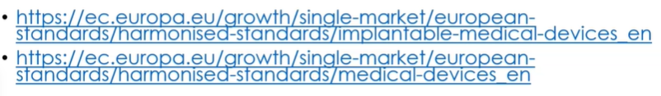

A harmonized standard is recognized by the European Union.

If the manufacturer can show compliance to these standards, it can then demonstrate to a notified body that they are compliant to the General Safety Performance Requirements, (GSPR).

There are two other areas where a manufacturer can gain support to demonstrate compliance, and that is

* MEDDEV Guidance Documents and the
* MDCG Guidelines

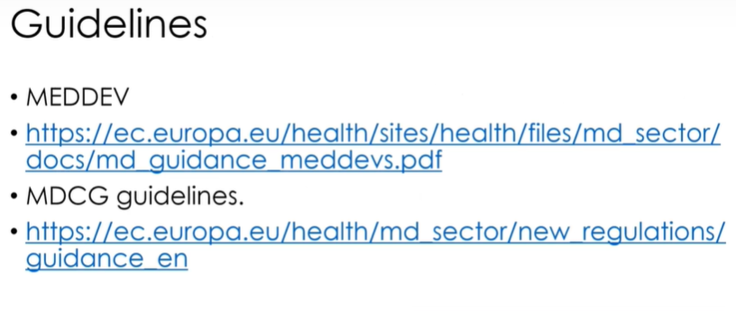

MEDDEV = MEDical DEVices Documents

MEDDEV stands for MEDical DEVices Documents.

The MEDDEV Guidance Documents are developed by various working groups on behalf of the European Commission to assist stakeholders in implementing directives related to medical devices.

The MEDDEVs promote a common approach to be followed by manufacturers and notified bodies that are involved in conformity assessment procedures.

Although the guidelines are not legally binding, it is expected that the guidelines be followed, ensuring the uniform application of relevant directive provisions.

MDCG = medical device coordination group

Members of the MDCG are the competent authorities of the EU Member States

For example, if we are trying to be compliant with the Clinical Evaluation Report, we need to mention MEDDEV, 2.7.1 revision 4.

We can say we are compliant with guidelines as well as standards.

Again, I have these as resource documents to this lesson.

**What have we learned?**

Understand Annex I GSPR

Understand Annex I GSPR Chapter one general requirements.

Understand Annex I GSPR Chapter two, design and manufacturing.

Understand Annex I GSPR Chapter three labels and instruction for use (IFU).

Understand how standards and guidelines support the General Safety Performance Requirements, (GSPR).

**QUIZ Annex I, GSPR**

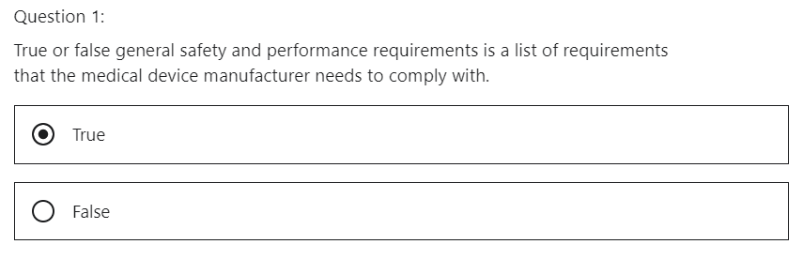

Correct. Formally called the essential requirements from the medical device directive

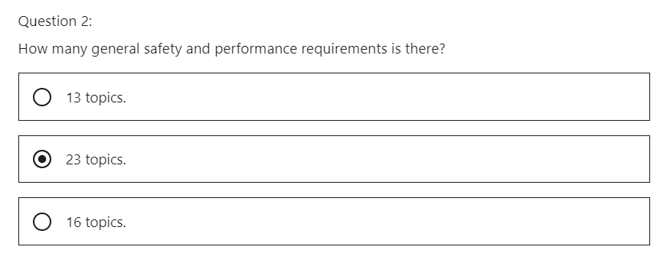

The EU MDR 2017/745 has 23 topics to comply with.

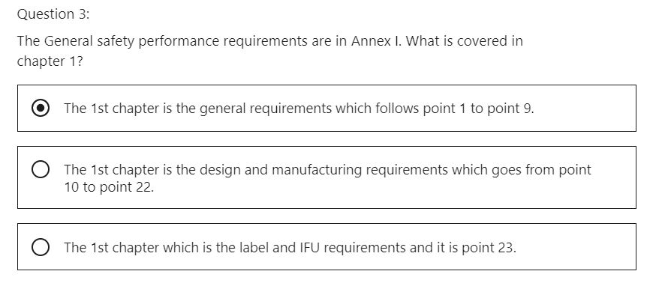

Correct. Chapter 1 is mandatory for the manufacturer

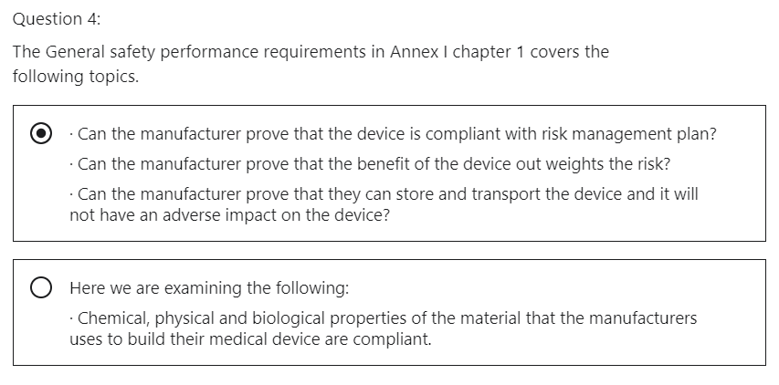

Correct. Can the manufacturer prove that the device works as intended?

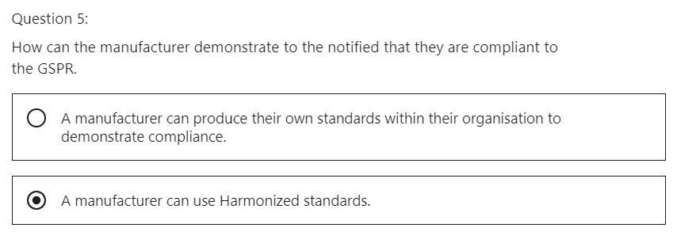

Correct. The EU commission publishes the standards that can be used to demonstrate conformance with the regulation.

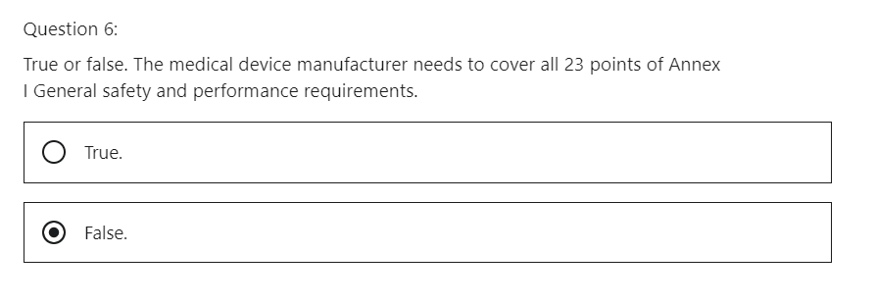

Correct. Some of the requirements of the annex may not be within the scope of your device. Point 9 is specifically for Annex XVI which relates to a device that does not have an intended medical purpose. So therefore, it will not cover all medical device manufacturers and they will not have to be compliant with point 9.

## 3 Intended Purpose

Hi, welcome to the medical device regulation MDR 2017/745 lecture on the Intended Purpose.

What will we learn:

* **INTENDED PURPOSE** of the medical device.
* **Intended Population** (patient population)
* **Indications for Use** (under which circumstances doctor advises to use the medical device)
* **Intended User** (who will use the medical device)
* **Intended Use** (how will the medical device be used)
* **Claims** (the manufacturer claims that the medical device has a certain Performance, certain Benefit and also a certain Risk)

* Indication = In medicine, a sign, symptom, or medical condition that leads to the recommendation of a treatment, test, or procedure.

In **CHAPTER I - SCOPE AND DEFINITIONS, Article 2 - Definitions, paragraph 12**, there is a definition of the INTENDED PURPOSE.

(12) ‘intended purpose’ means the use for which a device is intended according to the data supplied by the manufacturer on the label, in the instructions for use or in promotional or sales materials or statements and as specified by the manufacturer in the clinical evaluation.

To me, this definition is not very clear.

I will explain it in simple terms.

The reason why I highlight it is because it performs the basis of the general safety and performance requirements, ANNEX I - GENERAL SAFETY AND PERFORMANCE REQUIREMENTS.

ANNEX II - TECHNICAL DOCUMENTATION, The Technical Documentation in ANNEX II, helps the manufacturer write the instructions for use, it will establish the clinical evaluation plan the manufacturer will develop to prove efficacy and safety.

The INTENDED PURPOSE is the description of the medical problem that you want to address, which your medical device wants to alleviate.

For example, the medical device, a drug eluting stent, wants to alleviate coronary artery disease.

* alleviate = make (suffering, deficiency, or a problem) less severe.

The medical problem in this case is coronary artery disease and the medical device is the drug eluting stent.

Therefore: intended purpose = coronary disease alleviation

**INTENDED PURPOSE**

Intended purpose is the general description of purpose of your device (for what purpose are we using the medical device?)

**Intended Use**

The intended use is part of the Intended Purpose.

The Intended Use is a description of how you meant to use the device (how to use the medical device).

The manufacturer can use the following guidelines to help define the intended purpose.

**INTENDED PURPOSE** of the medical device

**1 - Intended Population**

e.g., the manufacturer states that the medical device is to be used on adults from the age of 18 to 65

**2 -** **Indications for Use**

The manufacturer states that the device is for a person with a certain type of disease.

**3 - Intended User**

The manufacturer states who the user is, will it be a lay person, the patient, or the doctor.

**4 - Intended Use**

The manufacturer must explain how to use the device

**5 – Claims** (Performance and Benefit vs Risk)

The manufacturer defines what he claims that the medical device does.

For example, manufacturer CLAIMS that the drug eluting stent can open a coronary artery occlusion, from 8 millimeters to 32 millimeters in length and prevent restenosis within a five-year period.

The manufacturer needs to prove these claims are true, by providing preclinical and clinical trials or equivalents.

This will be explained in further detail in this section.

**1 - Intended Population ANALYSIS**

Intended Patient Population

Who will use your device?

For example, demographic's the device may exclude children up to a certain age.

Other example, the manufacturer may not want the device to be used on pregnant women.

Another example could be that the device cannot be used on certain skin pigmentation.

The manufacturer must be thinking of these items as they work their way to developing the intended purpose.

**2 - Indications for Use ANALYSIS**

Will the medical device improve the health of a person who is already healthy?

Does the medical device help a person with a certain disease?

The manufacturer will also state **contraindications**.

This means that the manufacturer will specify the disease the device will not treat.

For doctors, an INDICATION is a symptom or circumstance that makes a particular medical treatment desirable. Serious anxiety, for example, is often an indication for prescribing a tranquilizer.

A CONTRAINDICATION, then, is a symptom or condition that makes a treatment risky, such as taking certain other medications at the same time.

A CONTRAINDICATION is a specific situation in which a drug, procedure, or surgery should not be used because it may be harmful to the person.

There are two types of contraindications:

1. RELATIVE CONTRAINDICATION means that caution should be used when two drugs or procedures are used together. (It is acceptable to do so if the benefits outweigh the risk.)
2. ABSOLUTE CONTRAINDICATION means that event or substance could cause a life-threatening situation. A procedure or medicine that falls under this category must be avoided.

For example, is the medical device going to treat high blood pressure, but not low blood pressure?

**3 - Intended User ANALYSIS**

Who will use the device?

* User (any healthcare professional or lay person)
* Patient

We need to understand the difference between the user and the patient.

The user is the person using the device

The patient is the person on which the device is used.

CHAPTER I - SCOPE AND DEFINITIONS, Article 2 – Definitions

(37) ‘**user**’ means any healthcare professional or lay person who uses a device.

(38) ‘**lay person**’ means an individual who does not have formal education in a relevant field of healthcare or medical discipline.

It is important to understand this definition when we are defining the user of the device, as a user can be a layperson.

Will the device be used by the layperson?

Can the instructions for use be understood by the lay person?

The user can be a professional health care worker, will training need to take place?

**4 - Intended Use ANALYSIS**

The Manufacturer should state, for the user, **how to use** the medical device

Attention, the Intended Use can sometimes be mixed up with the Intended Purpose.

The Manufacturer should **specify the details**, give as much details as possible. Where should the device be used with regard to the location of the device.

The Manufacturer should specify requirements for the room, for example, a CT scan may require ambient light as to relax a patient as illustrated in the picture.

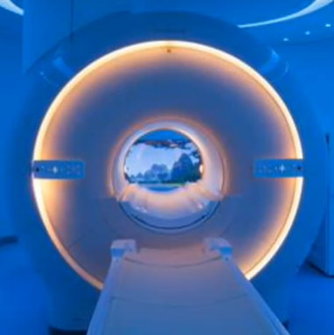

The Manufacturer should specify how to use the medical device on the patient, for example, the location of use on the body is this in the hand, leg, stomach, etc.

The Manufacturer should state if the medical device invasive or noninvasive.

The Manufacturer should state how long should the medical device be used, for example, you can use it 10 minutes per day for maximum, one week on the patient.

This will help you to understand how to test your product.

The more information you gather here, the easier you can develop protocols to test your product.

Is the medical device single use, sterile, reusable?

The manufacturer should state if, the user of the medical device needs specific tools to clean the medical device, for example, reusable, invasive medical devices need to be cleaned, disinfected and made sterile in a central decontamination unit in a health care setting.

The manufacturer should state any **precaution measures** before using the medical device, for example, in the case of the CT scan, the user operates the CT scan behind a protective barrier.

**5 – Claims** (Performance and Benefit vs Risk) **ANALYSIS**

The manufacturer must state the claim of the device.

The manufacturer defines what he claims that the medical device does.

This is broken into two sections, the Performance and the Benefit.

CLAIM - Performance of the medical device

An example of the performance could be a bare metal stent (this time as opposed to a drug eluting stent).

The bare metal stent can **perform** the action of opening an inclusion in a coronary artery from 8 millimeters to 32 millimeters in length.

This time, it is not coated with a drug.

CLAIM – Benefit vs Risk of the medical device

the benefit is that the action of opening an inclusion in a coronary artery, **alleviates** the coronary artery disease.

At this juncture, the manufacturer needs to state the Risk vs Benefit of the medical device.

The bare metal stents can save a person from dying. **Benefit**

The risk could be an infection due to the metal in the human body. **Risk**

The benefit outweighs the risk.

This claim will be what is on the brochure, on the instructions for use.

What have we learned?

We understand how the manufacturer can create the Intended Purpose.

Who is the intended patient population

What is the Indication for Use

Who is the user

What is the Intended Use

How to create the claims (risk versus benefits)

|  |  |
| --- | --- |
|  | INTENDED PURPOSE |
| 1 | Intended Population |
| 2 | Indication for Use |
| 3 | Intended User |
| 4 | Intended Use |
| 5 | Claim (Performance and Risk vs Benefit) |

QUIZ INTENDED PURPOSE

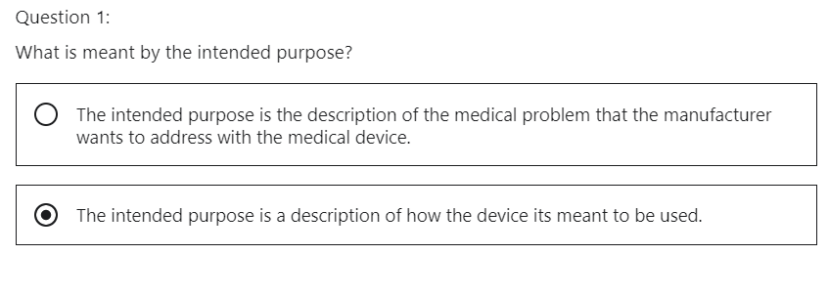

This is a description of the intended use. It is a part of the intended purpose description of how the medical device is meant to be used. “How to use it”.

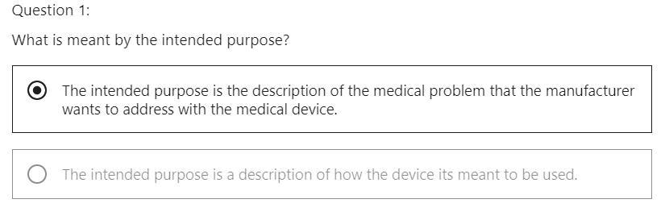

Correct. Intended purpose is the general description of purpose of the medical device. “What is it?”

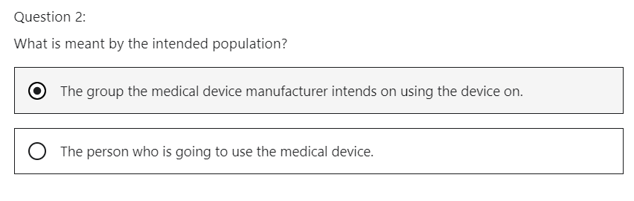

Correct. For example, demographics could be a consideration for the intended population. The device may exclude children to a certain age.

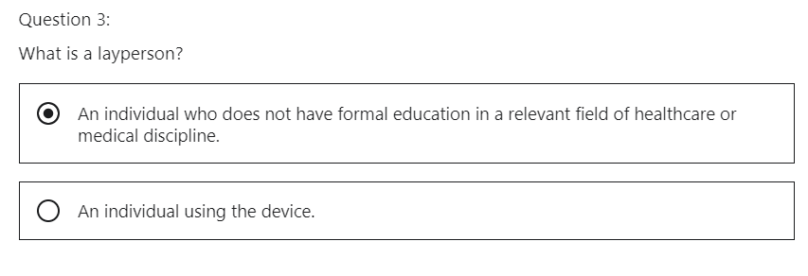

Correct. It is important to understand this definition when we are defining the user of the device. As a user can be a lay person

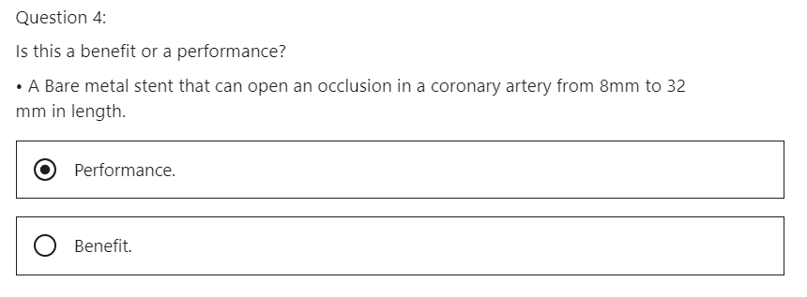

Correct. This explains how the bare metal stent performs.

## 4 Sufficient Clinical Data: Clinical Evaluation

Hi, welcome to the Medical Device Regulation MDR 2017/745 on Sufficient Clinical Data: clinical evaluation.

**What will we learn**

* what is clinical evaluation
* when is clinical evaluation undertaken
* why is clinical evaluation important
* what is Equivalence

ANNEX XIV - CLINICAL EVALUATION AND POST-MARKET CLINICAL FOLLOW-UP, PART A - CLINICAL EVALUATION, mandates a clinical evaluation and a clinical evaluation report.

This means collecting enough clinical evidence and non-clinical evidence to demonstrate conformity of the medical device with the general safety and performance requirements (GSPR) and shall be part of the technical documentation for the medical device.

**What is clinical evaluation?**

The definition given by the international medical device regulators is:

“Clinical evaluation is a set of ongoing activities that use scientifically sound methods for the assessment and analysis of clinical data to verify the safety, clinical performance and or effectiveness of the device when used as intended by the manufacturer.”

It is interesting to **note the word “ongoing” 😊**

We gather data on the device before it is released to market to prove efficacy and safety.

This data is gathered by preclinical activities and in clinical trials.

The monitoring of the device does not stop here but continues when the device is in the market.

We look at this in further detail in another section of this module.

**When is clinical evaluation undertaken?**

* Clinical evaluation is an ongoing process
* Clinical evaluation is first performed during the development of a medical device in order to identify data that needs to be generated for regulatory purposes and also the clinical evaluation is conducted throughout the life cycle of a medical device and will inform if a new device clinical investigation is necessary.

When the device is approved to be sold in the marketplace, the regulation mandates that further evaluation is constantly performed on the product.

Together with the outcomes which need to be studied, this is what is covered in Annex 14 of the medical device regulation (ANNEX XIV - CLINICAL EVALUATION AND POST-MARKET CLINICAL FOLLOW-UP).

**Why is clinical evaluation important?**

* When a medical device is placed on the market it must demonstrate the general safety and performance requirements (GSPR).
* The manufacturer must demonstrate from a clinical perspective that the device meets its intended purpose.

The main message here is that the device is safe to use and if it fulfills its Intended Purpose.

For example, the bare metal stent will open an occlusion in the coronary artery from 8 millimeters to 33 millimeters in minute without causing a detrimental side effect.

* The risk to benefit ratio is kept to a minimum (risk/benefit is a small number because the denominator is big 😊). This is another aspect that must be considered in the clinical evaluation.

Let's look at the bare metal stent again. It will open a blocked coronary artery.

This means the person will live, which is the **benefit**.

The bare metal stent could cause an infection in the patient, which is the **risk**.

In this case, the benefit far outweighs the risk.

* The claims about safety, clinical performance and effectiveness are supported by suitable evidence.

Each statement needs to be backed up by scientific evidence.

That determination of residual risks and side effects can be fed into risk management to put actions in place to reduce them

**What is Equivalence**

* A clinical evaluation may be based on clinical data relating to a device for which **equivalence** to the device in question can be demonstrated.

If you can prove your device is the same as a device on the marketplace, you can use that technical evaluation.

This can be supported by using literature review.

* The results of the clinical evaluation and the clinical evidence on which it is based, shall be documented in a clinical evaluation report, which shall support the assessment of the conformity of the device.

This is mandated in Annex 14 of the medical device regulation MDR 2017/745

(ANNEX XIV - CLINICAL EVALUATION AND POST-MARKET CLINICAL FOLLOW-UP).

What have we learned?

Understand what clinical evaluation is, understand when evaluation is undertaken.

Understand why clinical evaluation is important to understand what equivalency is.

QUIZ Clinical Evaluation

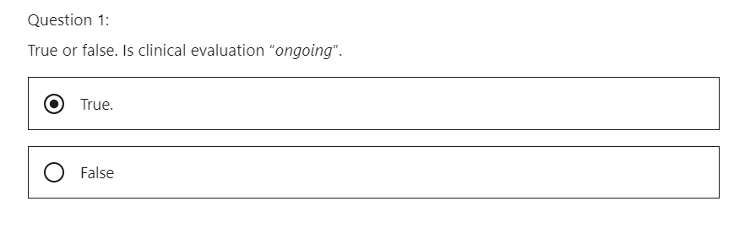

Correct. The medical device manufacturer gathers data on the device before it is released to market to prove efficacy and safety. This data is gathered by pre-clinical activities and in clinical trials. The monitoring of the device does not stop here but continues when the device is in the market.

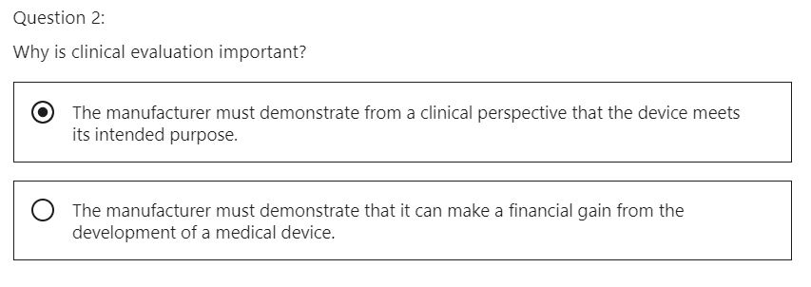

Correct. When a medical device is placed on the market it must demonstrate the General safety and performance requirements.

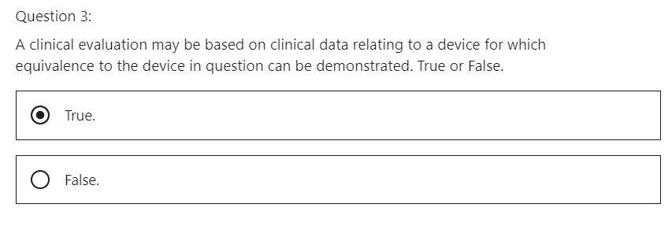

Correct. The results of the clinical evaluation and the clinical evidence on which it is based shall be documented in a clinical evaluation report which shall support the assessment of the conformity of the device.

## 5 Sufficient Clinical Data: Post Market Clinical follow-up

Hi, welcome to the Medical Device Regulation MDR 2017/745 lecture on sufficient clinical data: Post Market Clinical follow-up, also known as PMCF

**What will we learn**

* why do we need Post Market Clinical follow-up (PMCF)
* what is the Post Market Clinical follow-up Plan (PMCF Plan)
* what method do we use to collect data.

ANNEX XIV - CLINICAL EVALUATION AND POST-MARKET CLINICAL FOLLOW-UP, PART B - POST-MARKET CLINICAL FOLLOW-UP **mandates** a Post Market Clinical Follow-up.

This means continually collecting technical evidence to demonstrate conformity with the general safety and performance requirements while the device is in the marketplace.

This will continue during the lifecycle of the product.

It will be used to assess any further risk to the patient or the user.

This can be fed back into the risk management file contained within the technical documentation.

Therefore, if changes need to be done to the design of the device, it can be controlled.

**Why do we need clinical data?**

* PMCF Clinical Data is mandated in the medical device regulation 2017/745.

It is highlighted in Article 61; it is highlighted in Article 1 that the manufacturer needs to prove compliance with the general safety performance requirements and also in Annex 14.

**CHAPTER VI - CLINICAL EVALUATION AND CLINICAL INVESTIGATIONS**, Article 61 - Clinical evaluation

**CHAPTER I - SCOPE AND DEFINITIONS**, Article 1 - Subject matter and scope

**ANNEX XIV - CLINICAL EVALUATION AND POST-MARKET CLINICAL FOLLOW-UP**

* The manufacturer needs to demonstrate the claims for the device are true by using scientific document evidence (PMCF, Clinical Data)
* PMCF Clinical Data will prove continued safety and efficacy.
* PMCF Clinical Data collection needs to be continuing while the product is in the marketplace.

Therefore PMCF Clinical Data needs to be adhered to

* this PMCF Clinical Data will be put back into the technical documentation via the risk management file.
* The post market follow up, PMCF will be addressed in the post market surveillance plan.

The PMCF plan will cover the following:

* confirming the safety and performance of the device throughout its expected lifetime
* identifying previously unknown side effects and monitoring the identified side effects and contra indications
* identifying and analyzing emergent risks on the basis of factual evidence,
* ensuring the continued acceptability of the benefit/risk ratio.

As you can see, the manufacturer will be providing evidence on how the device is performing in the marketplace.

The PMCF plan will include:

* The methods and procedures of the post market clinical follow up plan (PMCF Plan)
* it will explain how the data will be gathered.
* The PMCF Plan will explain how suitable registers* will be chosen.

*I will explain what a register is in this lecture.

* The post market clinical follow plan will explain how the information gathered will feed back into the risk management section of the technical documentation.
* It will specify the objectives to be addressed by the post market clinical up follow up
* An evaluation of the clinical data relating to equivalent or similar devices
* Reference to any relevant common specification harmonised standards when used by the manufacturer and a relevant guidance on the post market clinical follow up
* A detailed and adequately justified time schedule for the post market clinical follow up activities should be undertaken by the manufacturer.
* The information needs to be coming in at regular intervals with specific timelines to be compliant with the regulation.
* The manufacturer shall analyze the findings of the Post Market Clinical Follow-Up and document the results in a Post Market Clinical Follow-Up Evaluation Report, that shall be part of the Clinical Evaluation Report and the technical documentation and
* analysis of the data needs to be performed to identify any new signals on safety and performance.

**What method do we use to collect data.**

What are the different methods for collecting sufficient clinical data:

**surveys** can be used, surveys are sent to health care professionals that use the manufacturer's device.

Data can be gathered quickly.

A low level return rate can have a negative impact on data.

It might not be quite so accurate.

The manufacturer can use **hospital databases** to gain more in-depth knowledge on the use of the device.

It can take a long time to negotiate a contract to gain access to the databases.

**Investigator sponsored studies**, the manufacturer sponsors a critical study of the marketed device, this can have a long lead time to gather data.

**What is a medical device registry?**

It's important to note what the International Medical Device Regulators Forum mean by the term “medical device registry”.

The organization defines a device registry as any organized system that collects data on routine clinical care and assesses meaningful outcomes while comprehensively covering a devices target patient population.

This helps to capture real world data, these registers are a useful resource for gathering clinical data.

The higher the classification of a device, the more details that a manufacturer will require.

So **National Registries** are another source to collect sufficient clinical data.

**Small Product Registry**, This time it is on a smaller scale. Manufacturer-friendly practitioners are required

**Large Company Registry**.

This can take more investment from a medical device company to do this but will be needed for Class III medical devices !

What have we learned?

We understand

why we need post market to follow

what is a post market power plant.

We understand the different methods of collecting post market clinical follow up data.

QUIZ Post Market Clinical Follow-up, PMCF

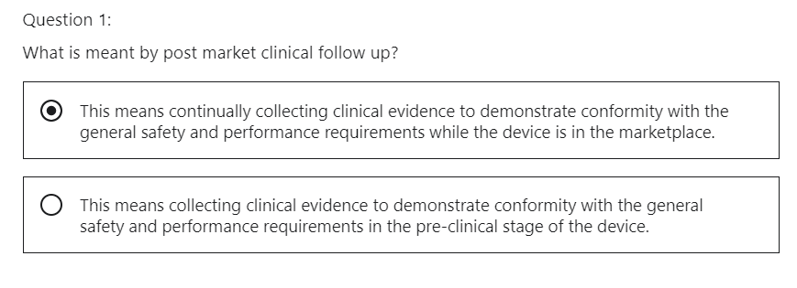

This is correct. This will continue during the life cycle of the product. It will be used to assess any further risk to the patient or the user.

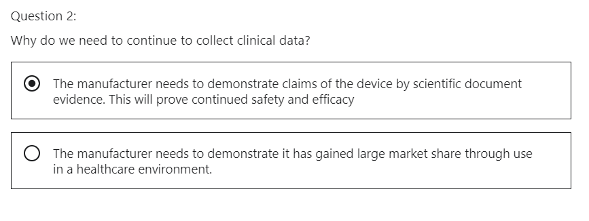

The MDR 2017/745 mandates proof of clinical evidence before premarket approval but this needs to continue during the lifetime of the device.

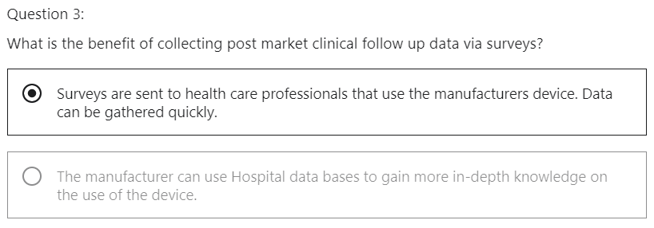

Correct. On the negative side a Low-level return rate can have an impact on data. It might not be quite so accurate.

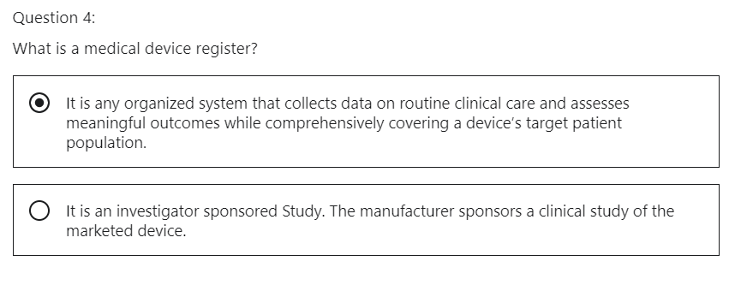

Correct. This helps to capture real world data.

# **Section 8: Post market surveillance**

## 1 Introduction

Hi, what will we discuss in this section

We will discuss **post market surveillance**.

Section eight will explain what is post market surveillance.

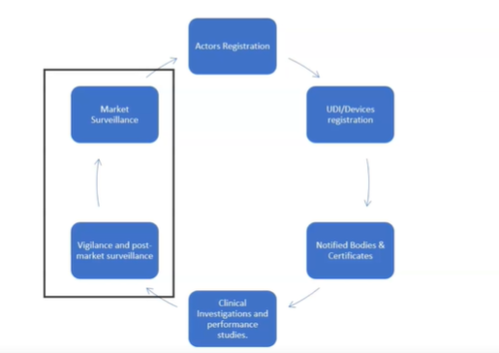

Section eight will discuss the following.

What does the regulation call out for Post Market Surveillance

POST MARKET SURVEILLANCE

* Post market surveillance system and plan (PMS system, PMS Plan)
* Post market surveillance report PMS Report)
* Periodic safety update report (PSUR)
* Vigilance System
* Analysis of Vigilance Data
* Role of the Competent Authority and the European Commission regarding market surveillance.

## 2 Post Market Surveillance System & Plan

Hi, welcome to the Medical Device Regulation 2017/745 lecture on POST MARKET SURVEILLANCE.

What will we learn?

* What does the regulation say about the post market surveillance?
* What a post market surveillance system should contain
* Data gathered from the post market surveillance system, how will they be used
* What will a manufacturer do with that data?
* What is a post market surveillance plan (PMS Plan)?

**POST MARKET SURVEILLANCE, PMS**

The MDR 2017/745 has a new definition for PMS.

You will find it in Article two definitions paragraph 60.

CHAPTER I - SCOPE AND DEFINITIONS, Article 2 - Definitions, paragraph (60)

(60) ‘post-market surveillance’ means all activities carried out by manufacturers in cooperation with other economic operators to institute and keep up to date a systematic procedure to proactively collect and review experience gained from devices they place on the market, make available on the market or put into service **for the purpose of identifying any need to immediately apply any necessary corrective or preventive actions.**

Notice

how the manufacturer carries out activities with other economic operators,

that economic operators can be a valuable source of data to see how the device is performing on the marketplace. The economic operators can be a valuable source of data to see how the device is performing on the market.

Notice there is an emphasis on proactive collection and review of data.

The responsibility is now on the manufacturer to be **proactive** instead of reactive when collecting data on the effectiveness and safety of the device in the marketplace.

This will be done by having a post market surveillance system and plan (PMS System, PMS Plan).

Collection of sufficient clinical data by post market follow-up and periodic summary of the reports.

These items will be discussed in this section of the module.

The medical device preamble, paragraph 74, is a nice definition, a post market surveillance that needs to be adhered to in order to be compliant with the medical device regulation 2017/745.

MDR Preamble, Page 10, paragraph 74, of MDR

(74) Manufacturers should play an active role during the post-market phase by systematically and actively gathering information from post-market experience with their devices in order to update their technical documentation and cooperate with the national competent authorities in charge of vigilance and market surveillance activities.

To this end, manufacturers should establish a comprehensive **post-market surveillance system**, set up under their quality management system and based on a **post-market surveillance plan**.

Relevant data and information gathered through post-market surveillance, as well as lessons learned from any implemented preventive and/or corrective actions, should be used to update any relevant part of technical documentation, such as those relating to risk assessment and clinical evaluation, and should also serve the purpose of transparency.

Let's explore it in a little more detail.

This is taken directly from the medical device regulation 2017/745 is in the preamble of the medical device regulation, paragraph 74.

There is a nice piece of detail, but let's break it down into simple steps.

* The manufacturer will have to take an active role in post market activities.
* The manufacturer will have to proactively gather data on the marketed medical device.
* This information will then go directly back into the technical documentation.

During this section, we will talk about post market clinical follow up PMCF and Periodic Safety Update reports PSUR.

Proactive means, gathering data on the device while it is in the marketplace.

An important part of market surveillance is the communication between the manufacturer and the competent Authority.

This is why the manufacturer must create their post market surveillance system, which must be documented as a plan. (PMS system and PMS Plan).

This PMS plan will be communicated to the competent authority and will be assessed as part of a notified Bodies Complaints audit.

Notice how the last part of the preamble explains to the manufacturer that data should be collected to post market surveillance.

This data needs to be fed back into the technical file via risk management.

There's two ways to collect data that is

* proactively, which encompasses Post Market Clinical Follow-up and periodic safety updates and
* reactively, which includes field safety action notices, this term will be explained in this section of the course
* all proactive data from the post market surveillance will be used to update the technical documents.

So how will this be executed?

This medical device regulation calls out to develop a SYSTEM to monitor the medical device in the marketplace for safety and efficacy.

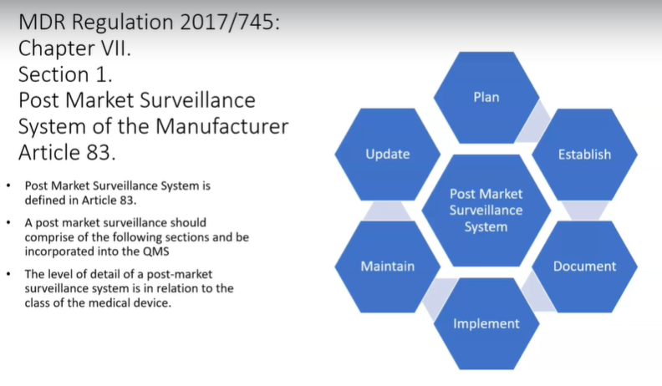

**PMS System**

Plan it

Establish it

Document it

Implement it

Maintain it

Update it

This is an important idea to understand how safe and effective the device on the marketplace is.

Post market surveillance regulation is called out in Chapter seven, Section one of the medical device regulation 2017/745.

CHAPTER VII - POST-MARKET SURVEILLANCE, VIGILANCE AND MARKET SURVEILLANCE

**The manufacturer is responsible for developing a system that will plan, establish, document, implement, maintain and update a post market surveillance system.**

This system will be correlated to the classification of the medical device.

In MDR it is stated that a manufacturer needs to demonstrate a SYSTEM for Post market surveillance.

The manufacturer needs to be active in acquiring post market surveillance data and the manufacturer needs to report all that information to a competent authority and when necessary, to the notified body. It needs to be risk based

Based on this valuable information.

What will the manufacturer do with this post market surveillance data?

* Implement corrective actions, if needed
* communicate the data to the competent authority and the Notified Body

**Post Market Surveillance Plan, Article 84**

CHAPTER VII - POST-MARKET SURVEILLANCE, VIGILANCE AND MARKET SURVEILLANCE

SECTION 1 - Post-market surveillance

Article 84 - Post-market surveillance plan

The regulation calls out for a plan in order for the post market surveillance system to be functional.

The requirements of the plan are detailed in Annex III, Section 1.

Annex III explains the Market Surveillance Plan section of the Technical Documentation

We will now examine what is required in the Post Market Surveillance Plan (PMS Plan) in the next post.

**PMS Plan, Annex III, Section 1, SOURCE OF DATA**

PMS plan will explain where it is gathering data from, on its medical device.

When the medical device is in the marketplace, it will gather information from the following locations.

* Information concerning serious incidents, information from periodic safety update reports PSUR’s and field safety incidents

(Periodic safety update reports PSUR’s will be explained in further detail in this section, they are new to the medical device regulation, but are well established within pharma regulation)

* Records, referring to non-serious incidents and data on any undesirable side effects.
* Information from trend reporting.

(Again, trend reporting is new to the medical device regulation and will be explained further within this section.)

* Relevant specialists or technical literature, databases and or registers

(a registry is an organized system that collects the data on routine clinical care and assesses meaningful outcomes while comprehensively covering a device’s target patient population. Information, including feedback and complaints provided by users, distributors and importers.)

(This is where economic operators play their part in the Post Market Surveillance.)

* Publicly available information about similar medical devices.

**PMS Plan, Annex III, Section 1, CONTENTS**

What will the plan cover:

* A proactive and systematic process to collect information

the manufacturer needs to be able to explain how data will be collected from the device in the marketplace.

* Effective processes to assess data

The manufacturer needs an effective way on how to process the data.

* Suitable indicators and thresholds that can be used to re-assess Risk VS Benefit

The manufacturer needs to establish a seatbelt indicator to see if you are on target.

For example, if the manufacturer is producing a fluoroscope and there is an increase in users having cancer, this is an indicator that needs to be investigated.

* Effective methods to investigate complaints. Analyze market related experience

His effective methods to investigate complaints, analyze market related experience. Does the manufacturer have a relevant procedure?

How to investigate complaints, does the manufacturer have a department that deals with complaints?

* Methods to manage trends that are reported

Is there a plan to monitor trends and make corrections if necessary?

* A method to communicate to the Competent Authority, Notified Body, Economic Operators and Users

What will the method be, to communicate to the Competent Authority, Notified Body, economic operators and users, which will be via EUDAMED

* Reference to procedures to fulfill the manufacturer's obligations to the post market surveillance system, post marketing plan and periodic safety update reports.

The PMS plan will be part of the technical documentation.

The Quality Management System will have to reference these procedures to satisfy the plan's requirements.

* A corrective action procedure to respond to issues

The PMS plan will reference to corrective action procedure to any issues with the device.

* Effective tools to identify devices for which a corrective action may be necessary

What tools can be used to identify root cause and corrective actions?

* A Post Market Clinical follow plan PMCF will be part of the post market surveillance plan PMS.

What have we learned?

We understand what needs to be in a post market surveillance system

we understand what a post market surveillance plan contains

we understand how the manufacturer uses the data generated from a post market surveillance plan.

POST MARKET SURVEILLANCE, PMS

* **PMS SYSTEM, PMS System**
  + Plan it
  + Establish it
  + Document it
  + Implement it
  + Maintain it
  + Update it
* **PMS PLAN, PMS Plan**
* **PMS Plan, its source of data is:**
  + serious incidents
  + PSUR’s
  + field safety incidents
  + non-serious incidents
  + undesirable side effects
  + trend reporting
  + Relevant specialists
  + technical literature
  + databases and or register
  + Publicly available information about similar medical devices.
* **PMS Plan, its contents are**
  + process to collect information/data
  + process to assess collected information/data
  + process to re-assess Risk VS Benefit
  + process to investigate complaints
  + process to analyze market related experience
  + process to manage trends
  + process to communicate with the Competent Authority, Notified Body, Economic Operators and Users
  + process to incorporate the PMS plan to the technical documentation
  + processes regarding the PMS System should be in the Quality Management System of the manufacturer
  + process to respond to issues with a corrective action
  + process to identify devices for which a corrective action may be necessary
  + a PMCF Plan*

*

post market surveillance plan

Post Market Clinical follow-up Plan

QUIZ PMS System, PMS Plan

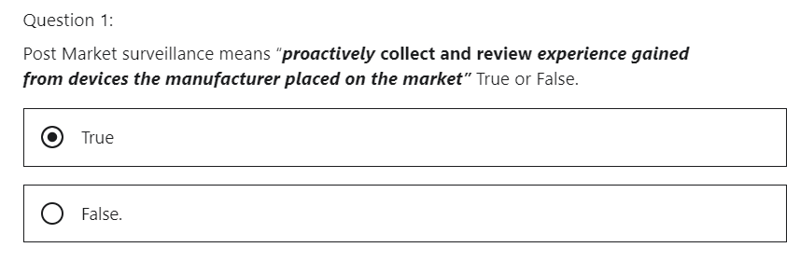

Correct. There is an emphasis on proactive collection and review of data. The onus is now on the manufacturer to be proactive instead of reactive when collecting data on the effectiveness and safety of the device in the marketplace.

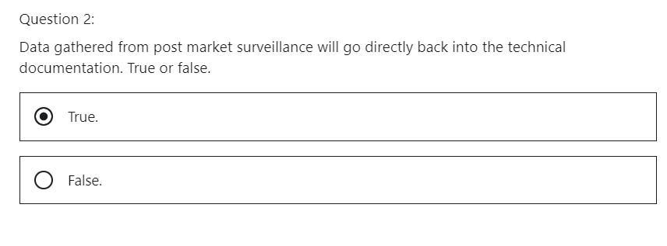

Correct. The manufacturer will have to take an active role in post market activities. The manufacturer will have to proactively gather data on the marketed medical device. This information will then go directly back into the technical documentation.

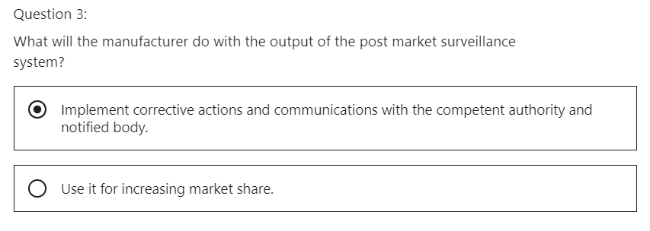

Correct. The manufacturer may have to implement corrective actives to prevent safety incidents in the marketplace.

## 3 Post Market Surveillance Report & Periodic Safety Update Report (PSUR)

Hi, welcome to the Medical Device Regulation 2017/745, Chapter seven, Section one.

We will discuss:

**Article 85, Post Market Surveillance Report**

CHAPTER VII - POST-MARKET SURVEILLANCE, VIGILANCE AND MARKET SURVEILLANCE, SECTION 1 - Post-market surveillance, Article 85 - Post-market surveillance report

**Article 86, Periodic Safety Update Reports PSUR’s.**

CHAPTER VII - POST-MARKET SURVEILLANCE, VIGILANCE AND MARKET SURVEILLANCE, SECTION 1 - Post-market surveillance, Article 86 - Periodic safety update report

What will we learn?

* What is a **Post Market Surveillance Report, (PMS Report), article 85**
* What is a **Periodic Safety Update Report (PSUR report), article 86**

**PMS Report, article 85**

* A medical device manufacturer of Class I medical devices must prepare a post marketing surveillance report to be compliant with the regulation.
* The PMS Report will give a summary of the results and the conclusion of the analysis of the post market surveillance data.
  + This data will be gathered as the manufacturer will be following the post market surveillance plan.
* The PMS Report will provide a description of the preventive and corrective action taken.
* The PMS Report must be updated when necessary and made available to the competent authority upon request.

**PSUR report, article 86**

* Manufacturers of Class IIa, Class IIb, Class III devices must prepare a periodic safety update report PSUR for each device.
* In the PSUR report, manufacturers are summarizing the results and conclusions of the analysis of the post market surveillance data that were gathered
* The PSUR report, will contain a preventive or corrective action, if this is needed according to the analysis of the gathered data.

(The manufacturer can use the PMCF as an input for the PSUR)

**Contents of the PSUR report, article 86**

* The conclusions of the Benefit to Risk determination

does the benefit outweigh the risk?

* The main finding of the Post Market Clinical follow up (PMCF)

This is the clinical data that is collected from the medical device in the marketplace

* The volume of sales of the device. An estimate of the size of the population. Where practicable, the usage frequency.

The responsibility is on the manufacturer to create the periodic safety update report.

One can start to appreciate there is a lot of work to do this.

The PSUR is new to the medical device regulation.

* For a Class IIa medical device, its PSUR report shall be updated when necessary and at least every two years and its PSUR report shall be a part of the Technical Documentation.

This demonstrates that the Technical Documentation is a living document that will need to be updated frequently.

* For a Class IIb and Class III medical devices, the PSUR report shall be updated at least annually and its PSUR report shall be a part of the Technical Documentation.

One can appreciate the challenging workload a manufacturer will have to be compliant with in order to satisfy the new regulation.

The PSUR has to be part of the Technical Documentation!

* For Class III devices or Implantable devices manufacturers shall submit periodic safety update reports by means of the electronic system, which will be EUDAMED

The periodic safety update report will be delivered to the notified body involved in the conformity assessment via EUDAMED.

* The Notified Body shall review the report and add its evaluation via EUDAMED with details of any action taken
* Such periodic safety update reports and the evaluation by the notified body shall be made available to competent authorities through EUDAMED.
* For Class IIa and Class IIb, the manufacturer shall make periodic safety update reports available to the notified body involved in the conformity assessment and upon request to competent authorities.

What have we learned:

* Class I devices need a post market surveillance report (PMS report)
* Class IIa, IIb, III devices need a periodic safety update report (PSUR report)
* PSUR report contains the benefit risk determination, PMCF, volume of sales and frequency of use
* Class IIa devices shall update the PSUR when necessary and at least every two years.
* Class IIb and Class III devices shall update the PSUR at least annually.

**QUIZ PMS report and PSUR report**

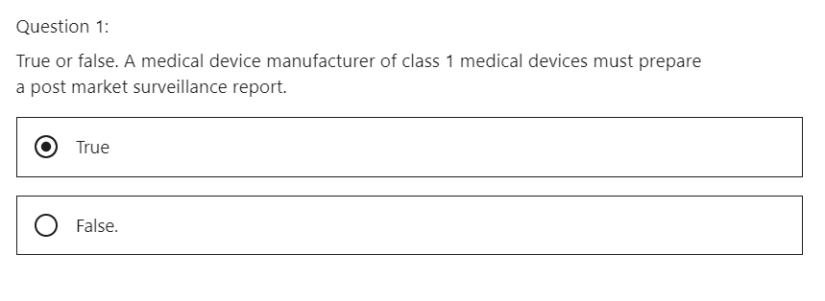

Correct. This is mandated in article 85 post market surveillance report in the MDR 2017/745.

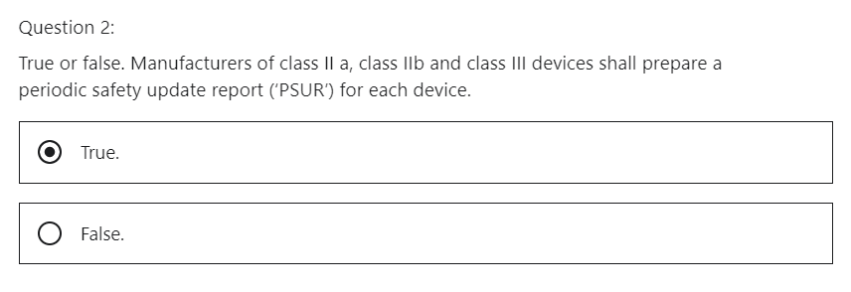

Correct. This is a requirement of the MDR 2017/745 under article 86.

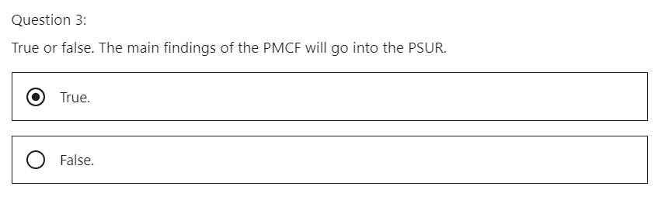

Correct. The post market clinical follow up is the clinical data that is collected from the medical device in the marketplace. This data will be an input into the periodic safety update report.

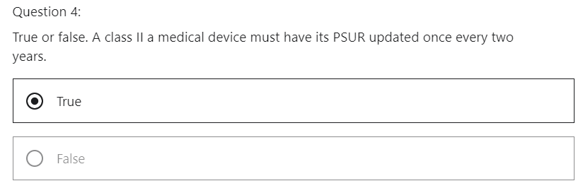

Correct. It is mandated under article 86.

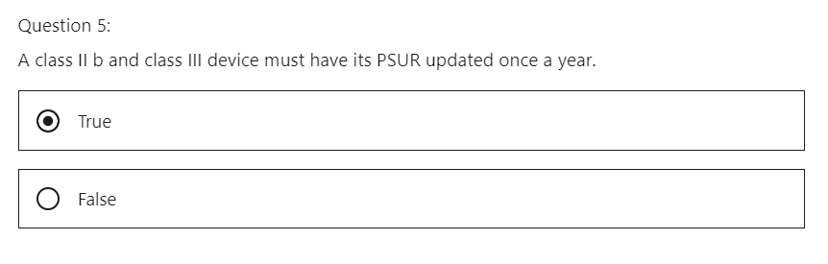

Correct. It is mandated under article 86.

## 4 Vigilance System

Hi, welcome to the Medical Device Regulation 2017/745 lecture on Chapter VII Vigilance, Section two, Article 87

* Reporting of serious incidents and
* Field Safety Corrective Actions.

What will we learn?

We will understand what is meant by reporting of **serious incidences** and **field safety corrective actions**,

We need to understand that we are now in the realm of being reactive.

What does this mean?

The manufacturer is reacting to signals of the device in the marketplace.

**Let's look at reporting of serious incidences and field safety, corrective actions.**

The manufacturer must report the following to be compliant.

* Any serious incidents involving devices made available on the European Union market will be reported to the relevant, competent authority.
* Any field safety corrective action in respect to devices made available on the European market will be reported to the relevant, competent authority.

**What is a serious incident?**

A serious incident has caused harm to a patient

**What is a field safety corrective action?**

a field safety corrective action is the action of the manufacturer in order to resolve an issue.

For example, if a medical device is packaged in a box, the labeling on the outside of the box was correct.

The labeling of the packaging of the device was incorrect inside the box, a manufacturer would have to check the packaging in the field.

This would be deemed as a **field safety corrective action** and would have to be communicated to the competent authority.

**What is a field safety notice?**

It means a communication sent by a manufacturer to a user or a customer in relation to a field safety corrective action.

In our example, the manufacturer will need to communicate the action of checking the products in the field to see if there is any more product with the wrong labeling.

**Let's take a closer look at the definition of a serious incident.**

Serious incident means any incident that directly or indirectly led might have led or might lead to any of the following.

* The death of a patient, user or other person
* the temporary or permanent, serious deterioration of a patient, user or other person's state of health

For example, a doctor is delivering a coronary stent to a patient via a catheter to open an occlusion. If the catheter breaks within the patient and there is internal bleeding, this is a serious incident. The manufacturer must obtain this information and report it to the competent authority.

For example, a patient dies after the use of a defibrillator and there is an indication of a problem with a defibrillator, the incident should be reported.

I have attached a guideline on a medical device vigilance system in the resource material to this lecture.

* MEDDEV 2.12-1 rev 8, January 2013, GUIDELINES ON A MEDICAL DEVICES VIGILANCE SYSTEM
* Global Harmonization Task Force, 30 November 2006, Medical Devices Post Market Surveillance: Global Guidance for Adverse Event Reporting for Medical Devices

It is a beautiful document.

**A serious incident can include the following**

a threat to public health

* an event which could result in imminent risk of death
* an event which could lead to serious deterioration in a person's state of health,
* serious illness that may require prompt remedial action
* an event that may cause significant morbidity, which means disease or mortality in humans.
* An event that is unusual or unexpected for the given place and time

For example, just can't include an event that is of significant and unexpected nature such that it becomes alarming as a potential public health hazard.

For example, human immunodeficiency virus HIV or Creutzfeldt-Jakob disease CJD.

**Reporting of Serious Incidents and Field Safety Corrective Actions**

* The report will be submitted to EUDAMED.
* The manufacturer must report a **serious incident** not later than 15 days.
* The manufacturer must report a **serious public health threat** not later than two days
* The manufacturer must report a **serious public health threat** immediately without any delay that could not be justified, but not later than two calendar days after awareness by the manufacturer of this threat.
* In the event of a death or unanticipated, serious deterioration in a person's health, the manufacturer will produce a report not later than 10 days
* When necessary, to ensure timely reporting, the manufacturer may submit an initial report that is incomplete, that is followed up by a complete report.
* If a manufacturer becomes aware of an incident and is uncertain if it is reportable, it must report the incident within the timeframe.

The regulation is mandating the manufacturer to be cautious.

* The manufacturer must report field safety, corrective actions.
* The Member States must encourage health care providers, users and patients to report to the competent Authorities suspected serious incidences.
* The competent authorities must record these serious incidents from health care providers, users and patients in a national central database
* the competent authority must give the manufacturer feedback of the suspected serious incidences which they received.
* It must be also noted that the patient's user and health care provider can report the incident directly to the manufacturer as well.

**What is the next step when a serious incident or a field safety action is reported to a manufacturer**?

The manufacturer will follow up on the feedback from the competent authority.

If the manufacturer deems is a serious incident, they shall provide a report and execute on a follow up.

If the manufacturer deems it not a serious incident, it will provide an explanation to the competent authority

the competent authority may disagree and require a serious incident report.

**What have we learned?**

A manufacturer must report serious instances and field safety actions via EUDAMED.

We looked at the timelines associated with each event:

* in the event of a serious incident the manufacturer must report before 15 days pass
* in the event of a serious public health threat the manufacturer must report before 2 days pass
* in the event of a death the manufacturer must report before 10 days pass

Member states must encourage health care providers, users and patients to report incidents to competent authorities.

The manufacturer must react to the information gathered by the competent authority.

VIGILANCE

Reporting of serious incidents

Field Safety Corrective Actions

QUIZ Vigilance System

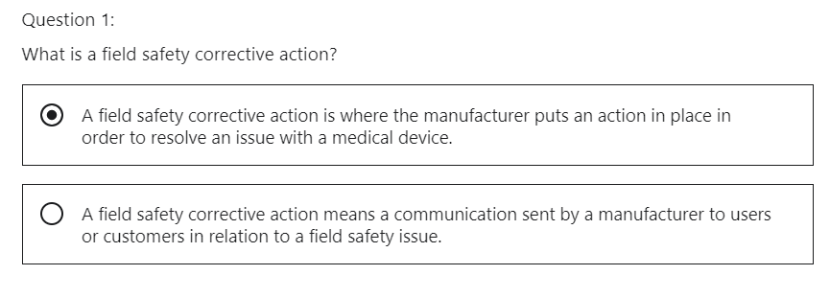

For example, incorrect labelling of a medical device package.

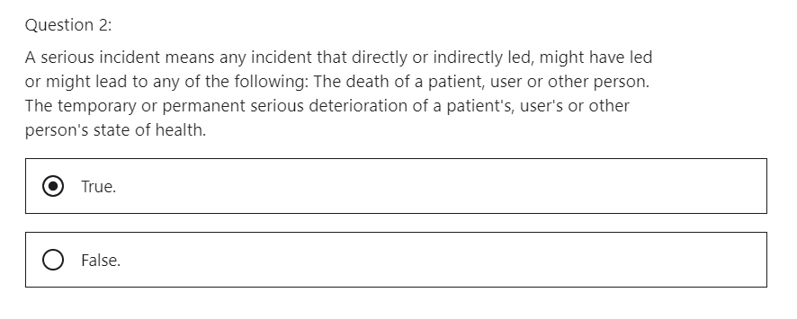

This is correct for example, a doctor is delivering a coronary stent to a patient via a catheter to open an occlusion. If the catheter breaks within the patient and there is internal bleeding this is a serious incident. The manufacturer must obtain this information and report it to the competent authority.

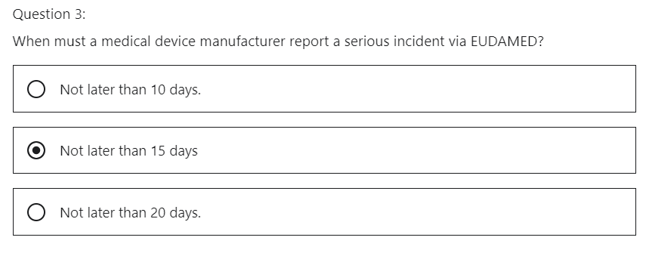

This is correct. It is mandated under article 87.

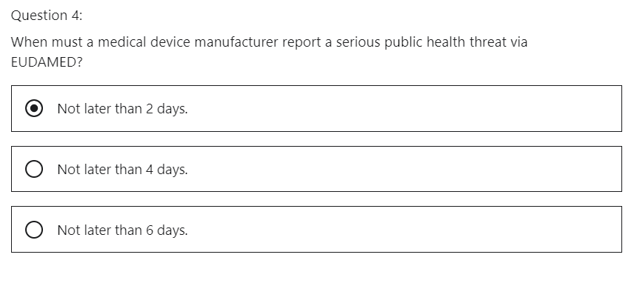

Correct. It is mandated under article 87.

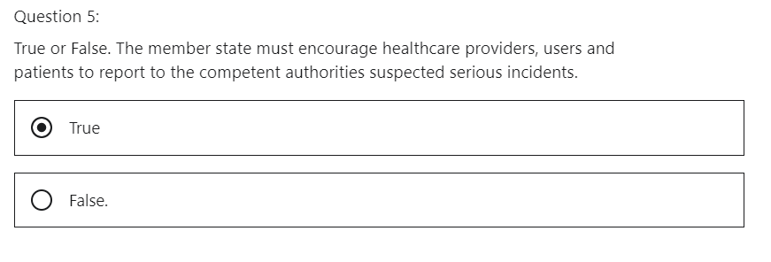

That is correct. The competent authorities must record these serious incidents from healthcare providers, users and patients in a national central database.

## 5 Analysis of Vigilance Data

Hi, welcome to the Medical Device Regulation 2017 /745 lecture on

Chapter VII Vigilance, Section two analysis, which is covered under Article 89 and 90.

CHAPTER VII - POST-MARKET SURVEILLANCE, VIGILANCE AND MARKET SURVEILLANCE

SECTION 2 – Vigilance

Article 89 - Analysis of serious incidents and field safety corrective actions

Article 90 - Analysis of vigilance data

What will we learn?

We will understand what is meant by analysis of

* serious incidents and
* field safety corrective actions.

This is covered under Article 89 - Analysis of serious incidents and field safety corrective actions

Once a serious incident is reported

* the manufacturer must initiate an investigation in relation to the serious incident and the device concerned.
* This will contain a risk assessment of the incident.
* The investigation will also include the field safety, corrective action.

What is a field safety corrective action (FCSCA) and a field safety notice?

this definition is given in “Reference Medical Devices: Guidance Documents. Guidelines on a medical devices vigilance system” created by the European Commission.

“A FIELD SAFETY CORRECTIVE ACTION is an action taken by the MANUFACTURER to reduce a risk of death or serious deterioration in the state of health associated with the use of the medical device that is already placed on the market.”

“Such actions, whether associated with direct or indirect harm, should be reported, and should be notified via a FIELD SAFETY NOTICE.”

**Examples of field safety corrective actions:**

the return of the medical device to that supplier manufacturer site makes it an issue with the manufacturing process, for example, a machine which was out of calibration.

This would mean a field safety notice.

The field safety corrective action would be a recall of the product that went through the machine that was out of calibration.

Manufacturer must cooperate with the competent authority and the relevant notified body during that investigation.

It is the responsibility of the competent authority to evaluate any serious incidents and field safety

Actions.

The competent authority must monitor the manufacturers investigation.

* The manufacturer must upload a final report onto EUDAMED
* if the medical device has a medicinal property the European Medicines Agency, EMEA Competent Authority needs to be notified.
* The competent authority must use the EUDAMED system to communicate to the other competent authorities with regard to corrective actions established by the manufacturer.

The manufacturer must let the user know about the field safety actions.

This will be done by a field safety notice.

The field safety notice will allow identification of the device and the manufacturer

the relevant unique device identification UDI will be used to identify the products.

A single registration number of the manufacturer will be used to identify the manufacturer.

These identifications will be on the field safety notice.

The competent authority where the manufacturer is registered, will take ownership for the follow up of the corrective actions within the field safety notice.

The Competent Authority will use EUDAMED as a means of communication.

This communication will be between the other competent authorities and the EU commission

Analysis of Vigilance data.

Article 90

Vigilance data will be monitored in EUDAMED.

This is to allow to identify trends.

This may identify new risks or concerns.

A new signal could be identified, for example, an unknown risk.

The competent authority will communicate with the manufacturer or the authorized representative.

What have we learned?

Following a serious incident:

The manufacturer will initiate an investigation

The competent authority must monitor the manufacturer's investigation

The manufacturer must upload a final report onto EUDAMED.

The field safety notice will act as a method of identifying the manufacturer.

The field safety notice will give an update on all actions.

The competent authority of where the manufacturer is registered will take ownership of the field safety notice follow up

The competent authority will monitor the vigilance data and will give the manufacturer an action based on these trends.

QUIZ Analysis of vigilance data

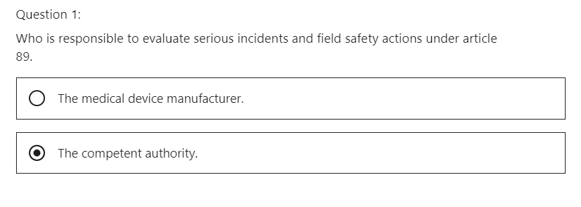 Correct. Once the data is supplied to the competent authority. It is the responsibility of the competent authority to evaluate any serious incidents and field safety actions.

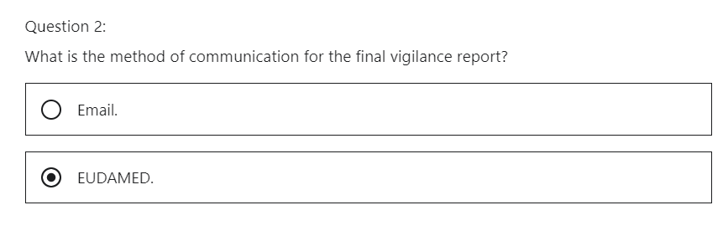

Correct. Article 89 mandates that the manufacturer must upload a final report onto EUDAMED.

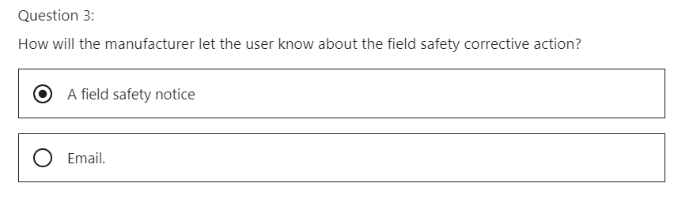

That is correct. It is mandated under article 89.

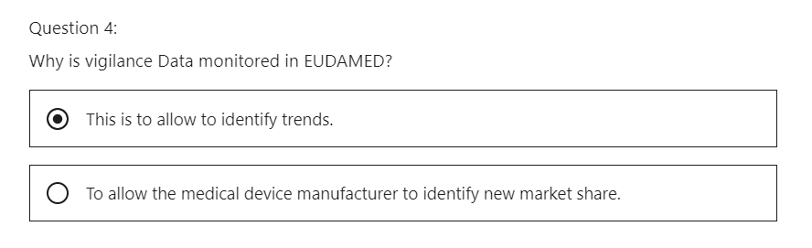

This is correct. This may identify new risks or concerns. A new signal could be identified for example an unknown risk.

## 6 Role of CA & EC within Market Surveillance

Hi, welcome to the Medical Device Regulation 2017/745 Lecture on

Chapter VII, Section 3, Market Surveillance.

CHAPTER VII - POST-MARKET SURVEILLANCE, VIGILANCE AND MARKET SURVEILLANCE

SECTION 3 - Market surveillance

What will we learn?

We will understand what is meant by **market surveillance** and go into detail in Section three of Chapter seven.

This is the third section of Chapter seven,

Post market surveillance focuses on the role and responsibility of the competent authority and the commission regarding post market surveillance.

We are examining the medical device regulation 2017/745, Chapter VII, Section 3 - Market surveillance.

We will examine what is the role and responsibility of the competent authority and the Commission in regard to **market surveillance**.

Market surveillance is covered by Chapter seven, Section three in the medical device regulation 2017/745.

Article 93 - Market surveillance activities

It is covered by 8 articles.

Let's examine each article, in summary.

**Article 93 - Market surveillance activities**

The Competent Authorities Responsibility is as follows.

**1 CA will Perform checks on the medical device conformity to specifications and performance.**

The competent authority will perform conformity assessments of a medical device.

This conformity will be based on specifications and performance of the device,

**2 CA will Review of documentation and physical samples from the economic operator**

The competent authority will ask for documentation on the medical device and physical samples of the device from the manufacturer.

**3 CA will Focus on risk assessment, risk management, vigilance data and complaints**

from this information, the competent authority can make an informed decision.

**4 Economic operator will provide documents and samples**

**5 CA will carry put announced and unannounced inspections of the economic operator**

This will help the economic operator to be consistently prepared.

**6 CA will produce reports from inspections and annually summary reports.**

These will be available via EUDAMED.

Remember, this is one of the main roles that the competent authority has when managing the medical device in the marketplace.

The competent authority responsibility is as follows:

(According to Article 93 - Market surveillance activities)

* The economic operator will be allowed to examine reports and respond before and upload on EUDAMED

the competent authority needs to ensure that this occurs.

* The competent authorities will review their market surveillance activities every four years for improvement.

This is a self-examination to ensure their own procedures are relevant, and up to date

* They will work with other competent authorities within the EU for shared learnings and improvements.

Remember, a decision or an incident on an approved medical device in Ireland will have an impact on the same medical device in Germany.

“Evaluation of devices suspected of presenting an unacceptable risk or noncompliance or other non-compliance”, Article 94.

* The competent authority may believe a risk is due to a signal from market surveillance activities or vigilance.

What must the competent authority do if they identify a risk?

* The competent authority may deem the risk to be
  + an unacceptable risk to the health of the patient, public or end user.
  + risk may be that the device is not compliant to regulation.
* The competent authority will carry out an assessment of the device.
* The economic operator will cooperate with the competent authority.

Notice how the regulation gives step by step information on what must be done by a competent authority

“Procedure for dealing with devices presenting an unacceptable risk to health and safety.”, Article 95.

Article 95 - Procedure for dealing with devices presenting an unacceptable risk to health and safety

What happens next now that a risk has been identified?

How do you deal with it?

* If an issue is found with the medical device, the competent authority expects the economic operator to act
* the competent authority will notify the commission or other member states and the notified body that issued the certificate, via EUDAMED,
* the economic operator, will take a corrective action. If they don't, the competent authority will restrict or prohibit market approval of that device on the European market.
* The competent authority will communicate these measures to the commission, other member states and the notified body via EUDAMED
* The withdrawal of the product will have details of noncompliance and risk.
* Other member states will help the competent authority with any information that may help the investigation.
* If there is a disagreement between member states on the action, it will be communicated via EUDAMED.

The competent authority will always be thinking risk versus benefit.

If the benefit outweighs the risk, they will endeavor to keep the product on the marketplace.

Their primary objective is the safety of the device.

“Procedure for dealing with devices, presenting an unacceptable risk to health and safety”, Article 95.

Article 95 - Procedure for dealing with devices presenting an unacceptable risk to health and safety

The measures that the competent authority issued will have a two month period to allow other competent authorities or economic operators to object.

If there is no objection within two months, the measures will be deemed justified.

All member states should implement prohibitive measures without delay

**“Procedure for evaluating national measures at union level” Article 96.**

Article 96 - Procedure for evaluating national measures at Union level

* What happens if there is a disagreement with the measures taken by the competent authority?
* This objection may come from the economic operator or a member state.
* The commission will evaluate the objection and decide
* The commission will decide if the objection is viable or not.

**“Other non-compliance”, Article 97.**

Article 97 - Other non-compliance

* If there is a non-compliance but it is not life threatening, then the economic operator must bring it to a close.

This allows the economic operator time to close the action and prevent that medical device being withdrawn from the European marketplace.

* If the economic operator does not bring it to a close, then the competent authority will stop the market authorization of their products.

**“Preventive Health Protection Measures”, Article 98.**

Article 98 - Preventive health protection measures

* After evaluation if the competent authority deems it necessary, it can prohibit the device on the market if, in their opinion, the action was not adequate.
* The competent authority will notify the commission and other member states via EUDAMED of this decision.
* The competent authority will explain the reason why the device is being prohibited.
* The commission has six months to decide if it was the wrong or right thing to do. They will consult the medical device coordination group (MDCG).

**“Good administration practice” Article 99**

Article 99 - Good administrative practice

* If the competent authority recognizes a risk, they need to communicate the following to the economic operator exactly what the measure is, why they are implementing it, what action the economic operator needs to take and the timeline.
* If the issue is life threatening, the action is immediate. Otherwise, the economic operator will be given a timeline to remedy.
* If the economic operator can prove it has taken a corrective action to remedy the issue, the competent authority will remove the measure.
* The notified body who was involved in the conformity assessment will be informed of the measures taken via EUDAMED.

This is a good philosophy as it gives the notified body a chance to learn if they missed anything on the conformity assessment.

Notice how the regulation is depending more and more around you EUDAMED for communication and follow up activities.

**“Electronic System on Market Surveillance” Article 100**

Article 100 - Electronic system on market surveillance

* Market surveillance data will be managed via EUDAMED
* EUDAMED will manage the following data from market surveillance
* summaries of the results of the market surveillance activities.
* Final inspection report
* information in relation to devices presenting an unacceptable risk to health and safety
* information in relation to the preventive health protection measures,
* summaries of the results of the reviews and assessments of the market surveillance activities of the member states.

What have we learned?

* We understand what the competent authorities responsibilities are in market surveillance.
* We understand what the competent authority responsibilities are in regard to investigating a safety risk.
* We understand the authority they have in regard to withdrawing a device from the marketplace.
* We understand responsibilities of the other competent authorities within the union, the Notified Body that did the conformity assessment of the medical device under investigation. The economic operator and the Commission’s role in case of disagreements.
* EUDAMED will become the channel to communicate findings from the market surveillance that the competent authority will use.

**QUIZ Role of Competent Authority & European Commission within Market Surveillance**

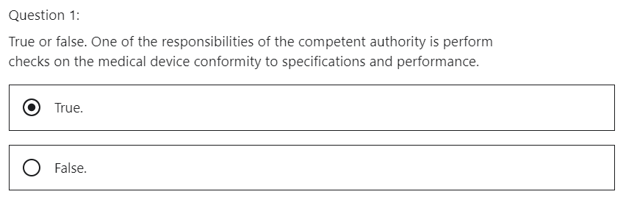

Correct. The competent authority will perform conformity assessments of a medical device. This conformity will be based on specifications and performance of the device.

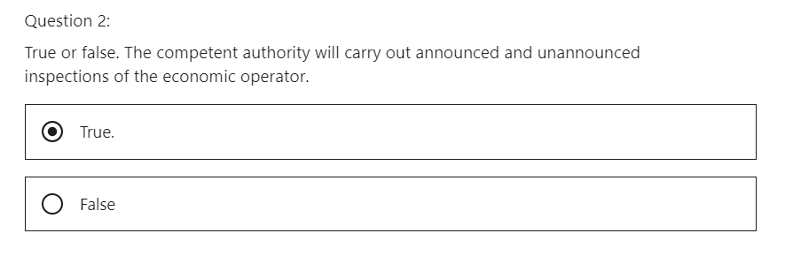

This is correct. This will help the economic to be consistently prepared but this can be challenging.

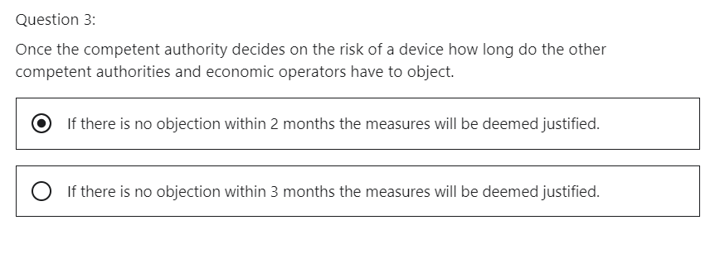

Correct. This is mandated under article 95.

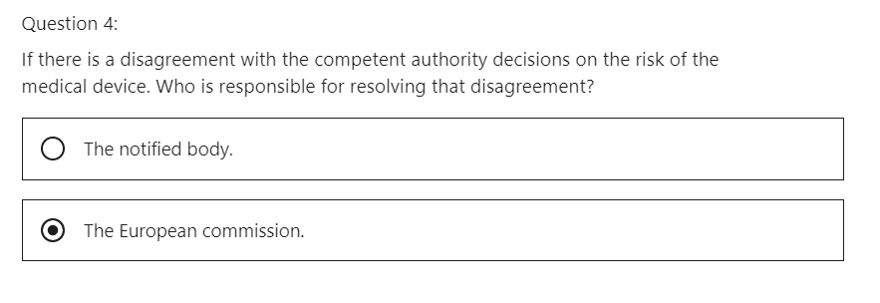

That is correct. The commission will decide if the objection is viable or not.

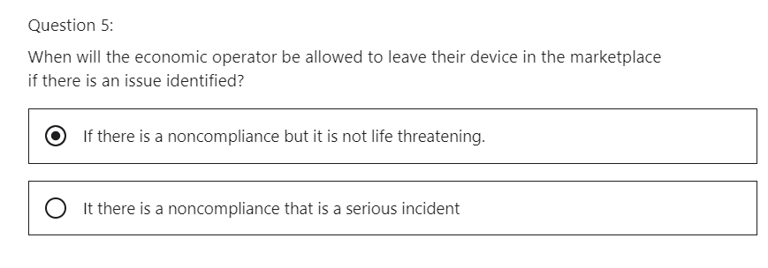

Correct. The economic operator must bring it to a closed. This allows the economic operator time to close the action and prevent the medical device being withdrawn from the European Market.

# **Section 9: Miscellaneous**

## 1 Introduction

Hi, welcome to Section nine other items.

Hi, in this section, we look for some other items to help to explain the medical device regulation 2017/745 further,

What will we cover?

* We will understand the role and responsibility of the medical device coordination group (MDCG)
* Post Brexit, what does it mean to the European medical device regulation?
* Switzerland's mutual recognition agreement with the EU
* Turkey and EFTA responsibility regarding the medical device regulation 2017/745
* common specifications, what are they?
* The rolling plan, the European Commission's roadmap for the implementation of the Medical Device Regulation 2017/745.

Let's go.

## 2 Medical Device Coordination Group “Guidelines”

Hi, welcome to the Medical Device Regulation 2017/745 lecture on medical device coordination group or M.D. C.G.

What will we learn?

* We will understand what is meant by the medical device coordination group.

The Medical Device Coordination Group MDCG deals with key issues from the medical device sector.

They consist of a group of experts from regulation and industry that work with the European Commission.

it gives advice and guidance on the following areas.

1. Notified body oversight,
2. standardization,
3. market surveillance,
4. passing by international matters,
5. new technologies,
6. clinical investigation

Let's examine this a little further.

**1 Notified Body Oversight.**

The group shares experiences and exchange views on issues relating to notified bodies and the application of conformity assessment procedures with the aim of a consistent application of requirements and procedures.

They give guidance on the regulation to ensure standardization across the European market.

Passed by international matters, they give guidance, ensure new technologies are safe, ensure clinical

investigations are performed safely and ethically.

Its expertise is divided into 13 subgroups, which respectively provide advice and draft guidance on their expertise field, we will examine the 13 subgroups in this lecture.

The members of the subgroups are appointed by the member states for a duration of three years.

Stakeholders participate as observers and are appointed following a call for applications procedure also, for a duration of three years

They meet regularly with the EU Commission as chair.

These members are experts in the medical device industry and regulation.

The main objective is to provide guidance on medical device regulation.

The **notified bodies subgroup** oversees, drafts of technical recommendations on matters relating to notified bodies and conformity assessment.

**Standards**, the subgroup discusses general issues relating to standardization and, when necessary, coordinates proposals for development and use of technical and specific standard documents in diverse

Fields

The clinical investigation and evaluation subgroup or the CIA for short, develops and promotes harmonization with regard to clinical evaluation and investigation.

The **post marketing surveillance subgroup** develops and revises guidance documents, exchanges, information discusses actual incident cases and reviews current reporting practices, including measures to improve the reporting behavior of all actors.

The **market surveillance sub-group** NS focuses on enforcement activities and administrative measures

by competent authorities in relation to surveillance and control of devices put on the market.

The borderline and Classification Sub-Group advises on the qualification and classification types of the

medical device.

Some very useful guidance documents have been produced.

For example, the MEDDEV 2.4/1 revision nine, which really helps with classifying a medical device.

The **New Technologies Sub-Group** advises on issues related to the application of new and emerging technologies to medical devices, including software, apps and cybersecurity.

The **EUDAMED sub-group** facilitates the implementation of the EUDAMED database, providing advice and coordinating as appropriate the work of other MDCG working groups when input to a specific EUDAMED module is required.

The **Unique Device Identification Sub-Group** provides advice for all matters relating to device identification and traceability.

The **International Matters Subgroup** prepares a common European view on the International Medical Device Regulatory Forum issues and discuss other international issues related to medical devices and in vitro diagnostic medical devices in particular It monitors international regulation trends.

This is fantastic as it starts to help with global regulation harmonization.

The in **vitro diagnostic medical devices subgroup** develops and promotes harmonization with regard to in vitro diagnostic specific issues.

The **nomenclature sub-group** provides assistance on all implementation issues related to the medical device nomenclature, with the aim to support the functioning of the future European database on medical devices EUDAMED.

Nomenclature means how to name medical device inputs into the EUDAMED database.

The **ANNEX XVI products sub-group** develops common specifications for those groups of products without unintended medical purpose that are listed in regulation 2017/745 annex 16.

what have we learned?

We understand what the medical device coordination group MDCG is.

We understand it consists of 13 subcommittees.

The medical device coordination group consists of a group of experts from regulation and industry that work with the European Commission.

It gives advice and guidance on the medical device regulation 2017/745

QUIZ Understand the role of the Medical Device Coordination Group

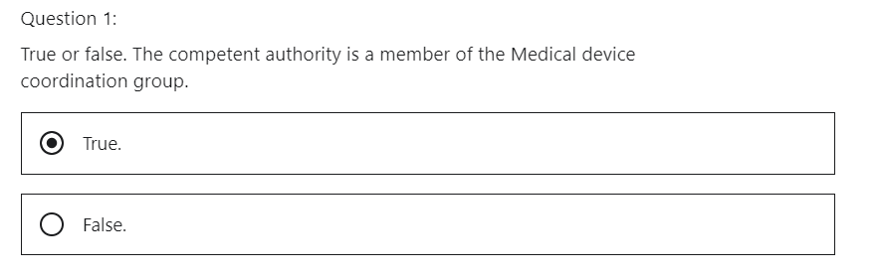

The competent authority is part of the MDCG. They break into WG Working Groups. Their aim is to create guidance on the current medical device regulation.



Correct. The members of the subgroups are appointed by the Member States for a duration of 3 years.

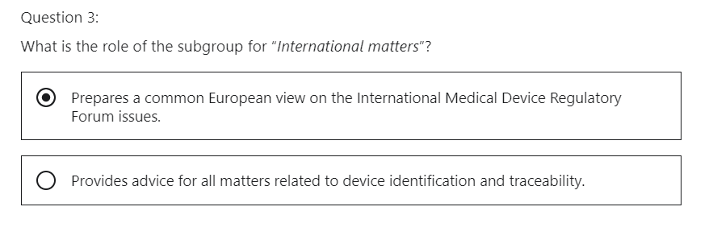

Correct. It will discuss other international issues related to medical devices and in-vitro diagnostic medical devices, it monitors international regulation trends

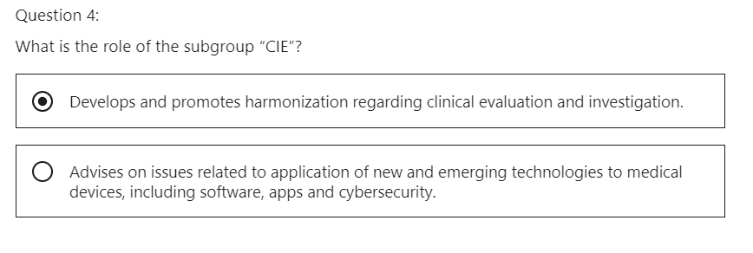

Correct. It is the Clinical investigation and evaluation subgroup or CIE for short.

## 3 Brexit

Hi.

Welcome to the lecture on BREXIT

What will we learn,

what is the impact of the UK leaving the European Union (Brexit)?, in the context of the medical device regulation, 2017/745.

The UK is not a member of the European Union since January 2021.

This means that any medical device manufactured within the UK will be manufactured outside Europe.

The U.K. medical device manufacturer has to obtain a European authorized representative and a distributor.

The U.K. medical device manufacturers will have to be compliant with this part of the regulation if they want to gain market approval in the European Union marketplace.

The UK is not a member of the European Union since January 2021, as you can see from the diagram, the UK is outside European Union.

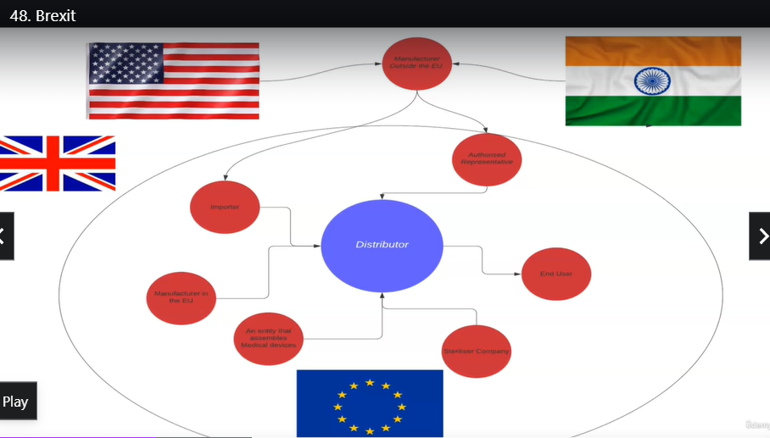

This means that any medical device manufacturer within the UK will be a manufacturer outside Europe.

The UK has to obtain a European authorized representative and a distributor.

The Medicines and Healthcare Products Regulatory Agency MHRA is the UK Competence Authority.

They have issued guidelines which are attached as a resource with this lecture.

It is interesting to note that we can understand the rules concerning a medical device manufacturer outside the European Union as we've gone through that, in detail in this module.

**Now we have to contemplate the rules that the UK government are mandating regarding marketing a medical device in their market.**

(contemplate = think deeply and at length)

Manufacturers within the European Union need to adhere to these directions if they want to market their medical device within the UK.

So let's go through the directions.

Direction from MHRA (CA of the UK)

* CE marked products can still be placed on the U.K. market until June 30th, 2023.

This is important for the economic operators to understand.

* CE certificates that are issued by a notified body located in the European Union are valid until June 30th, 2023.

So, these two last points are interesting as the MHRA are allowing a transition period.

* Direction from the MHRA as of January the 1st, 2021 non UK medical device manufacturers within the European Union need to register their device with the MHRA on their database.

The MHRA have given a transition period for registration.

The transition date correlates to the class of the device.

Class III and class IIb implantable devices need to be registered within four months

class IIb and class IIa devices need to be registered within eight months.

Class I devices need to be registered within 12 months.

**Direction from MHRA**, a non-UK based manufacturer situated in the European Union, wanting to market their device in the UK, will need a UK representative.

This is similar to the role of the European authorized representative.

The UK representative will need to ensure that the European Union manufacturers are compliant with the UK medical device regulation.

One can start to appreciate that this is going to be challenging to organize the structure for a European Union medical device manufacturer.

**Direction from MHRA**, the UK will have their own notified bodies.

They will be a list of accredited UK notified bodies.

This would be similar to the European Union list of notified bodies, which is located in Nando.

The list of notified bodies in Europe is attached as a resource to this lecture.

These accredited UK notified bodies will be able to perform conformity assessments in compliance with UK regulation.

This certification will be called UK CA, UK Conformity Assessment, the new logo is illustrated here.



Products sold in the U.K. will have to have this mark on the packaging.

If the European Union manufacturer has stock already manufactured before January the 1st, 2021, then this is exempt of the U.K. CA mark.

Both UK and European Union manufacturers need to understand these rules to be allowed to market medical devices in either jurisdiction.

What have we learned

what is the impact of the UK leaving the EU (Brexit) in the context of the medical device regulation 2017/745.

We understand the rules laid down by the UK for compliance with their regulation.

We understand the rules the UK must follow to be compliant with European regulations.

Overall, you can appreciate there is work involved in getting ready by the UK manufacturer, the European manufacturer and non-European Union manufacturers.

QUIZ BREXIT, Understand how Brexit will affect medical device regulation in Europe.

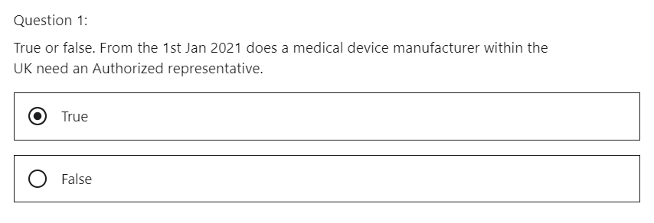

Correct. Since the UK is not a member of the European Union, they now need an EAR.

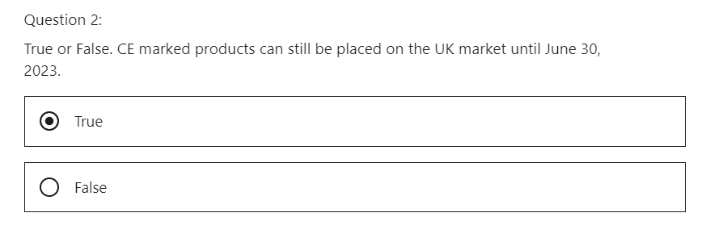

Correct. This is important for the economic operators to understand.

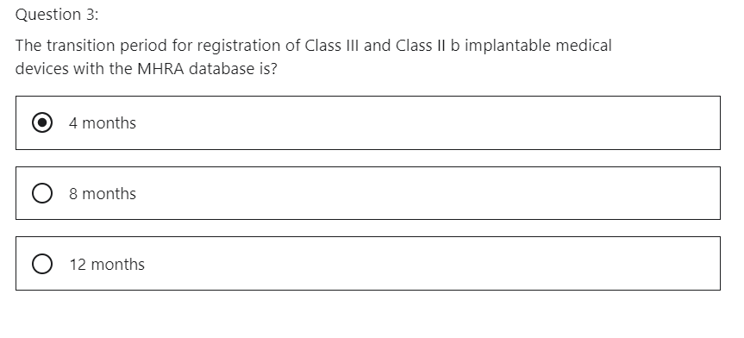

Correct. The MHRA are allowing this transition time.

UK CA

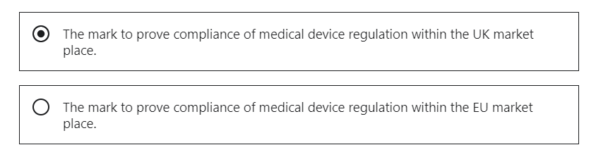

Correct. This will mark will have to transition onto the medical device packaging within the UK

## 4 Switzerland Mutual Recognition Agreement

Hi, welcome to the lecture on the medical device regulation 2017/745 and Switzerland's mutual recognition agreement.

What will we learn?

* We will understand a mutual recognition agreement between Switzerland and the EU.
* What is the current status of the mutual recognition agreement MRA?
* How does this affect medical device regulation2017/745 in Switzerland?

Switzerland is not part of the EU but is bound to the union through a series of agreements.

There is, for example, a mutual recognition agreement MRA a covering medical devices in order to enable these devices move freely between the EU and the Swiss markets.

This MRA was associated with the medical device directive, a new agreement had to be introduced due to the fact that the medical device regulation, 2017/745 was being introduced.

There are over 120 MRA’s linked to a wider framework agreement between the EU and Switzerland

In 2014, Switzerland and the EU started to negotiate a new institutional framework agreement.

This was called “InSta”for short. This resulted in a proposal in 2018.

However, at the end of 2018, the Swiss rejected this proposal in a public consultation.

The main reason had to do with immigration by EU citizens

That rejection had been fuelled by the right wing Swiss political party as the which claimed that these immigrants were taking away jobs from the Swiss and benefiting from Swiss Social Security.

With the Institutional Framework Agreement rejected, it was not possible to sign New MRA’s..

This meant that the immigration issue was about much more than allowing free movement of people.

It had other impacts.

For example, Swiss stock exchanges had no longer direct access to EU markets, and the medical device industry now saw the consequences of this vote, with the medical device regulation not being covered by a signed MRA.

This led to a sort of a limbo for the medical device regulation 2017/745 date of implication

on September 27, 2020 the Swiss held several referendums.

This resulted in a total of five issues of which their opinion was asked.

Subjects covered included a vote on whether to limit immigration for EU citizens, which also had implications for the medical device regulation MDR and the date of its application in Switzerland.

The referendum was rejected.

This meant that it could lead to new negotiations of the Institutional Framework Agreement.

The new institutional framework agreement will take time and will require at least one new referendum.

It is therefore expected the Institutional Framework Agreement will be signed no earlier than in Q2 of 2022, but possibly later.

This also implies that the MRA for the medical device regulation will not be signed before the regulations date of application in May 2021.

This means that for medical device manufacturers in Switzerland will become a third country, at least for some time.

This means that an authorized representative must be appointed for any cross-border traffic.

What have we learned?

* There will be a delay in signing a new MRA between Switzerland and the EU.
* This will have a delay in mutual recognition agreement on the medical device regulation 2017 /745
* for a temporary period Switzerland will be treated as an outside body within the European Medical Device Regulation Framework.

QUIZ Switzerland Mutual Recognition Agreement

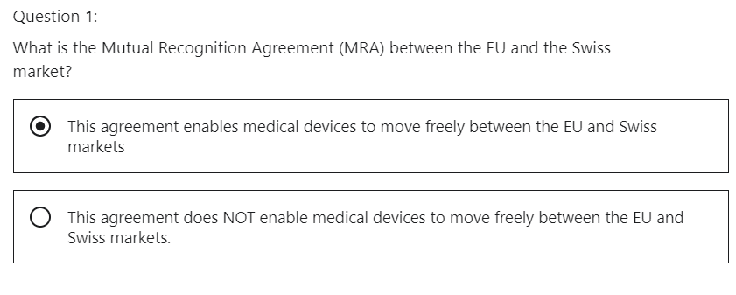

Correct. Switzerland is not part of the EU but is bound to the union through a series of agreements.

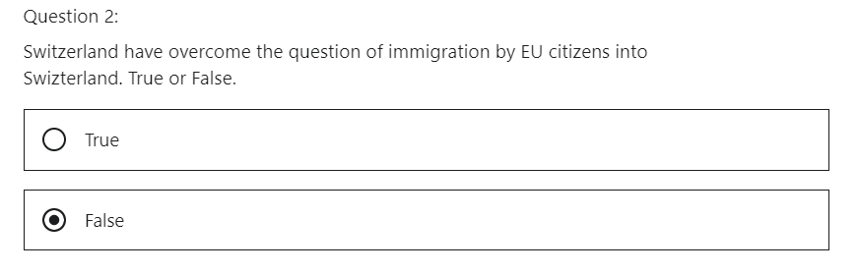

The referendum to prevent immigration of EU citizens into Swizterland was rejected on September 27, 2020. This meant that it could lead to the mutual recognition of medical device regulation between the EU and Swizterland.

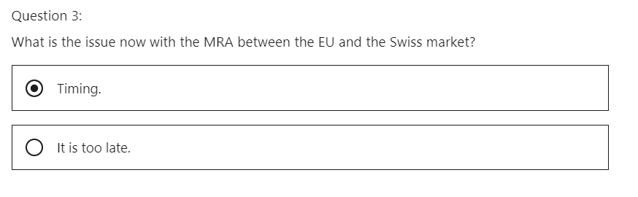

Correct. It is expected the Institutional Framework Agreement will be signed no earlier than Q2 of 2022, but possibly later.

## 5 Turkey and EFTA MDR 2017/745

Hi, welcome to the lecture medical device regulation 2017/745, the Turkey Association Agreement and the EFTA bilateral agreement.

What will we learn?

* We will understand the association with Turkey and the EU.
* We will understand the bilateral agreements with the EFTA.
* How does this affect the medical device regulation 2017/745 Turkey and the EFTA.

Turkey has an association agreement dating back to 1963 with the EU, which has mechanisms are very similar to the mutual recognition agreement.

This has meant that the medical device directive has been implemented at a national level, CE marked medical devices can be sold in Turkey and Turkish manufactured medical devices can be sold in the European Union marketplace.

The Turkish Medicines and Medical Devices Agency TITCK is the Turkish competent authority.

They are working on the medical device regulation and is on course to introduce its own national version of the regulation.

The issue as of January 2021 is that they may not make the May 2021 deadline of the medical device regulation coming into force in the European Union market.

Therefore, for a period of time they may be seen as a third country which will demand a European authorized representative during this transition.

First of all, what is the European Free Trade Association, also known as the EFTA?

CE marking on a product ensures the free movement of the product within the EFTA and the European Union EU.

EFTA European Free Trade Association consists of Switzerland, Iceland, Liechtenstein and Norway.

We've already discussed Switzerland in the lecture on Switzerland Mutual Recognition Agreement, which had a challenge due to a referendum on immigration.

Now let's discuss Iceland, Liechtenstein, and Norway.

The European Free Trade Association EFTA member states are working to pass their own national versions of the medical device regulation 2017/745.

The issue as of January 2021 is that they may not make the May 2021 deadline of the medical device regulation coming into force in the European Union market for a period of time they may be seen as a third country, which will demand a European authorized representative during this transition.

What have we learned?

* Turkey and the EFTA hold agreements with the EU based on the medical device directives
* they are currently working on transposing the medical device regulation 2017/745 into their national legislation.
* The main challenge is to meet the May 2021 date of implementation of the medical device regulation 2017/745.

It may lead to a transition time where these countries are seen as a third country, therefore, it may mandate an authorized representative for a period of time.

QUIZ Understand how Turkey and the EFTA will be compliant to the MDR 2017 745

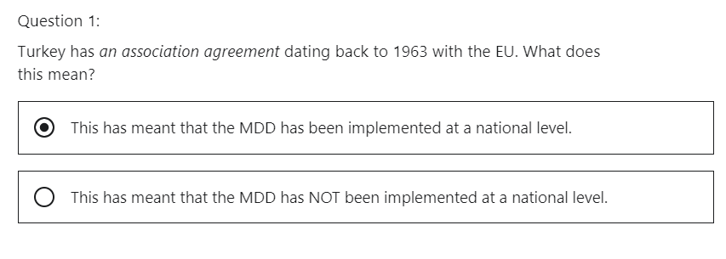

Correct. CE marked medical devices can be sold in Turkey and Turkish manufactured medical devices can be sold in the European Union Market place.

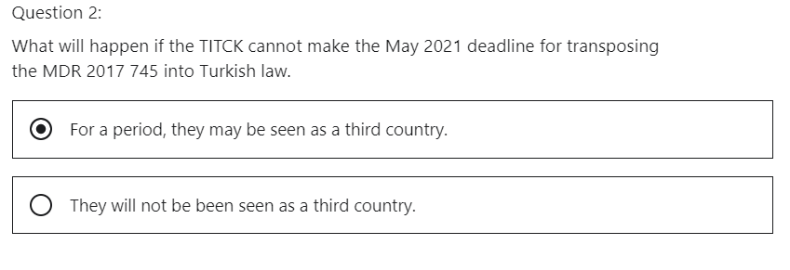

Which will demand a European authorised representative during this transition.

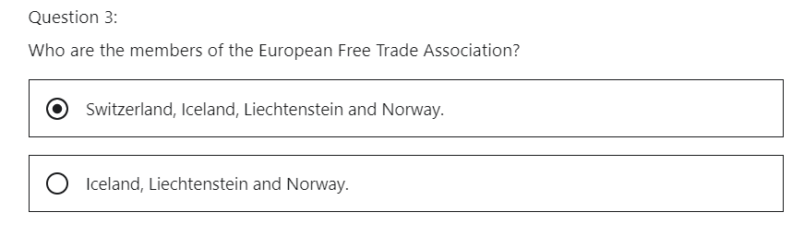

Correct. CE Marking on a product ensures the free movement of the product within the EFTA &amp; European Union (EU).

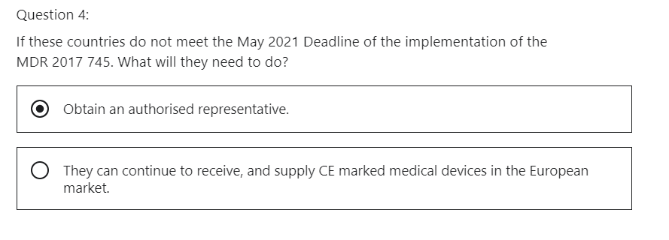

True. The will need a representative in the EU for regulation.

## 6 Common Specifications

Hi, welcome to the lecture on Common Specification.

What will we learn?

We will understand the common specification within the context of the medical device regulation, 2017/745.

The EU Medical Device Regulation 2017/745 mandates the manufacturer meets General Safety and Performance Requirements GSPR on a medical device.

If the manufacturer cannot meet these requirements, they are not compliant and therefore will not get permission to market their device on the European Union market.

EU regulations allow manufacturers to make **use of harmonized standards** for evidence that they are compliant with the general safety performance requirements.

Standards contain such specific criteria; EU regulations and directives allow manufacturers to make use of harmonized standards for evidence

Where harmonized standards do not exist or are insufficient, specific criteria are lacking.

It is these deficiencies that common specifications shall overcome.

Common specifications are mandated in Article nine.

The method that a manufacturer proves that they are compliant to the medical device regulation is accreditation to harmonized standards.

For example, a manufacturer will prove compliance to a quality management system by having a ISO 13845 certificate.

If a standard is not sufficient to prove compliance to the medical device regulation or there is a public

health concern, the commission will produce a **common specification** to address this gap.

This will be done by consultation with the medical device coordination group MDCG.

**Who implements common specifications?**

The EU Commission will implement common technical specifications where no harmonized standards exist or where they are not sufficient.

Article 105 defines the tasks of the Medical Device Coordination Group MDCG to contribute to the development of standards, common specifications and scientific guidelines, including product specific guidelines.

What have we learned

* if a standard is not sufficient to prove compliance to the medical device regulation or there is a public health concern, then a common specification is required.
* Common specifications will be created by the medical device coordination group MDCG.

QUIZ Understand what is meant by Common Specification in the context of the MDR 2017 745.

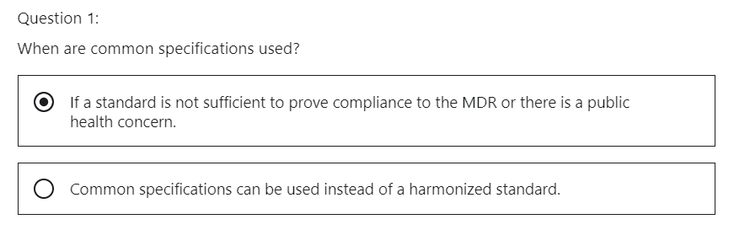

Correct. The commission will produce a common specification to address this gap.

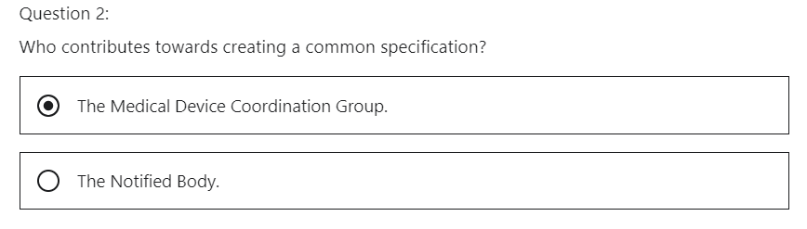

Correct. Article 105 defines the tasks of the Medical Device Coordination Group (MDCG) to contribute to the development of standards, common specifications and of scientific guidelines, including product specific guidelines.

## 7 The Rolling Plan

What will we learn, we will understand what the rolling plan is.

The rolling plan is the steps that the European Union are taking to complete the transition of the medical device regulation to 2017/745 within the European Union.

The slide shows an excerpt from the rolling plan.

The rolling plan is attached as a resource to this lecture.

So, for example, let's look at item number three, which puts an action in for, Annex 16.

This annex mandates that the devices without a medical purpose need to be compliant to the medical device regulation 2017/745, the action title or subject is common specifications for products without a medical purpose.

It explains where in the medical device regulation products without a medical purpose are covered.

It describes what the action is going to be to allow the medical device manufacturer to be compliant with this part of the regulation.

In this case, it is the creation of a common specification.

The expected closure date is Q2 2021.

And what is the current status?

What have we learned, what is the rolling plan?

We understand it is a set of actions laid down by the European Commission to ensure successful completion of the medical device regulation 2017/745.

QUIZ The Rolling Plan

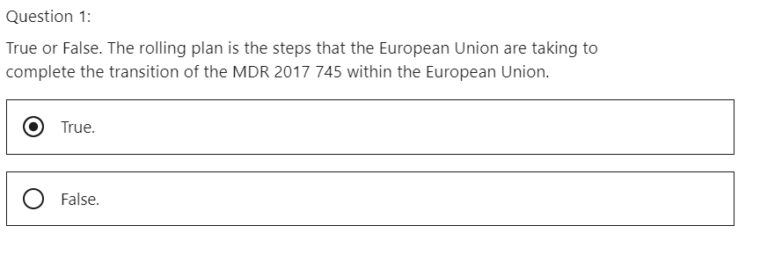

# Section 10: Bonus section

Hi, welcome to the bonus lecture section.

I would like to introduce you to other courses that I have created.

**European medical device regulation, in simple terms**

if you take this course, you can count on these results, understand how medical device regulation works in the European Union, differentiate between a regulation and a directive, steps required to gain permission to manufacture and sell a medical device in the European Union.

The PDF format of this lecture is attached so you can click on the link below to access the course.

**Medical device process validation explained in simple terms**

if you take this course, you can count on these results, understand what process validation means for any industry, understand why we need process validation. Understand the process of validation within the medical device industry.

The PDF of this lecture is attached, so you can click on the link below to access the course.

**Quality control, seven basic tools, basic clean improvements** get a real understanding how these valuable tools can help you in your workplace. If you take this course, you can count on these results, apply their techniques of their tools. This means students will be able to collect data, analyze data and put actions in place to resolve issues.

Students will be able to harness Excel as a tool to apply the seven basic tools. This course will explain the types of data used in statistics and simple terms. The PDF format of this lecture is attached, so you can click on the link below to access the course.

I have supplied you with reference material in this section of the course.

This reference material will help you implement the medical device regulation 2017/745.

Thank you, so much and good luck, Marty.